GREEN INFRASTRUCTURE ASSESSMENT REPORT
MS4 AREA CAPITAL IMPROVEMENT PROGRAM PROJECTS
School Name/Building ID:

Design No. :

Project Description:

Prepared For:
NYC School Construction Authority
3030 Thomson Avenue
Long Island City, NY 11101

Prepared By:
[Company/Designer Name]

[Report Date]

TABLE OF CONTENTS
Page No.
1.0 OVERVIEW………………………………………..………………………….X

2.0 EXISTING SITE CONDITIONS…………………..……………………X
2.1 Topography and Drainage………………………………………………...X
2.2 Geotechnical Analysis…….…………………….……….………….…….X

3.0 GREEN INFRASTRUCTURE FEASIBILITY….…………………X
3.1 Green Infrastructure Strategies…….………..…………………….…….X
3.2 Hydrologic and Hydraulic Analysis…….………………………....…….X
3.3 Comparison of Green Infrastructure and Site Detention..……..…...X

4.0 APPENDICES……..………………………………………………….…….X
- Site Plan
- References
- Supporting Documentation

Project Location

Project Description

Site Area (SF)

Building Footprint (SF)

Total Impervious Area (SF)

Project Scope
[Report required for roof replacement projects and modifications to playground, other paved areas, and landscaped areas that drain to a storm sewer or directly to a waterway. Describe the type of project.]

1.0 OVERVIEW

Green Infrastructure Strategies Summary

Strategy | Feasible | Non-Feasible | Ranking | Magnitude of Cost
Porous Pavers
Precast porous concrete
Rain garden/vegetated bioretention/bioswale
Rain Barrels and Cisterns
Extensive green roof
Subsurface retention chambers/drywells
Subsurface retention pipe

[The table is to be filled in after investigating all potential green infrastructure practices that would be potentially appropriate for the project, with consideration to site conditions, allowable space (SF), soil percolation rate, and local code requirements. As an example, a roof replacement project would typically only look at green roof or other strategies that could be implemented on the roof (and thus a geotechnical investigation or on-site retention structures would not be investigated as part of the project), while a playground project would look at strategies that would be applicable to a grade level project. However, if the roof replacement project had some on ground work, some of the site practices would be appropriate to look at. Rank all green infrastructure strategies from most technically feasible to least technically feasible. Put NA in spaces that were not investigated for the project as not appropriate to the type of project. Provide a magnitude of cost for each of the items based on typical construction values. Those that are the most technically feasible and beneficial shall be included in the scope report as an additional recommended item. If project is required to provide site detention above what is currently existing on the site, provide the “Systems Meeting DEP Site Detention Requirements Summary” table and the comparisons Section in Part 3 of the Green Infrastructure Assessment Report_Capacity template.]

2.0 EXISTING SITE CONDITIONS
2.1 TOPOGRAPHY AND DRAINAGE
Provide a narrative and indicate the following, provide site plan to denote as needed:
- Site Topography including site slope description
- Drainage points on site, connection to storm sewer system and discharge location
- Municipal Separate Storm Sewer System (MS4) designation and type
- Identify existing storm water inlets and infrastructure on the site and all required green infrastructure setbacks. Reference: Table 2-1: Green Infrastructure Setback Requirements¹
Utilize the Green Infrastructure Feasibility Flow Chart² to determine if on-site infrastructure is feasible based on lot size, building size, potential location, etc., and if not feasible indicate the reason in Section 3. If there is none, do not proceed with the geotechnical analysis for soil percolation and describe the findings in Section 3. If any are feasible, perform the below geotechnical analysis for soil type and permeability at the potential locations. If there is none, do not proceed with the geotechnical analysis for soil percolation and describe the findings in Section 3.
2.2 GEOTECHNICAL ANALYSIS
Indicate the following results of geotechnical investigation to determine feasibility of green infrastructure practices:
- Soil profile and permeability
- Soil percolation test results- infiltration rate
- Depth to Groundwater level
- Depth to Bedrock
If the percolation rate is less than .5in/hr, on-site green infrastructure is not feasible and should be so stated in Section 3.

3.0 GREEN INFRASTRUCTURE FEASIBILITY
3.1 GREEN INFRASTRUCTURE STRATEGIES
Provide a narrative describing feasibility and non-feasibility of each considered green infrastructure strategy as denoted above in 1.0 Overview, with consideration to the following factors:
a) Technical feasibility (Structural Feasibility, sufficient space, soil conditions, etc.)
b) Hydraulic Analysis
c) Potential on-site retention (gallons)
d) Available SF (mechanical equipment on roof, code mandated clearances, etc.)
e) Maintenance considerations and cost effectiveness
f) Siting Considerations (presence of existing vegetation, ease of maintenance and access to planted areas and cleanouts, underlying soil permeability and load-bearing capacity, and cost)

3.2 HYDROLOGIC AND HYDRAULIC ANALYSIS
If the soil percolation rate meets the minimum .5in./hr, summarize methodology and results for all calculations including:
Peak flow rates, storage volumes, infiltration volume, critical water surface elevations, green infrastructure sizing, design capture volume, drainage times. Consultant to indicate percentage of stormwater retained on the site for each of the strategies.

4.0 APPENDICES
APPENDIX A - SITE PLAN
Provide narrative and map or diagrams indicating project siting and location of green infrastructure strategies.

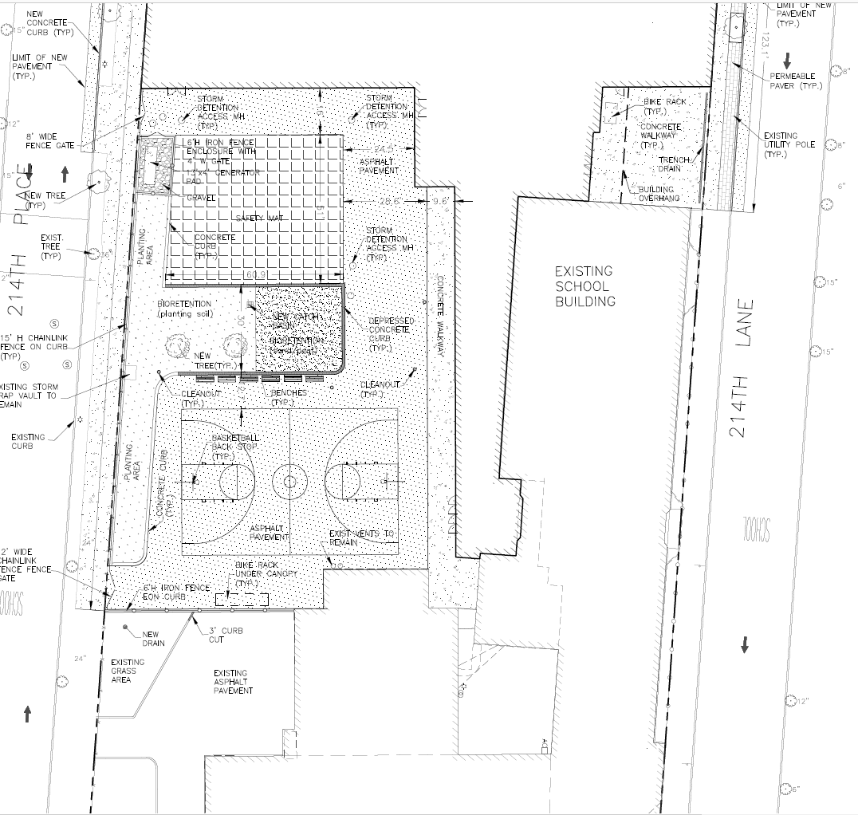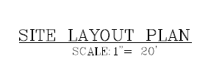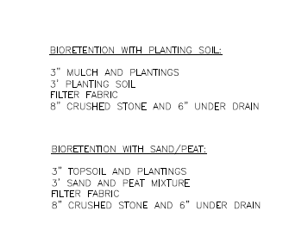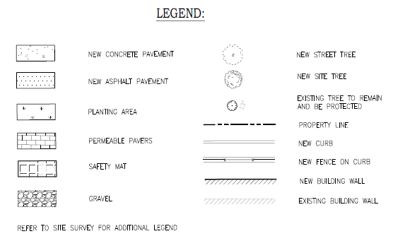
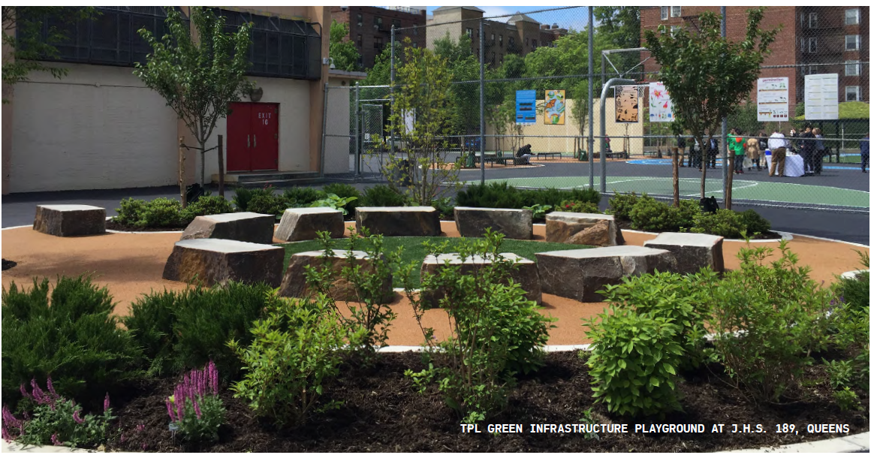
Source: NYC Green Infrastructure 2018 Annual Report https://www1.nyc.gov/assets/dep/downloads/pdf/water/stormwater/green-infrastructure/gi-annual-report-2018.pdf

APPENDIX B - REFERENCES
- NYC Green Infrastructure On-site Design Manual: https://www1.nyc.gov/assets/dep/downloads/pdf/water/stormwater/green-infrastructure/nyc-green-infrastructure-onsite-design-manual-v1.pdf
- Green Infrastructure Assessment Feasibility Flow Chart http://scan/Departments/ArchitectureEngineering/DesignStandards/PPGHDocuments/GreenInfrastructureFlowchart.pdf
- MS4Permit: https://www1.nyc.gov/html/dep/pdf/water_sewer/spdes-ms4-permit.pdf
- NYC Stormwater Management Program: https://www1.nyc.gov/assets/dep/downloads/pdf/water/stormwater/ms4/nyc-swmp-plan-full.pdf
- 2012 DEP Guideline for the Design and Construction of Stormwater Systems https://www1.nyc.gov/assets/dep/downloads/pdf/water/stormwater/stormwater-design-construction-guidelines-2012-final.pdf

APPENDIX C - SUPPORTING DOCUMENTATION

