GREEN INFRASTRUCTURE ASSESSMENT REPORT
☐GREEN SCHOOLS GUIDE 2019 SUBMISSION
☐MS4 AREA CAPACITY PROJECTS NOT SUBJECT TO GSG

School Name/Building ID:

LLW No. :

Project Description:

Prepared For:
NYC School Construction Authority
3030 Thomson Avenue
Long Island City, NY 11101

Prepared By:
[Company/Designer Name]

[Report Date]

TABLE OF CONTENTS
Page No.
1.0 OVERVIEW………………………………………..………………………….X

2.0 EXISTING SITE CONDITIONS…………………..……………………X
2.1 Topography and Drainage………………………………………………...X
2.2 Geotechnical Analysis…….…………………….……….…………..…….X

3.0 GREEN INFRASTRUCTURE ASSESSMENT.………...…..……X
3.1 Green Infrastructure Strategies…….………..……………………..…….X
3.2 Hydrologic and Hydraulic Analysis…….…………………………..…….X
3.3 Comparison of Green Infrastructure and Site Detention..……..…….X

4.0 GREEN SCHOOLS GUIDE CREDIT FEASIBILITY....….…….X

5.0 APPENDICES……..…………………………………………………..…….X
- Site Plan
- References
- Supporting Documentation

[Remove Part 4, Green Schools Guide Credit Feasibility, if project is not a GSG project]

Project Location

Project Type
[Indicate New Construction, Substantial Reconstruction, Addition, Annex]

Site Area (SF)

GSG Project Boundary (SF)

Building Footprint (SF)

Total Impervious Area (SF)

Project Scope
[Provide a description of the project, and a description of potential available roof and site space]

1.0 OVERVIEW

Green Infrastructure Strategies Summary
Strategy | Feasible | Non-Feasible | Ranking | Magnitude of Cost
Porous Pavers
Precast porous concrete
Rain garden/vegetated bioretention/bioswale
Rain Barrels and Cisterns
Extensive green roof
Subsurface retention chambers/drywells
Subsurface retention pipe

Systems Meeting DEP Site Detention Requirements Summary
Strategy | Feasible | Non-Feasible | Ranking | Magnitude of Cost
Precast box culverts
Precast detention tanks
Roof Detention

[The Green Infrastructure Strategies table is to be filled in after investigating all potential green infrastructure practices for the project, with consideration for site conditions, allowable space (SF), soil percolation rate, and local code requirements. Rank all green infrastructure strategies from most technically feasible to least technically feasible. Put NA in spaces that were not investigated for the project as not appropriate to the type of project. Provide a magnitude of cost for each of the items based on typical construction values.
For the System Meeting DEP Site Detention requirements, indicate those practices that appear to be the most cost efficient and technically feasible for the given site. Add additional rows for other DEP accepted practices if practical]

2.0 EXISTING SITE CONDITIONS
2.1 TOPOGRAPHY AND DRAINAGE
Provide a narrative and indicate the following, provide site plan to denote as needed:
- Site Topography including site slope description
- Drainage points on site, connection to storm sewer system and discharge location
- Municipal Separate Storm Sewer System (MS4) designation and type, if in such area
- Identify existing storm water inlets and infrastructure on the site and all required green infrastructure setbacks. Reference: Table 2-1: Green Infrastructure Setback Requirements¹
Utilize the Green Infrastructure Feasibility Flow Chart² to determine if on-site infrastructure is feasible based on lot size, building size, potential location, etc., and if not feasible indicate the reason in Section 3. If there is none, do not proceed with the geotechnical analysis for soil percolation and describe the findings in Section 3. If any are feasible, perform the below geotechnical analysis for soil type and permeability at the potential locations. If there is none, do not proceed with the geotechnical analysis for soil percolation and describe the findings in Section 3.

2.2 GEOTECHNICAL ANALYSIS
Indicate the following results of geotechnical investigation to determine feasibility of green infrastructure practices:
- Soil profile, permeability, and load bearing capacity
- Soil percolation test results- infiltration rate
- Depth to Groundwater level
- Depth to Bedrock
If the percolation rate is less than .5in/hr, on-site green infrastructure is not feasible and should be so stated in Section 3.

3.0 GREEN INFRASTRUCTURE ASSESSMENT
3.1 GREEN INFRASTRUCTURE STRATEGIES
Provide a narrative describing feasibility and non-feasibility of each considered green infrastructure strategy as denoted above in 1.0 Overview, with consideration to the following factors. This will meet the requirements for GSG Credit S2.3P, Green Infrastructure Assessment, and the DEP reporting requirements for projects in MS4 areas. Update narrative in all subsequent submissions:
a) Technical feasibility (sufficient space, soil conditions, etc.)
b) Hydraulic Analysis
c) Potential on-site retention (gallons)
d) Available SF (mechanical equipment on roof, code mandated clearances, etc.)
e) Maintenance considerations and cost effectiveness
f) Siting Considerations (presence of existing vegetation, ease of maintenance and access to planted areas and cleanouts, underlying soil permeability and load-bearing capacity, and cost)

3.2 HYDROLOGIC AND HYDRAULIC ANALYSIS
If the soil percolation rate meets the minimum .5in./hr, summarize methodology and results for all calculations including:
Peak flow rates, storage volumes, infiltration volume, critical water surface elevations, green infrastructure sizing, design capture volume, drainage times. Consultant to indicate percentage of stormwater retained on the site for each of the strategies.

3.3 COMPARISON OF GREEN INFRASTRUCTURE AND SITE DETENTION
Discuss the site detention system likely to be used that meets all DEP requirements and compare with the different feasible green infrastructure practices and how much, if not all, of the site detention can be removed by doing the green infrastructure.

4.0 GREEN SCHOOLS GUIDE CREDIT FEASIBILITY
[If green infrastructure was determined to be feasible, provide a written feasibility for meeting GSG Credit S2.4, Rainwater Management. Provide a comparison of what will be required to meet the required site detention based on DEP requirements and, for projects required to prepare and follow a SWPP, for providing stormwater structures improving the quality of the water discharge, and the additional work to meet the credit. Provide an order of magnitude cost for each of the systems.]

5.0 APPENDICES
APPENDIX A - SITE PLAN
[Provide narrative and map or diagrams indicating project siting and location of green infrastructure strategies.]

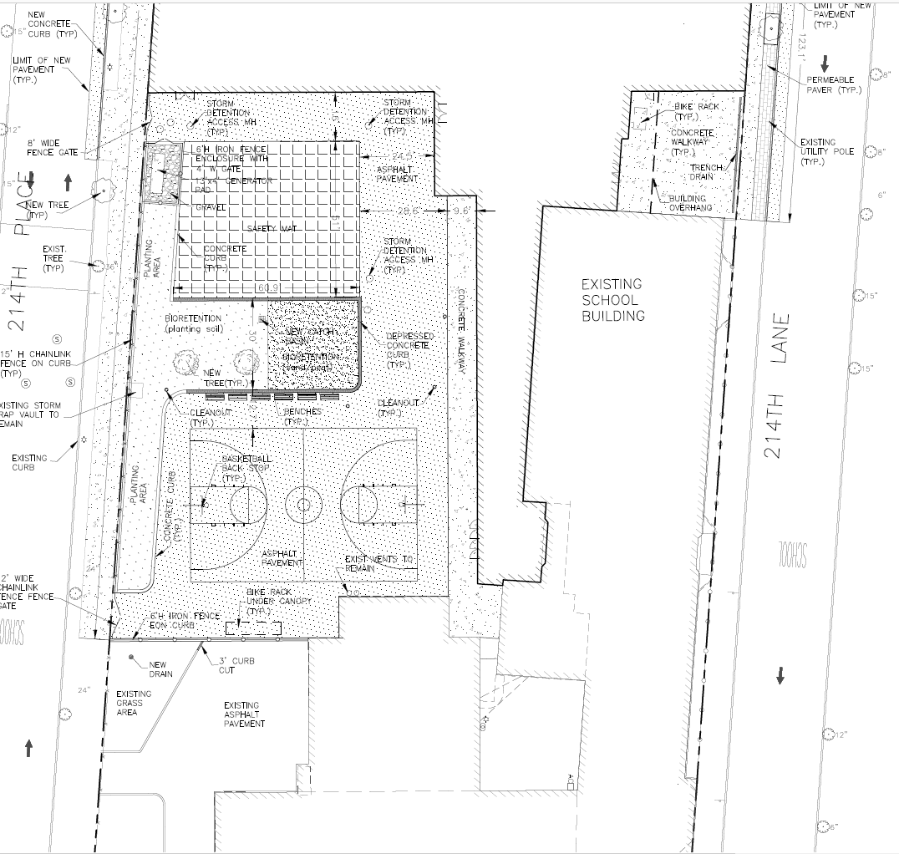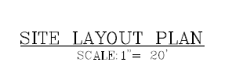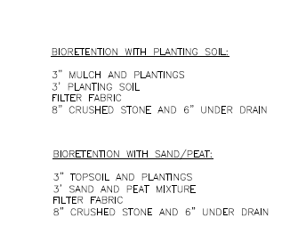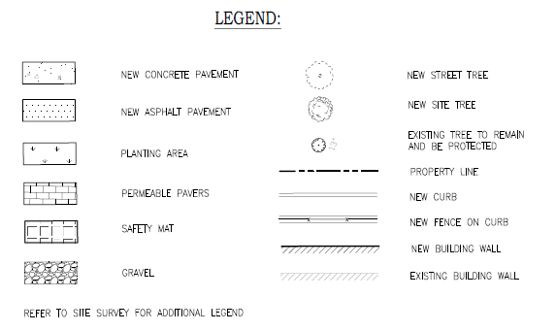
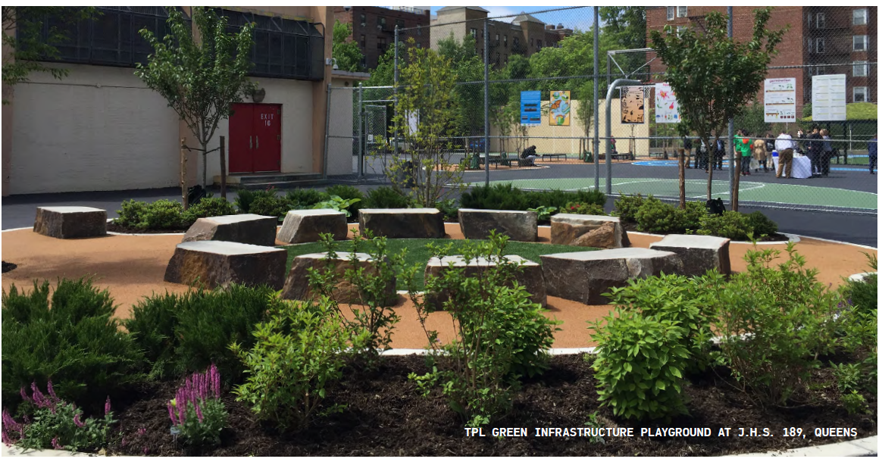
Source: NYC Green Infrastructure 2018 Annual Report https://www1.nyc.gov/assets/dep/downloads/pdf/water/stormwater/green-infrastructure/gi-annual-report-2018.pdf

APPENDIX B - REFERENCES
- NYC Green Infrastructure On-site Design Manual: https://www1.nyc.gov/assets/dep/downloads/pdf/water/stormwater/green-infrastructure/nyc-green-infrastructure-onsite-design-manual-v1.pdf
- Green Infrastructure Assessment Feasibility Flow Chart http://scan/Departments/ArchitectureEngineering/DesignStandards/PPGHDocuments/GreenInfrastructureFlowchart.pdf
- MS4Permit: https://www1.nyc.gov/html/dep/pdf/water_sewer/spdes-ms4-permit.pdf
- NYC Stormwater Management Program: https://www1.nyc.gov/assets/dep/downloads/pdf/water/stormwater/ms4/nyc-swmp-plan-full.pdf
- 2012 DEP Guideline for the Design and Construction of Stormwater Systems https://www1.nyc.gov/assets/dep/downloads/pdf/water/stormwater/stormwater-design-construction-guidelines-2012-final.pdf

APPENDIX C - SUPPORTING DOCUMENTATION

