Simple Box Model Workflow
June 15, 2020

Background

Scope
This document describes the simple box model required to meet the GSG Integrated Design Process Credit.
This document covers IDP box models using eQuest, which is the Authority’s selected energy modeling program. Modelers should provide the information requested in the Box Model Information Summary.

Notes
The purpose of these box models is to get a comparative idea of how different schemes compare to each other. As such, the total EUI for each scheme is not to be utilized within any templates or within the IDP Workshop Report, as there is not enough information to provide a realistic EUI.
To reduce the level of effort, the eQuest Modeling path recommends using the built-in wizards, which have different schedules and HVAC systems. It is not expected that the IDP model will be used to generate the model at DD and beyond.
eQuest allows for PV modeling, but the PV modeling is only based on size and orientation- shading from adjacent buildings are not considered. It is assumed that the PV generated will be proportional to the roof area, so the roof area is required for the Box Model Information Summary. eQuest does not have capability to perform shading studies. To assess the impact of shading, the lighting reduction due to daylight dimming is included in the Box Model Information Summary.

eQuest

Schematic Design Wizard

General Information
- Select Building Type:
- School, K-6 Elementary
- Middle School
- Secondary (High School)
- Select Location
- Select Heating Equipment
- Hot water coils

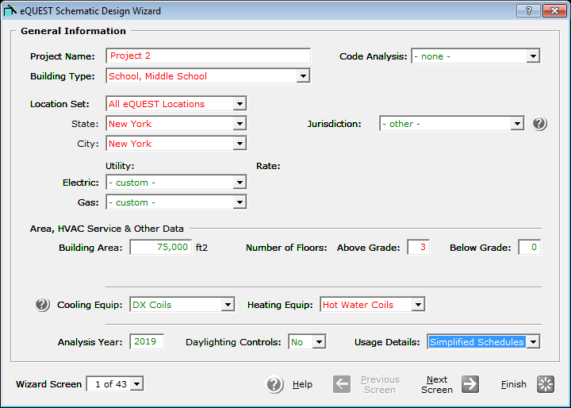

Building Footprint
- Select Footprint
- Footprint should adequately represent the proposed scheme
- Select shape based on each individual scheme. Use custom shape if necessary
- Revise footprint dimensions, building orientation, area per floor and floor to floor heights as appropriate
- Perimeter/Core zoning pattern should be adequate for most applications

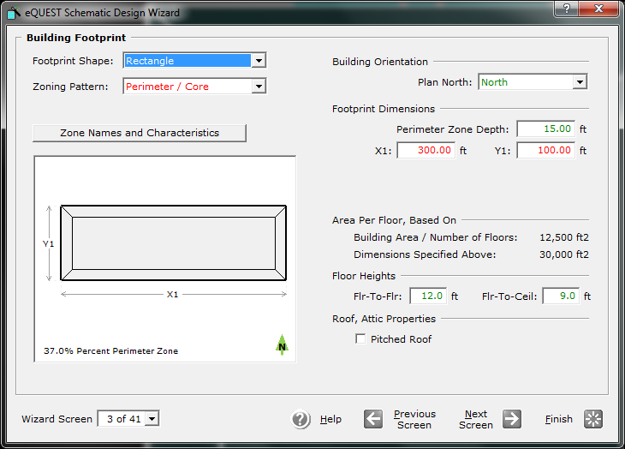

Building Construction
- Roof:
- 6 in concrete
- 6” polyurethane (R-36)
- w/ Ltwt conc cap Insulation
- Wall:
- 6”CMU
- Solid Grounted
- R-15 mtl furred
- Ground Floor
- R-10 Full underslab insulation

*Please note that the below inputs are specified for the IDP Box Model only. Due to software limitations, prescriptive R-values typical of SCA standards are not prescribed for the below roof and slab assemblies. However, a U-value has been assigned to simulate SCA standards.
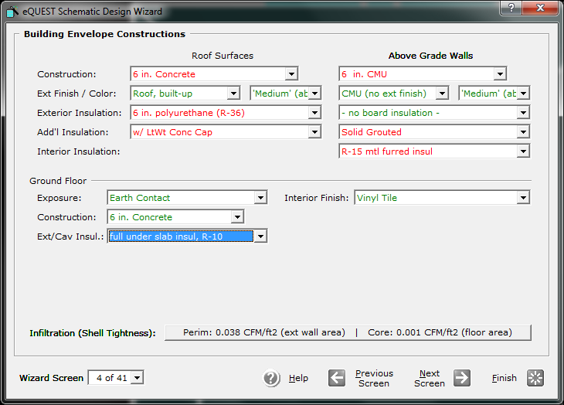

Exterior Windows
- Glass Category
- Specify Properties (See below)
- Frame type
- Alum, Brk Fixed w Insulated spacers
- Frame Width
- Set to 0
- % Window
- Set % window to 20% on all facades

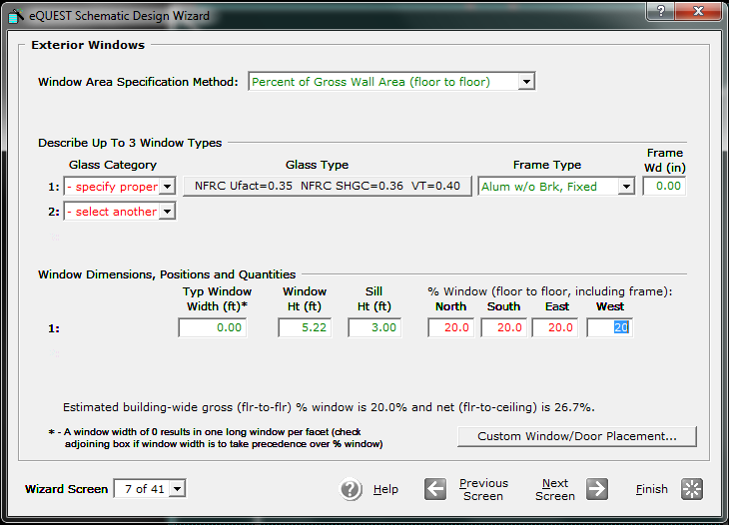

Glass Properties
- NFRC U-Factor = 0.34 (33% fixed, 67% operable, adjusted for air films)
- NFRC SHGC = 0.36
- Visible Transmittance = 0.4
- The other properties in the dialog box will not affect the model.
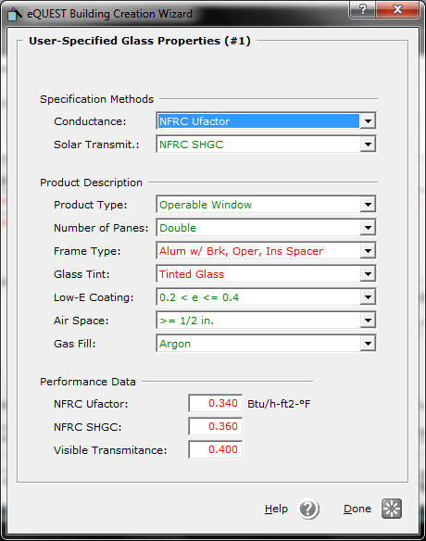

Exterior Windows
- Exterior Window Shades and Blinds
- Remove all window shades
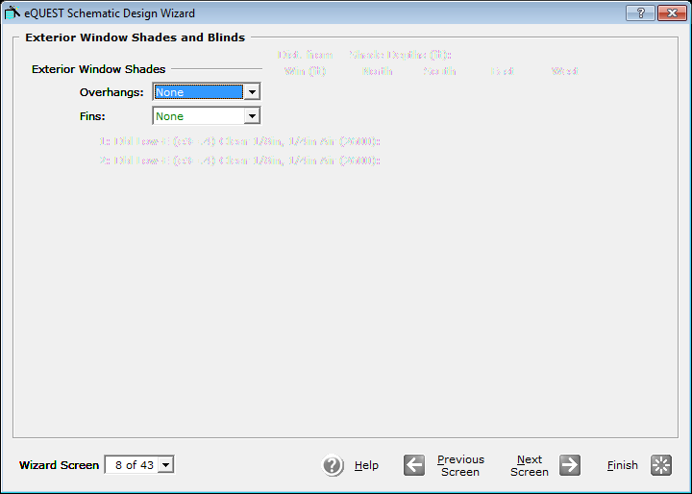

Occupied Loads by Activity Area
- Adjust activity areas as desired
- Adjust lighting to LPD = 0.50 W/ft2 for whole building
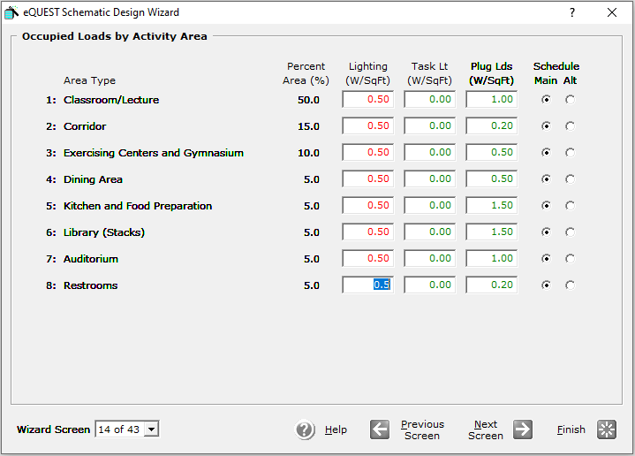

HVAC System
- Set heating and cooling to DX Coils, Hot Water Coils (Air-cooled chillers are not available in Wizard- this is the closest approximation)
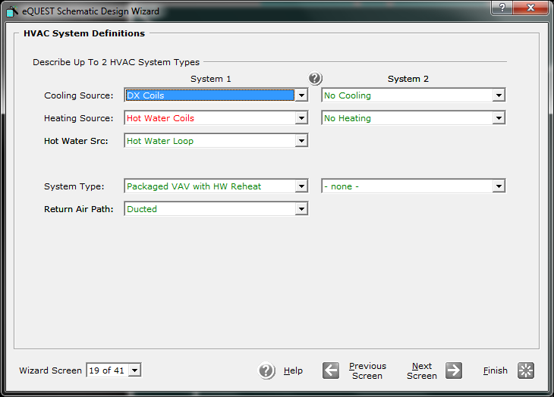

Packaged HVAC Equipment
- Revise EER to 9.7 (estimate for air-cooled chiller, allowing some additional energy for pumping)
- Do not allow crankcase heating
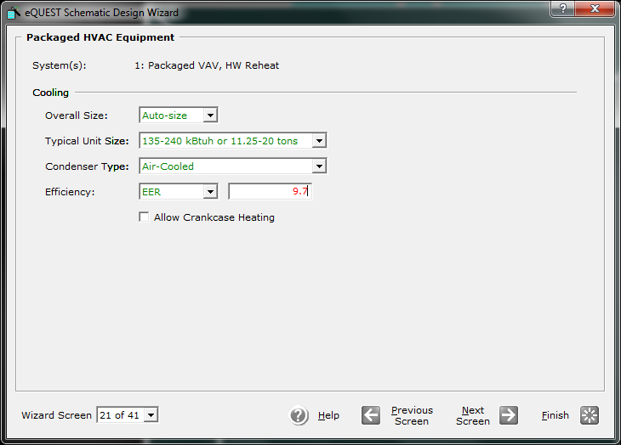

HVAC System Fans
- Set Static to 5”
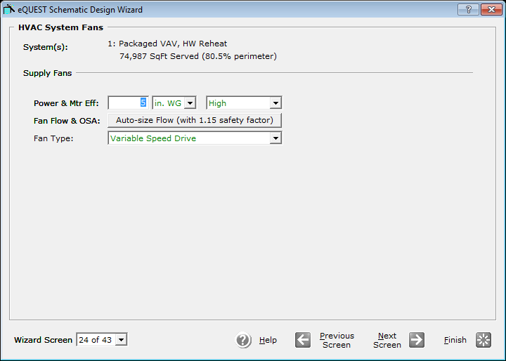

Heating Primary Equipment
- Set pump head to 80
- Set HW flow to variable
- Set Pump Control to VSD
- Set boiler efficiency to 89%

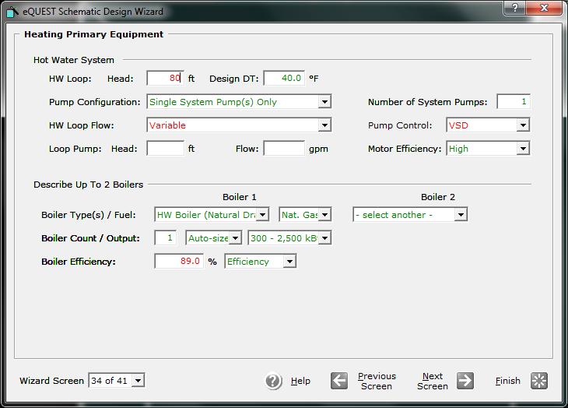

Energy Efficiency Measure Wizard
The Energy Efficiency Measure Wizard will be used to evaluate how the window area affects the overall EUI.
- Exit the building creation wizard.
- Open the Energy Efficiency Measure Wizard.
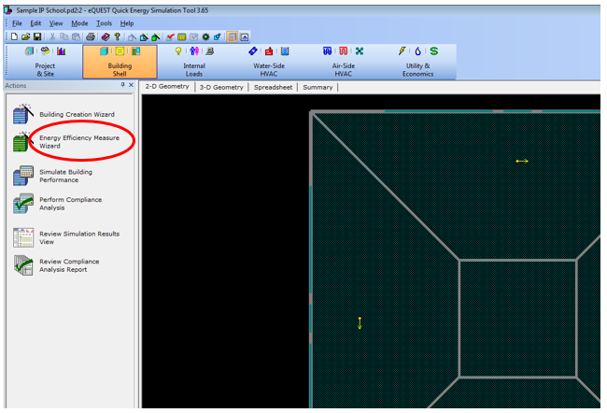

- Create a new run
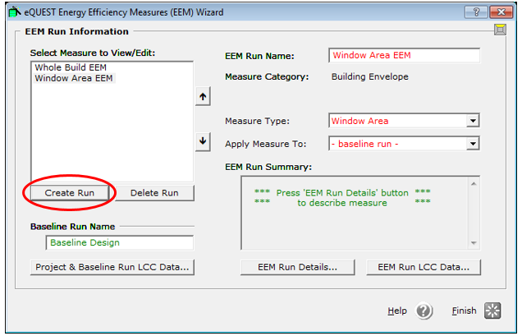

- Select Building Envelope & Window Area
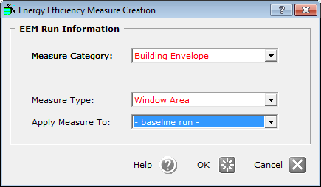

- Create run with 5% increase in window area on all facades.
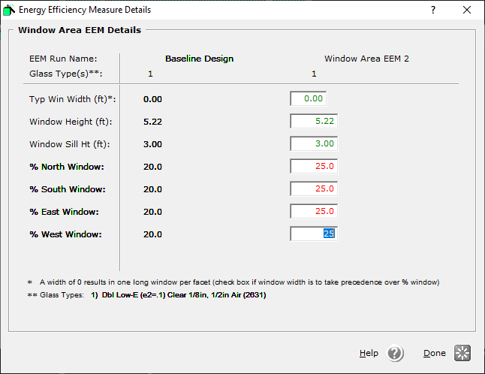

- Create another run with 5% reduction in window area on all facades (repeat steps 3, 4 and 5).
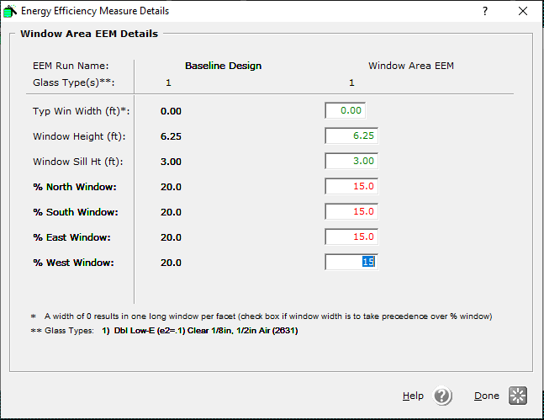

Design Detail Edit
Exit the Energy Efficiency Measure Wizard.
- Add building shades to represent adjacent buildings or notable topography.
- Add default daylight dimming to all perimeter zones
- Complete the Box Model Information Summary

