SCA Integrative Design Process Facilitator Guide & Agenda for Interior Fit-Out (IFO) Projects

Beginning in pre-design and continuing throughout the design phases, identify and use opportunities to achieve synergies across disciplines and building systems. Use the analyses and workshop described in this guide to inform the project design, provide integrative design strategies to SCA, and support ongoing performance and operations.

The Integrative Design Process is required for all projects and must be completed in the Pre-Schematic design phase of the project. The Integrative Design Process should be conducted prior to final scheme selection.This process prioritizes cost-effective solutions over both the short and long terms. Teams should plan for early and active participation, input, and analysis from all disciplines to discover the beneficial interrelationships and synergies between systems and components. An effective integrative design process can improve decision making, achieve high levels of space performance, improved learning and teaching environments, and lead to significant environmental benefits.

The Integrative Design Process outlines a process for completing the early-phase analysis of energy and water systems if applicable, assessing acoustical strategies, analysis of unique building envelope assemblies if applicable, daylighting opportunities, building element life-cycle assessment, active design, and climate resiliency if applicable. The Integrative Design Process also outlines the procedures for facilitating an IDP Workshop to present and synthesize the team’s analysis and assessment, and developing an IDP Workshop Report that summarizes the integrative potential and goals for the project. This process will require team members from various disciplines to meet and discuss the project goals, opportunities, and risks both from the perspective of their respective disciplines AND the perspective of the whole project and its end users. Project teams are encouraged to take ownership of and improve the Integrative Design Process to effectively identify and evaluate synergistic opportunities and benefits.

The following pages outline a process for incorporating integrative design into the design process.
IDP Workshop
The project team will identify a moderator to serve as the Facilitator to lead an Integrative Design workshop during the Pre-Schematic phase, prior to final scheme selection. The IDP Workshop shall be conducted prior to final scheme selection.
Preparation, workshop and follow up should include the following:
Before the IDP Workshop:
- Prepare a preliminary agenda with activity durations and list of participants distributed at least two days prior to the workshop.

- Engage SCA in workshop planning and agenda development.

- Assigned discipline lead shall prepare synopsis of each discovery analysis and send to the SCA at least 3 days before the workshop.

Analyses will be covered in detail in the next section.

- Prepare summary presentation of studies and analyses results including the questions they raised, to present at the workshop.

- Review the SCA IDP Interior Fit-Out energy modeling guidelines (under development).
Project design team to coordinate printing and distribution of workshop report and any other materials. Minimize printing materials. Limited copies of material will be available during the workshop.
Discipline leads such as acoustical consultant, energy modeler, sustainability consultant, AOR and EOR must attend workshop. Attendance of other consultants should be coordinated with DPM.

During the IDP Workshop:
- Facilitate workshop to identify, clarify, and evaluate integrative design opportunities. Facilitator to provide visual aids to facilitate the discussion (powerpoint, sticky notes, easel, whiteboard, paper, pads, markers, etc.)

- Listen to and synthesize SCA and Design Team responses to identified challenges, opportunities, and next steps.

- Prepare workshop meeting minutes. Include comments, suggestions, and recommendations, identifying the party making the comment, etc.

After the IDP Workshop:
- Within 2 weeks of the IDP Workshop, summarize potential strategies and follow up actions required, along with responsible parties for each, into an Integrative Design Workshop Report including:

    - All analysis completed and included. Clarify any non-applicable analyses.
    - Meeting minutes from workshop.
    - Integrative design narrative with stated energy and water goals.
    - Design impacts that may inform scheme selection.
    - Report with results and design impacts after workshop.
    - Narrative outlining strategy for meeting SCA standards and local law.
    - Preliminary Interior-Fit Out GSG checklist and credit impacts of strategies evaluated.
The required documentation for each analysis is outlined in the last section of this guide. In each discovery, indicate building systems and components that have been provided by the building owner/developer and proposed building systems and components.

Discovery #1 - Energy and Daylight Related Systems
Perform a preliminary energy and daylight analysis before the completion of Schematic Design that explores how to reduce energy loads and improve daylighting in the school and accomplish related sustainability goals by questioning default assumptions. Analyze and assess strategies associated with ALL of the following:
Energy use
    - Establish a performance target as described in credit E3.2 - Optimize Energy Performance, Appendix C- Interior Fit-Out Project Appendix, based on Local Law 32 of 2016 requirements.
Site conditions
Assess:
    - Building shading
Analyze the impacts of shading on the roof if applicable.
Consider the effects on daylight, glare, and solar gains.

    - Prevailing winds
Generally not applicable to Interior Fit-Out
However, analyze if prevailing wind will affect existing exterior wall infiltration into space. Consider prevailing winds when designing operable windows and parking lots/driveways to help blow exhaust away from school.

    - Exterior Lighting
Generally not applicable to Interior Fit-Out
However, if a separate school entrance is provided, indicate how safety and emergency lighting will be installed.

    - Landscaping
Generally not applicable to Interior Fit-Out
However, if project includes landscaped or garden areas at ground or roof terraces, assess potential irrigation need.

    - Adjacent site conditions
Describe how the program layout may be optimized based on the adjacent site conditions. Consider minimizing the effects of unwanted noise.

Massing, orientation, and envelope and façade elements
Assess how existing envelope and façade elements affect:
- Energy consumption  - Daylighting | - HVAC sizing  - Carbon emissions
Indicate existing condition U-values of exterior assemblies, including roof, walls, windows, and floors (indicate U-value of floor assembly over any unconditioned spaces, ie unconditioned cellar).
Consider how the following energy saving strategies have been incorporated into the program layout(s).
- Locating classrooms and offices in areas with adequate daylight and access to views
- Locating spaces that do not require daylighting- such as mechanical, storage and kitchen- in the interior of the building
- Locating mechanical space such that the piping and duct run lengths and bends are limited
- Locating bathrooms and kitchens adjacent to each other to reduce service water piping lengths
- Opportunities for improving envelope (ie. increasing insulation, upgrading windows, decreasing infiltration, etc.)
Analyze multiple layouts and summarize the pros and cons of each layout with respect to these strategies. If additional insulation is considered, a dew point analysis shall be conducted for future review.
Renewable Energy Analysis
Generally not applicable to Interior Fit-Out
    - Complete an assessment of on-site renewable energy potential as required by local law.
MEP Layout Optimization
    - Develop alternative solutions to optimize the MEP design and identify the best solution.
    - Consider the impact of an existing or improved Architectural system to meet the HVAC optimization goals.
    - New York City Geothermal Pre-feasibility Tool is not applicable for Interior Fit-Out
Daylight
    - Assess daylight access and design strategies for gymnasium.
Spatial daylight autonomy is assessed based on regularly occupied floor area, therefore gymnasiums have a significant impact on the project’s credit performance for daylight.

References/IDP Workshop Deliverables
The following deliverable is located on the SCA website in the NYC Green Schools Guide Section. Refer to the GSG Reference Materials tab and IDP Toolkit subtab. It is to be included in the IDP report and completed for review during the workshop:
IDP Energy Summary Interior Fit-Out
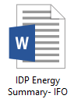
Discovery #2 - Water-Related Systems
Perform a preliminary water budget analysis before the completion of schematic design that explores how to reduce potable water loads in the project and accomplish related sustainability goals. Assess the project’s potential non-potable water supply sources and estimate water demand volumes, including the following:
Supply sources
Generally not applicable to Interior Fit-Out
    - Assess and quantify all potential non-potable water supply sources, such as on-site rainwater, graywater, and HVAC equipment condensate.
Annual Water Demand Analysis
    - Calculate annual water demands for project; match with potential supply sources.
Cost Impact
Generally not applicable to Interior Fit-Out
    - Analyze potential cost impact associated with installing any water conserving systems other than SCA standard.
Green Infrastructure
    - Discuss potential locations for green infrastructure.

If project has access to stormwater collection area at roof, HVAC condensate, etc. include in potential supply sources. For water demand, include only plumbing fixtures within project scope. If project includes landscaped or garden areas at ground or roof terraces, assess potential irrigation need.

Discovery #3 - Preliminary Life-Cycle Impacts Assessment (LCA)
Perform a preliminary Life-Cycle Assessment by identifying potential building envelope assemblies that may be used for the project and quantifying the LCA impacts of each using an SCA LCA Assessment Tool (Refer to SCA LCA Impact Assessment Guidelines for accepted Athena tool). Include results and LCA design considerations in the IDP Workshop Report.
Include only envelope assemblies that are within project scope (i.e. additional insulation, added terraces or green roof above interior fit-out spaces).
If project is located in a previously built out space, perform a preliminary Life-Cycle Assessment by identifying interior non-structural building elements that can be retained and reused. Elements could include finished ceilings, flooring, interior wall partitions, doors, exterior walls, and built-ins.
The following deliverable is located on the SCA website in the NYC Green Schools Guide Section. Refer to the GSG Reference Materials tab and IDP Toolkit subtab:

Discovery #4 - Active Design
Complete a Schematic Active Design Plan that identifies and locates all the potential Active Design strategies that can be implemented on the project. Refer to Active Design in a School Environment (I2.1A) for a list of potential strategies. Analysis should include all spaces to which the school has access, not just those within the project scope (i.e.existing playground, existing stairs, ramps, etc). Indicate whether each strategy listed below has been considered. The following deliverable is located on the SCA website in the NYC Green Schools Guide Section. Refer to the GSG Reference Materials tab and IDP Toolkit subtab:

Discovery #5 - Acoustics
Review the requirements for the Minimum (Q8.1P) and Enhanced Acoustics (Q8.2) credits and identify risks to achieving each credit. Bring a list of potential risks to the IDP workshop to discuss and address.
In addition to risk assessment above, evaluate spaces within the project building but outside the project scope (i.e. floors above and below school area) that may affect or be affected by noise. Consider sound transmission losses through existing windows and wall construction, HVAC background sound levels, as well as exterior noise levels.

Discovery #6 – Climate Resiliency
Review the Climate Resiliency Design Guidelines, March 2019 version 3. Use the exposure screening tool to assess risks for heat, precipitation and sea level rise. Complete the design strategies checklist for potential mitigation of risks.
(https://www1.nyc.gov/assets/orr/pdf/NYC_Climate_Resiliency_Design_Guidelines_v3-0.pdf).
Use FEMA data and the NYC Floor Hazard Mapper (http://www.nyc.gov/floodhazardmapper) to assess flood zones and sea level rise for the school building location, based on the expected useful life of the building. Determine if the predicted flood level or sea level may affect the programming for cellar/basement levels, mechanical and other critical/operational systems location, or requirement for additional square footage above the flood level.

Based on the future years scenario range:
- Apply the CRDG projected Sea Level Rise adjustment to the recommended Design Flood Elevation, perform a basic risk assessment, and determine whether the design should be adjusted.
- Assess the impact of the CRDG projected heating degree day and cooling degree day adjustments to the project’s mechanical load calculations, (Credit E3.3R HVAC system Sizing, Avoid Oversizing) perform a basic risk assessment, meet the Climate Zone 6 standard for fenestration and insulation, (Credit E3.2R – Optimize Energy Performance).

Although school projects may be located on upper floors, there are often entrances, lobbies with stairs and elevators, or other educational facilities on the first floor or cellar level.

The following IDP Workshop Deliverables are located on the SCA website in the NYC Green Schools Guide Section. Refer to the GSG Reference Materials tab and IDP Toolkit subtab:

1) Climate Resiliency Design Guidelines Design Strategies Checklist and 2) Exposure Screening Tool.
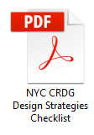
IDP Workshop Agenda
The agenda and duration of the IDP Workshop should follow the below format, but be adjusted accordingly for each project and coordinated with the GSG Review Committee. The agenda below has been provided as a helpful guide for setting up the IDP Workshop, and may not be applicable for all interior fit-out projects. Allocate a minimum of two hours for the workshop duration.

IDP OVERVIEW AND INTENT: 8:30am – 8:45am
- Integrated Design Process Overview and Intent

- Bring all disciplines together beginning in the pre-design phase and continuing throughout the design phases

- Use input from teams to identify cost effective and resource efficient solutions

- Execute strategies to save resources over both the short and long terms

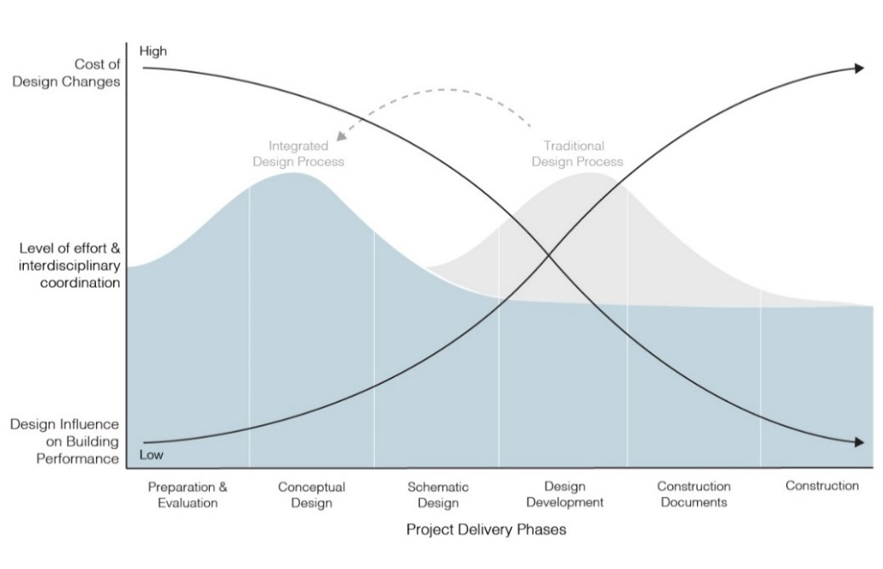

EARLY DESIGN ANALYSIS Part 1: 8:45am – 10:00am
- Energy, Water, LCA Discoveries

- Discovery #1: Energy and Daylight Related Systems (1 hour 20 minutes)

- Discuss performance target as described in credit E3.2 - Optimize Energy Performance.

- Discuss site conditions: site shading, prevailing winds, exterior lighting, and adjacent site conditions as applicable.

- Discuss how massing, envelope and façade elements affect energy consumption, daylighting, HVAC sizing, and energy consumption.

- Discuss best and alternate solution to optimize the MEP design and determine the
modifications to the Architectural system to meet the HVAC optimization goals.

- Discuss daylight access and design strategies for gymnasium.

- Discovery #2: Water-Related Systems (15 minutes)

- Discuss all potential nonpotable water supply sources, such as on-site rainwater, graywater, and HVAC equipment condensate.

- Discuss Annual Water Demand Analysis

- Discuss potential cost impact associated with installing any water conserving systems other than SCA standard.

- Discuss potential locations for green infrastructure.

- Discovery #3: Preliminary Life-cycle Impacts Assessment (LCA) (30 min)

- Discuss preliminary Life-Cycle Assessment by identifying potential building envelope assemblies that may be used for the project and quantifying the LCA impacts of each if applicable. Include results and LCA design considerations in the IDP Workshop Report.
- Discuss interior non-structural building elements that can be retained

EARLY DESIGN ANALYSIS Part 2: 10:00am – 10:30am
- Active Design, Acoustics, Climate Resiliency Discoveries

- Discovery #4: Active Design (15 min)

- Discuss Schematic Active Design Plan.

- Consider the stairs, youth/adult recreation space, and indoor exercise equipment specifications. Which of these could be complicated by SCA codes or practices? Discuss best practices or strategies to avoid for these components of active design.
- Consider focusing on improving health options for neighbors. Is the recreation space freely accessible to the public? How could the space better facilitate neighborhood wellness?

- Discovery #5: Acoustics (20 min)

- Discuss the list of potential risks to achieving Minimum (Q8.1P) and Enhanced Acoustics (Q8.2).

- Discovery #6 Climate Resiliency (20 min)

    - Review maps, exposure screening tool and design strategies checklist
    - Discuss any Medium or High results from the exposure screening tool
    - Discuss any impact on programming, green infrastructure, mechanical loads, fenestration design, as applicable.

WRAP UP: 10:30am – 11:00am
- IDP Workshop Report
  - Identify responsible parties
  - Summarize potential strategies
  - Identify follow up actions required

IDP Workshop Report

Complete an Integrative Design Workshop Report (to be included with the Schematic Design submission) that includes the following:

Report - Energy and Daylight Related Systems

  - Document how the energy and daylight analysis has informed the building design, MEP systems, and energy use. Include the following, as applicable:

    - Building program
    - Modification to, or significant downsizing of building systems (e.g., HVAC, lighting, controls)
    - Modifications to exterior materials (if applicable), interior finishes, and other systems

Report - Water Systems

  - Document how the water budget analysis informed building and site design decisions and the systems outlined below. If project applicable, demonstrate how at least one on-site nonpotable water supply source was analyzed to reduce the burden on the NYC municipal supply or wastewater treatment systems. Include the following, as applicable:

    - Annual Interior Fit-Out water use
    - Rainwater quantity and quality management systems
    - Landscaping, irrigation, and site elements if applicable
    - Potential locations for green infrastructure
    - Other systems

Report - Preliminary Life-Cycle Assessment

  - Document the LCA considerations impacts of all building envelope assemblies selected for the project including the following:

    - LCA environmental impacts for each assembly selected using an SCA LCA Assessment Tool (Refer to SCA LCA Impact Assessment Guidelines for accepted Athena tool).
    - LCA environmental impacts any assemblies that were considered and not selected with brief summary of why each assembly was not selected
    - LCA considerations in selection or improvement of building envelope assemblies
    - Quantify any interior non-structural elements to remain by surface area
    - Assess at least three of the following impact categories: global warming potential (greenhouse gases), depletion of the stratospheric ozone layer, acidification of land and water sources, eutrophication, formation of tropospheric ozone, depletion of nonrenewable energy sources

Report - Active Design

  - Update the Schematic Active Design Plan to include the following:

    - Floor plan with all potential Active Design strategies identified and located
    - Narrative summarizing design strategies that help the project meet the intent of S3.2
    - Floor plan for each scheme with all potential Active Design strategies identified and located

Report - Acoustics

  - Complete a preliminary acoustics narrative summarizing potential risks to achieving the Minimum (Q8.1P) and Enhanced Acoustics (Q8.2) credits, decision made in the IDP Workshop, and proposed strategies for addressing the risks.

Report – Climate Resiliency
  - Provide a Climate Resiliency narrative assessing considerations for the project. Include the following documents:
    - Provide results of CRDG Exposure Screening Tool
    - Provide completed CRDG Design Strategies Checklist
    - Provide maps of flood zones and sea level rise present and predicted for the school building location
    - If the project budget is more than $50 million and scores “Medium” or “High” in Heat, Precipitation, or Sea level rise, provide a list of recommendations for modifications to the current design to address the triggered climate risk. Include an order of magnitude cost for each recommended measure.

