LOCAL LAW 31/16 RENEWABLE ENERGY PRODUCTION REPORT
☐ NET ZERO ENERGY BUILDING FEASIBILITY [Local Law 31/16 compliant projects that are three stories above grade or less must complete a net zero energy building feasibility study. This form is to be included in the Green Schools Guide Schematic Design submission for E6.1P requirements and for Local Law 31 reporting purposes.]

School Name/Building ID:

LLW No. :

Project Description:

Prepared For:
NYC School Construction Authority
3030 Thomson Avenue
Long Island City, NY 11101

Prepared By:
[Company/Designer Name]

[Report Date]

TABLE OF CONTENTS

Page No.
1.0 OVERVIEW………………………………………..……………………….......X

2.0 RENEWABLE ENERGY SOURCES…………..………………..……X

3.0 NET ZERO ENERGY BUILDING LOAD MANAGEMENT STRATEGIES

4.0 RENEWABLE ENERGY ASSESSMENT…….………...…..….……X
4.1 Generation Targets...…….………..……………………………….…..…….X
4.2 Cost Analysis..……..………………………………………………….……...X
4.3 Benefits of Renewable Energy Production…………………………...…X

- APPENDICES………………………………………….…………X
A. Site Plan
- Production Results

Project Type
[Indicate per the following categories:
Capacity: New Construction- New Building, Addition, Annex

Substantial Reconstruction of Existing Building including Substantial Work on Building Envelope]

Site Area (SF)

Building Area (SF)

Potential Available Roof Space for Renewable Energy System (SF)

Potential Available Site Space for Renewable Energy System (SF)

1.0 OVERVIEW

2.0 RENEWABLE ENERGY SOURCES

Strategy | Feasible | Non-Feasible | Ranking | Magnitude of Cost
Solar energy
Wind
Closed-loop biomass*
Open-loop biomass*
Geothermal energy**
Small irrigation power*
Municipal solid waste*
Qualified hydropower production*

*These renewable energy strategies are not typically implemented for SCA projects. These measures will be evaluated on a project by project basis. Investigate the applicability of these strategies to the project.
**Ground source heat pumps do not qualify as a geothermal energy strategy.

[Rank the feasibility (from most technically feasible to least technically feasible) of the above qualified energy resources, as defined in section 45 of title 26 of the United States code. Denote NA in spaces that were not investigated for the project as not appropriate to the type of project. Provide a magnitude of cost for each of the items based on typical construction values.]

3.0 NET ZERO ENERGY BUILDING LOAD MANAGEMENT STRATEGIES
ENERGY CONSERVATION MEASURES
Include any ECMs that are not part of the SCA Standard Design Requirements and that can be considered to offset energy consumption.

ECM | EUI REDUCTION
Gearless Elevators with Regenerative Drives | .6
Wall Thermal Upgrades (R-30) | 2.65
Foundation Additional Insulation | .01
Window and Storefront Lower U-Value (0.18) | 2.02
Insulated Infill Panel Upgrade | .09
Thermal Bridging Mitigation | 2.39
Insulated Light Dispersion Panels (R-13) | .43
Oversized Ductwork & Piping | 2.1
Overvoltage Control Device | 1.1
Ground Source Heat Pump* | (Varies based on estimated project specific values)
TOTAL EUI REDUCTION
*Projects studying the feasibility of geothermal energy should indicate that New York City Geothermal Pre-feasibility Tool results have been included in the Green Schools Guide submission, as applicable.

4.0 RENEWABLE ENERGY ASSESSMENT
4.1 GENERATION TARGETS
Low Energy Intensity Building Target | x kBTU/SF/yr  (Source EUI)
Projected Annual Energy Usage | x kWh/yr

Net Zero Energy Building Energy Feasibility Study Target Production  (Equal to Energy Usage) | x kWh/yr
Onsite Energy Generating Building Energy Feasibility Study Target Production  (10% of Energy Usage)* | x kWh/yr
*Each project subject to Local Law 31 of 2016 shall consider the feasibility of designing and constructing such project as an onsite energy generating building.

4.2 COST ANALYSIS
[Provide construction costs attributable to complying with the net zero energy building requirements. Provide a magnitude of cost for renewable energy costs and load reduction costs based on typical construction values.]

RENEWABLE ENERGY AND LOAD REDUCTION COSTS
ITEM DESCRIPTION | ORDER OF MAGNITUDE COST
RENEWABLE ENERGY COSTS
LOAD REDUCTION COSTS
TOTAL COST

LIFECYCLE COST ANALYSIS
Parameter | Cost
Annual Cost Savings with Renewable Energy System ($/year)

Payback Period for Renewable Energy System (years)

Annual Cost of Carbon ($/year)

4.3 BENEFITS OF RENEWABLE ENERGY PRODUCTION
[Provide a narrative indicating all health, environmental and energy-related benefits achieved as a result of designing and constructing a net zero energy building. Include projected energy savings, reductions in peak load, and reduction in emissions. The below sample narrative has been provided, please utilize this as a reference to expand upon project-specific benefits or to demonstrate how the project can provide these benefits.]
The project has demonstrated benefits due to the implementation of a _____ system.
Due to its location [indicate site specific features that serve as advantages, including amount of real estate in SF, availability of building SF for rooftop installations, neighborhood features such as low-rise buildings to prevent shading on PV systems, site topography, climate, availability and accessibility to monitoring and/or servicing], the project is able to benefit from _____________.
Environmental impacts include less pollution emitted to the environment due to the use of a natural and clean source of energy and less reliance on fossil fuels which generate harmful emissions, less noise pollution, and the offset of carbon emissions produced by a non-renewable energy source.
Economic benefits include a return on investment, low operation and maintenance costs [due to fewer moving parts and long lifespan of equipment and components], less dependency on fluctuating utility costs, and net metering benefits. Additionally, an alternate source of electricity during peak demand will drive the project away from higher energy costs at this time.
Energy benefits include a potential for surplus production of energy that is used for _______, high efficiency system, a reliable source of energy, and less strain on the city’s power grid thereby avoiding blackouts.
By installing ____________, the project assists in compliance with Local Law 97/2019 due to annual reductions in greenhouse gas emissions and will support New York City’s goals of installing 100 MW of solar capacity.
Parameter | Savings
Annual Carbon Footprint Reduction* ( MTCO2e)

*Project teams are to multiply projected annual energy usage (kWh/yr) by the DCAS factor of .000288962 to determine the annual carbon footprint reduction.

5.0 APPENDICES
APPENDIX A - SITE PLAN [Provide a site and/or roof plan to denote location of feasible renewable energy strategies.]
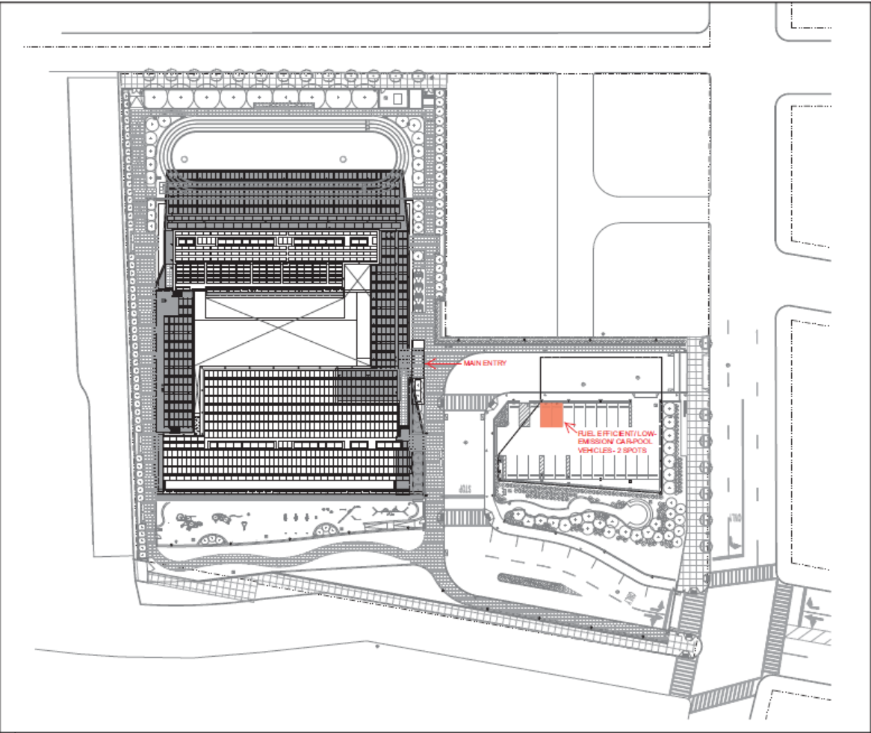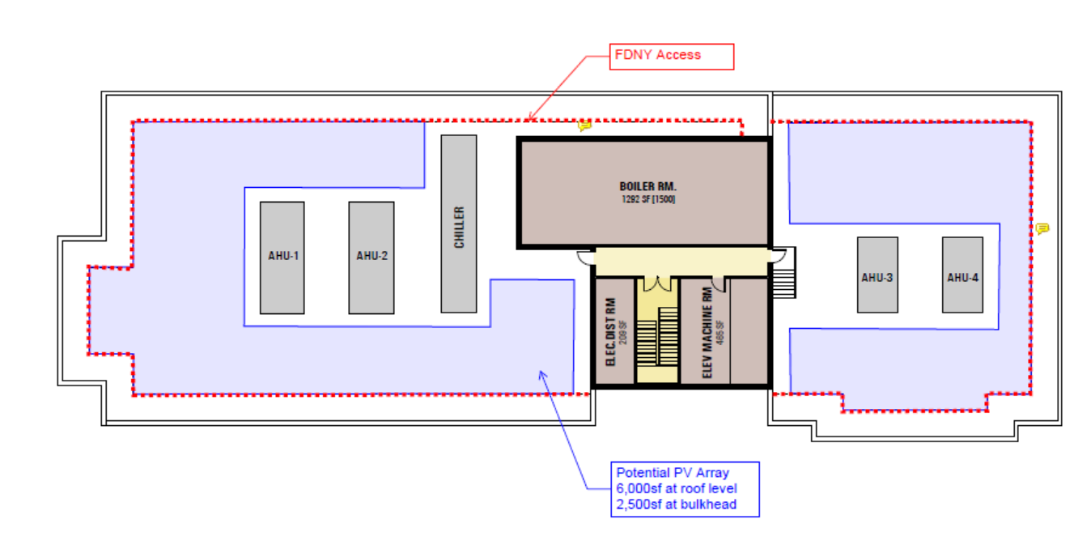
APPENDIX B – PRODUCTION RESULTS
[Attach results any software utilized to estimate energy production.
Projects studying the feasibility of solar energy should utilize the PVWatts Calculator, using the following instructions: (https://pvwatts.nrel.gov/).]

Step 1: Resource Data – [Enter Address]

Step 2: System Info
DC System Size (kW): [Enter proposed system size]
Module Type: Premium
Array Type: [Fixed (roof mount)]
System Losses (%): [14.08]
Tilt (deg): [10]
Azimuth (deg): [Enter project specific value based on site/building orientation]

Leave Advanced Parameters at software default values

Step 3: Retail Electricity Rate
Rate Type: Commercial
Rate ($/kWh): 0.116

