**Geothermal System Feasibility Report**

**K067**

**51 St. Edwards St.**

**New York, NY**

**NYC SCHOOL CONSTRUCTION AUTHORITY**



Completed by

**XYZ Consulting Engineers**

New York, NY

Report Date: April 29, 2019

TABLE OF CONTENTS

1.0 Background 1

2.0 Heating and Cooling System Design 1

3.0 Heating and Cooling System Capital Costing 1

4.0 Geothermal Pre-feasibility Tool 1

5.0 Geothermal Feasibility Tool 1

6.0 Findings and Next Steps 1

7.0 SCA Geothermal Feasibility Tool – References 1

7.01 Assumptions 1

7.02 Baseline Systems 1

7.03 Energy Consumption 1

7.04 Energy Demand 1

7.05 Energy Cost 1

7.06 Capital Cost 1

7.07 Annual Maintenance Cost 1

7.08 Carbon Impact 1

7.09 System Life Expectancy 1

7.10 Net Present Value (Low) 1

7.11 Net Present Value (High) 1

# Background

*SCA Geothermal System Feasibility Tool* analyzes the feasibility of a geothermal system for a major renovation/addition to Public Schools within New York City. The Proposed Design of XYZ Consulting Engineers is the renovation/addition of K067 which is a 5story, 121,000ft2existing school. The building includes classrooms, offices and support spaces. The geothermal system feasibility assessment is based on the 100% SD drawing set dated October 26, 2018.

# Heating and Cooling System Design

The SCA standard heating system design chosen for this building is a gas-fired condensing boiler system serving fin tube radiation, AHU preheat coils, and VAV box reheat coils throughout the building.

The SCA standard cooling system chosen for this building is an air-cooled chiller system serving AHU cooling coils throughout the building.

# Heating and Cooling System Capital Costing

The costing for the heating and cooling system was found to be in line with the ranges noted in the SCA Geothermal System Feasibility Tool. It is believed that the costing for the boiler and chiller systems on this project will fall in the lower end of this range.

# Geothermal Pre-feasibility Tool

The online geothermal pre-feasibility tool developed by the NYC Mayor’s Office of Sustainability and NYC DDC was used to determine the geological, and to a basic extent technical feasibility of a geothermal system. The project building was located within the *NYC Geothermal Pre-feasibility Tool* (link below) by searching for the project site.



The project specific building site information (Lot Area, Building Area, Building Footprint) was entered into the screening tool under the “Building” category (see Figure 1). The screening tool determined that the building site has Geological and Technical Suitability for all geothermal systems (standing column well, closed loop, and open loop). For the project building, standing column well and closed loop geothermal systems were determined to be recommended for a Full System Feasibility Study (see Figure 1).

|  |
| --- |
|  |

*Figure 1. NYC Geo Pre-Feasibility Tool Map*

Based on the results in Figure 1, the project site is recommended for a Full Feasibility study and these results were entered into the *SCA Geothermal Feasibility Tool,* as outlined in Section 5.0.

# Geothermal Feasibility Tool

Since the *NYC Geothermal Pre-feasibility Tool* indicated “Yes” for standing column well and closed loop geothermal system type Full System Feasibility, these results were be entered into the S*CA Geothermal System Feasibility Tool*. The Building Site Information table (i.e. project name, project address, building area, number of floors, and lot size) was entered into Table A of the tool, shown below.



The screening tool determined that the building site has Geological and Technical Suitability for standing column well and closed loop systems. These results were entered into Table 1 within the SCA Geothermal Feasibility Tool, shown below.



For the project building, standing column well and closed loop systems were determined to be recommended for a Full System Feasibility Study. This information was entered into Table 2 within the SCA Geothermal Feasibility Tool, shown below.



Within Table C of the tool, the Baseline Cooling System Type was selected as an air-cooled chiller and the Baseline Heating System Type was confirmed to be Hot Water Condensing Boilers. The Cooling Load was entered as 400ft2/ton and the Heating Load was entered as 25 Btu/ft2, per the design, shown below. These peak cooling loads and heating loads were confirmed to be input as loads prior to any equipment safety factors or redundancy requirements.



Once all this information was entered, the SCA Geothermal Feasibility Tool determined that a geothermal system is not required for this project under both low cost and high cost assumptions, indicated in Table 3 of the tool, shown below.



Section 7.0 provides further reference information on the calculations/assumptions for each of these tabs in the tool.

# Findings and Next Steps

Based on the results in the SCA Geothermal Feasibility Tool, the air- cooled chiller cooling plant and the hot water condensing boiler heating plant type were determined to have the lowest net present value and therefore be favorable over that of the geothermal standing column or closed loop system types. Therefore, in proceeding into the design documents, this project will continue to be designed for an air-cooled chiller and gas-fired hot water condensing boilersystem types.

# SCA Geothermal Feasibility Tool – References

## Assumptions

The Assumptions tab within the *SCA Geothermal Feasibility Tool* lists the cooling and heating systems performance data consisting of calculations derived from operating data entered in the Baseline Systems tab which are based on NYC SCA requirements, ASHRAE 90.1, or industry standards.

## Baseline Systems

The baseline systems utilized in this tool are based on NYC SCA eQuest Input Summary, NYC Green Schools Guide 2016, SCA Design Requirements Document, and ASHRAE 90.1 – 2010/2016.

The cooling system types under the Baseline Systems tab are based on ASHRAE 90.1 – 2013 for the air-cooled chillers (Full load = 1.22 kW/ton, IPLV = 0.88 kW/ton) and water-cooled chiller (Full load = 0.68 kW/ton, IPLV = 0.56 kW/ton).

The boiler performance data was based on SCA eQuest Input Summary (see Figure 10).

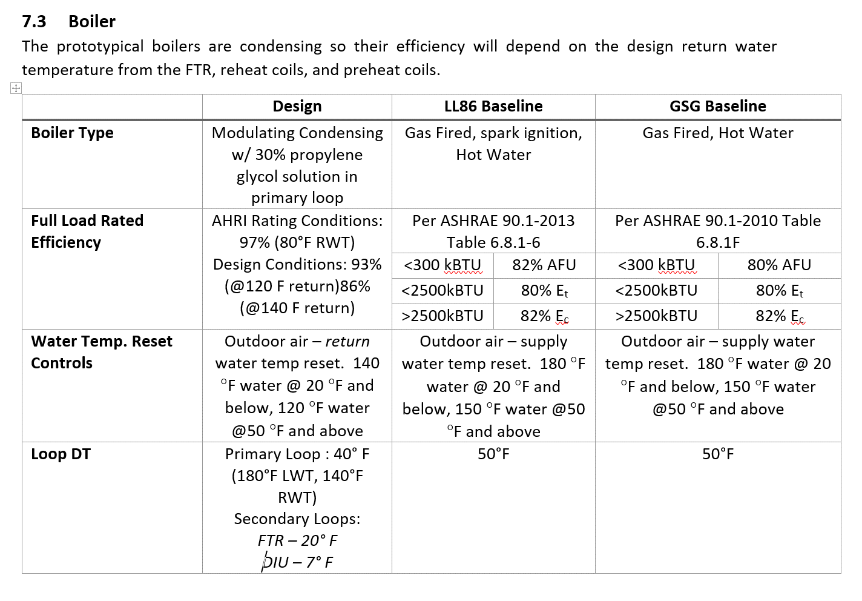

*Figure 10. SCA Boiler Performance Requirements*

The geothermal systems data performance indicated in the Geothermal Systems table under the Baseline Systems tab is based on experience and manufacturer’s efficiency data.

## Energy Consumption

The Energy Consumption tab within the *SCA Geothermal Feasibility Tool* displays the BIN analysis calculations performed based on Central Park, NY weather data from the BinMaker software tool to calculate the total energy consumption of each system type studied. BIN hours were separated into average school occupied hours and average school unoccupied hours, based on an occupied schedule of an average of 4.5 days per week, 7am-6pm on full days. From this, heating and cooling load profiles were developed for both occupied and unoccupied periods.

Annual kWh and annual therms are calculated for each system type based on load, hours, and equipment efficiencies. Energy usage for the heat pumps, chillers, boilers (burner electrical load and gas loads), pumps, and heat rejection systems were evaluated. Geothermal heat pump efficiencies were compensated for assumed heat exchangers for standing column and open well systems with manufacturer’s heat pump efficiency data. The geothermal system types were calculated with the assumption that these are variable flow well water systems.

## Energy Demand

The Energy Demand tab within the *SCA Geothermal Feasibility Tool* displays the monthly and annual cooling electric demand, monthly and annual heating electric demand and total plant monthly and annual electric demand calculated for each system studied based on the values inputted in the Summary tab and the Baseline Systems tab. With current monthly demand costs being high this had a negative effect on geothermal heat pump heating energy. The current baseline condensing gas boilers have a relatively low monthly demand throughout the heating season.

## Energy Cost

The Energy Cost tab within the *SCA Geothermal Feasibility Tool* calculates the total energy cost of each system studied based on the total energy consumption calculated in the Energy Consumption tab and the total demand calculated in the Energy Demand tab along with the utility rates entered in the Summary tab.

## Capital Cost

The capital cost for each heating and cooling plant system type is variable depending on the particular system design and project bidding conditions. With the proposed design for geothermal equipment within the building being variable and assuming institutional level equipment being used the majority of the cost difference between the geothermal options and baseline systems is in the well field or well water systems. The construction cost ranges for the various geothermal options include parameters such as the amount of well casing required for the particular site specific drilling conditions along with heat exchangers and pumping systems for standing column/ open loop systems. Well field construction costs were developed with the help of well field contractors familiar with installing various well field systems within the 5 boroughs.

An assumption was made that air handling systems within the building would meet SCA standards and have load reducing strategies such as energy recovery and demand control ventilation which is critical for reducing plant equipment and well field capacities.

The tool also assumes that SCA requirements for a perimeter radiation heating system is included in all system types in order to reduce off hours fan energy usage. Building fan energy usage is assumed to be similar for each system type and will be based on actual design.

## Annual Maintenance Cost

The Annual Maintenance Cost tab indicates the incremental low and high maintenance costs for each system studied per year. The air-cooled chiller maintenance costs were based on annual cleaning of the air-cooled condenser. The water-cooled chiller maintenance costs were based on the annual cleaning of the cooling tower and annual condenser water chemical treatment. The geothermal closed loop maintenance costs were based on minor water treatment required annually. The geothermal standing column system maintenance costs were based on heat exchanger and well pump maintenance costs. The geothermal open loop system maintenance costs were based on heat exchanger, water filtration, and well pump maintenance costs. The tool indicates a significant variance in maintenance costs for both standing column and open loop systems due to site specific water quality and actual system installation.

## Carbon Impact

The Carbon tab within the spreadsheet tool indicates the annual carbon dioxide emissions cost per system type studied. This is determined by using Energy Star’s CO2 emission rates for natural gas and electricity. In addition, LL6 dollar value per metric ton of carbon dioxide equivalent per year was used to determine this cost estimate.

## System Life Expectancy

The System Life Expectancy tab within the spreadsheet tool indicates the estimated low and high life expectancies of each system type studied. These values were taken from ASHRAE’s Life Expectancy Chart while the life expectancy on the geothermal heat pump systems were based on industry standards. NPV analysis for all systems are currently based on 20 years in the tool per LL6, so this specific system information is not yet factored into analysis. Factoring this in would further disadvantage geothermal systems.

## Net Present Value (Low)

The NPV (Low) tab within the SCA Geothermal Feasibility Tool spreadsheet indicates the low net present value analysis on each system type studied. The net present value calculations are based on the initial costs (capital costs) of each system type, the total annual costs (utility cost, maintenance cost, and carbon cost) of each system type, along with an assumed discount/interest rate of 5%.

## Net Present Value (High)

The NPV (High) tab within the *SCA Geothermal Feasibility Tool* spreadsheet indicates the high net present value analysis on each system type studied. The net present value calculations are based on the initial costs (capital costs) of each system type, the total annual costs (utility cost, maintenance cost, and carbon cost) of each system type, along with an assumed discount/interest rate of 5%. The high NPV calculations were developed using risk or lack of risk between the systems studied.