**Geothermal System Feasibility Tool**

**User Guide**

**NYC SCHOOL CONSTRUCTION AUTHORITY**



TABLE OF CONTENTS

1.0 Background 3

2.0 NYC Geothermal Pre-feasibility Tool 3

3.0 SCA Geothermal System Feasibility Tool – Summary 4

4.0 SCA Geothermal Feasibility Tool – References 7

4.01 Assumptions 7

4.02 Baseline Systems 7

4.03 Energy Consumption 7

4.04 Energy Demand 8

4.05 Energy Cost 8

4.06 Capital Cost 8

4.07 Annual Maintenance Cost 8

4.08 Carbon Impact 9

4.09 System Life Expectancy 9

4.10 Net Present Value (Low) 9

4.11 Net Present Value (High) 9

5.0 Appendices 10

Sample Report

Template Report

NYC SCA Geothermal System Feasibility Process Flow Diagram

# Background

This user guide contains instructions for the design team to follow when completing the SCA Geothermal System Feasibility Tool. This tool was created for design teams to use to document geothermal feasibility assessment findings to determine if a project building site is feasible for a geothermal system (standing column, closed-loop, or open-loop) in order to meet the Geothermal Feasibility Law of LL06/2016.

The benefits of geothermal systems is highlighted in the *Geothermal Systems and their Applications in New York City* document by The City of New York dated February, 2015.

# NYC Geothermal Pre-feasibility Tool

The NYC Mayor’s Office of Sustainability and NYC DDC developed and made publicly available an online screening tool (referred to as *NYC Geothermal Pre-feasibility Tool* in this User Guide) that can be used to determine the geological, and to a basic extent technical feasibility of a geothermal system for a building site. This screening tool shall be utilized as the first stage of determining if a geothermal system is feasible for an SCA building site and will feed into the developed *SCA Geothermal System Feasibility Tool* if this *NYC Geothermal Pre-feasibility Tool* yields passing results. This *SCA Geothermal System Feasibility Tool* is a result of further development for technical and cost feasibility of geothermal system conducted by SCA and OLA for NYC schools. Depending on which type of geothermal system is recommended for a full system feasibility study in the *NYC Geothermal Pre-feasibility Tool*, this will narrow down which system options are reviewed within the *SCA Geothermal System Feasibility Tool*. This review process is illustrated in the below flow diagram (see Figure 1). See attached appendices for the full geothermal system feasibility process flow diagram.

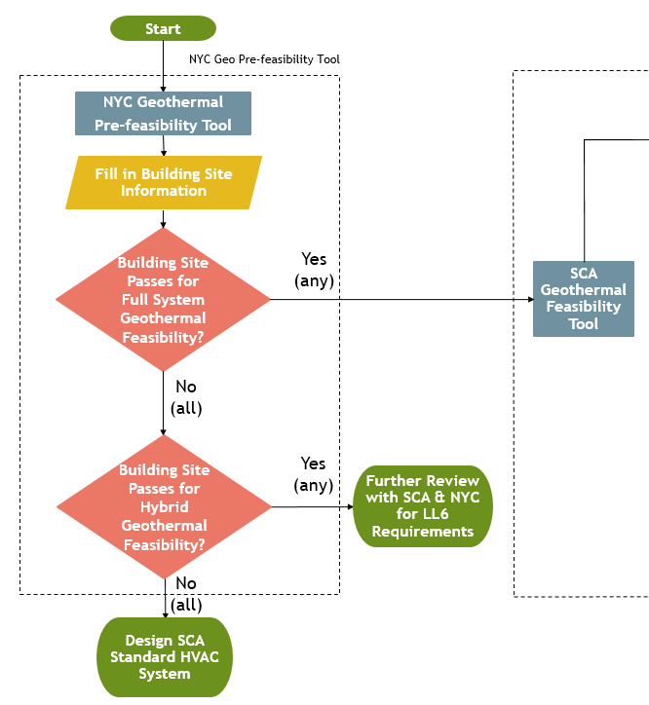

*Figure 1. NYC Geo Pre-feasibility Tool Flow Diagram*

The first step for this process would be to enter the building site information into the *NYC Geothermal Pre-feasibility Tool* (see Figure 2). The link to this tool can be found below and in the Instructions tab of the *SCA Geothermal System Feasibility Tool*.

Under the “Building” category, the user can modify the Lot Area, Building Area, Building Footprint, and the Building Type to the right-hand side of each of these default values in order to adjust the existing building information to account for the current design.

* For the gut renovation of an existing school, this building information will need to be verified and modified if necessary (for example, the DDC noted that this DOB building database does not include mechanical spaces and cellar/basement spaces).
* For the addition to an existing school building, the modification to the pre-feasibility tool will be required in order to appropriately represent lot area, building area, and available site area. One option is to enter just the building addition area (to accurately represent the capacity potential) and to modify the lot area by removing the existing building area to appropriately represent the available free site area.



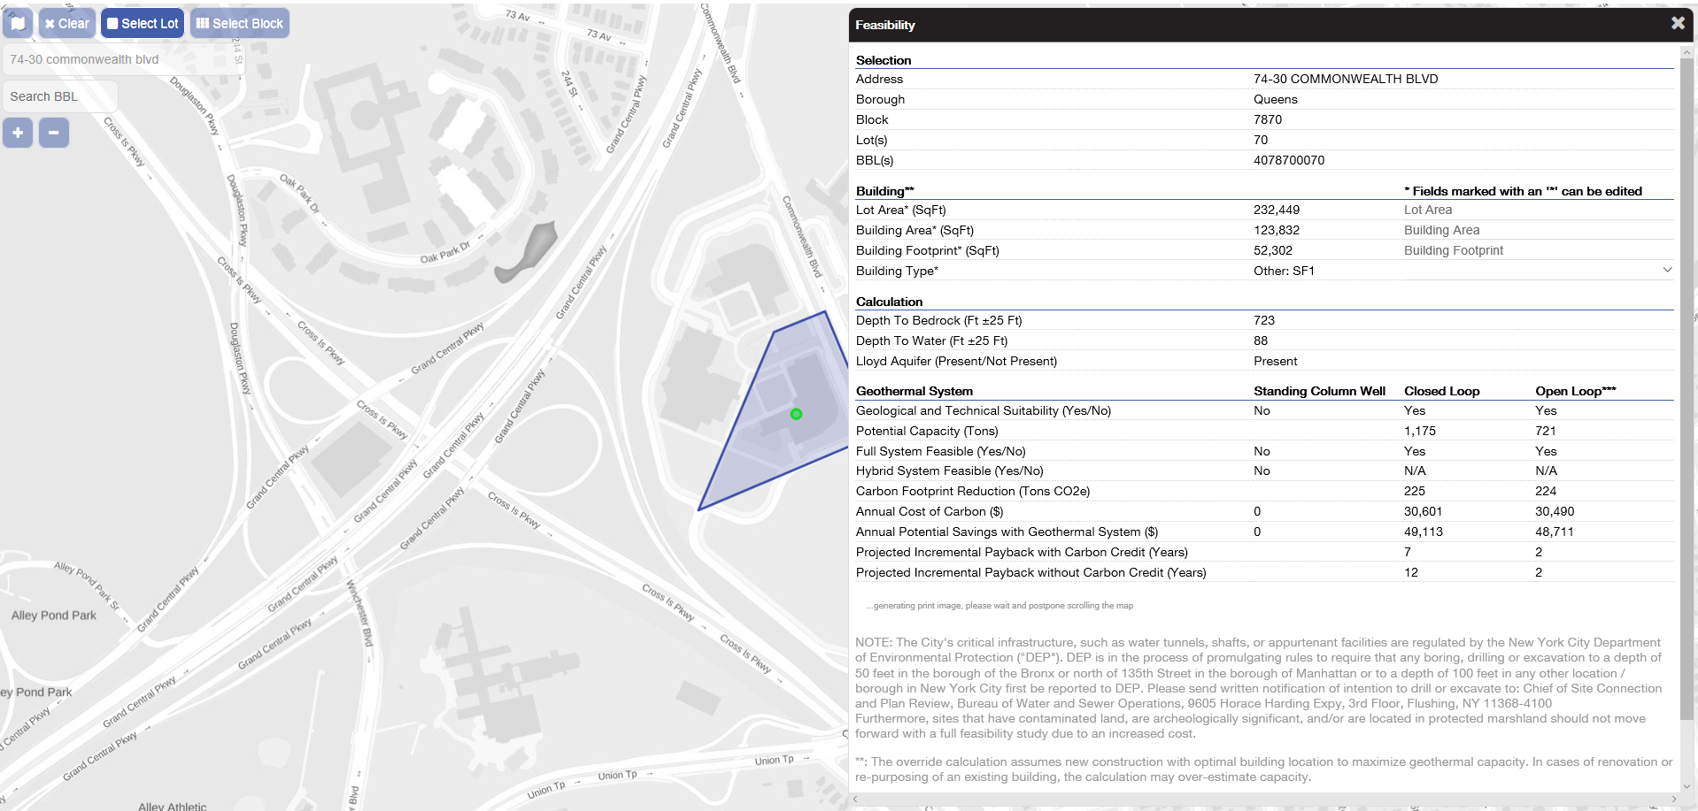

*Figure 2. NYC Geo Pre-Feasibility Tool Map*

Once the building site information is entered, the *NYC Geothermal Pre-feasibility Tool* will automatically determine if a building site has Geological and Technical Suitability. In addition, this tool will automatically determine if the project site is recommended for a Full System Feasibility study or not. If “Yes” for any indicated geothermal system type, these results will be entered into the *SCA Geothermal System Feasibility Tool*. If “No” for all indicated geothermal system types, the *SCA Geothermal System Feasibility Tool* is not required and the design team can proceed with the design of SCA standard HVAC systems (the path for hybrid geothermal feasibility is still being reviewed by SCA).

# SCA Geothermal System Feasibility Tool – Summary

As noted above, if the *NYC Geothermal Pre-feasibility Tool* indicates “Yes” for any geothermal system type Full System Feasibility, these results will be entered into the S*CA Geothermal System Feasibility Tool*. This process is illustrated in the below flow diagram (see Figure 3). See attached appendices for the full geothermal system feasibility process flow diagram.

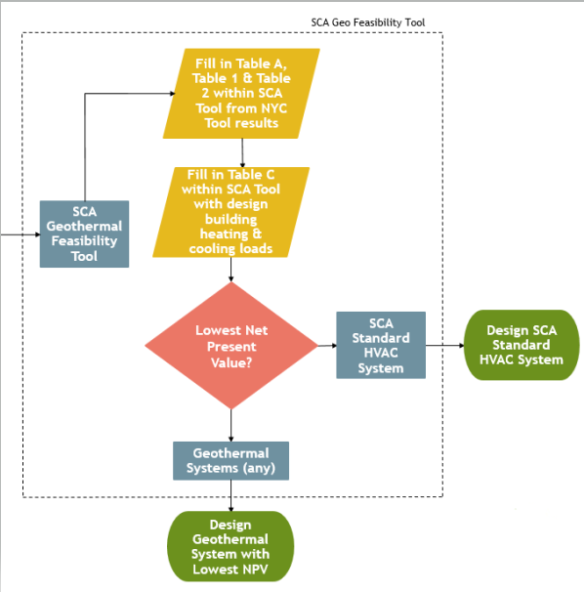

*Figure 3. SCA Geo Feasibility Tool Flow Diagram*

The first step for the SCA design team when using this tool would be to fill in the Table A Building Site Information shaded in orange (i.e. project name, project address, building area, number of floors, and lot area) at the top left side under the Summary tab (see Figure 4).



*Figure 4. SCA Tool Building Site Information*

Depending on which geothermal systems pass for full feasibility, the user will use the drop down menu to fill in Table 1 in the Summary tab of the *SCA Geothermal Feasibility Tool* (see Figure 5 below).





*Figure 5. SCA Tool Table 1 – NYC Geo Pre-feasibility Tool Results*

Relevant information from the *NYC Geothermal Pre-feasibility Tool* can then be entered into Table 2 in the Summary tab of the *SCA Geothermal Feasibility Tool* (see Figure 6 below).



*Figure 6. SCA Tool Table 2 – NYC Geo Pre-feasibility Tool Results*

The non-demand electricity ($/kWh), demand ($/kW), and natural gas ($/therm) rates are “fixed” in Table B at the top right of the Summary tab (see Figure 7). SCA will review these rates and change based on DCAS’ changes. The oil ($/gallons) utility rate can be entered by the design team if oil-fired equipment is used. Please note that the DCAS energy rates references are provided at the right of this table for reference (see Figure 7 for electricity).



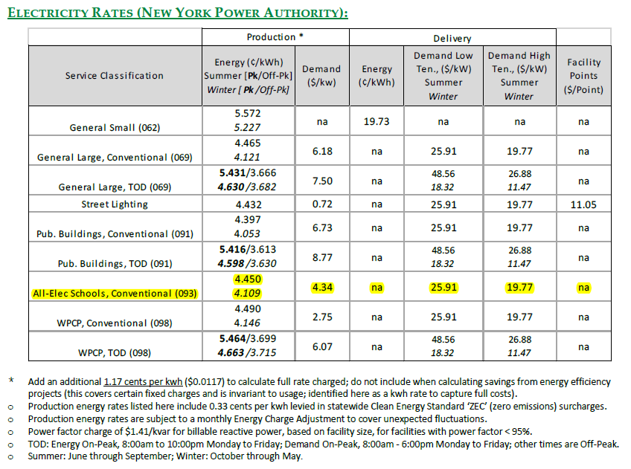

*Figure 7. SCA Tool Table B - Current Electricity Rates*

Next, still within the tool’s Summary tab, the design team should fill in Table C: SCA Standard HVAC Baseline System (see Figure 8). The drop down arrow under the Baseline Cooling System Type should be used to select the project’s baseline system type of either an air-cooled or water-cooled chiller, enter in the Cooling Load (ft2/ton) of this system and the Heating Load (Btu/ft2) of the heating system. Peak cooling loads and heating loads shall be input as loads prior to any equipment safety factors or redundancy requirements. For long term efficiency, the proposed systems will provide a balance between heating and cooling loads and system capacity. Please note, only a hot water condensing boiler heating system type option is available for the baseline systems per SCA standard system requirements.



*Figure 8. SCA Standard HVAC Baseline System Table*

Once this information is entered, the *SCA Geothermal System Feasibility Tool* will automatically determine if a geothermal system is required for this project under both low cost and high cost assumptions (see Figure 9). If a geothermal system is required, the design team shall proceed with the design of the geothermal system type chosen as the lowest net present value. If a geothermal system in not required, the design team can proceed with the design of the SCA standard HVAC systems.



*Figure 9. Geothermal System Feasibility Results Table*

The design team can review the other tabs within the tool for reference to see how each component in the table above was calculated. Section 4.0 provides further information on the calculations/assumptions for each of these tabs in the tool.

Upon completion of the *SCA Geothermal Feasibility Tool*, the design team will need to fill out the SCA Geothermal Feasibility Report (with tables from the Tool, as indicated in the user notes within the Report), fill out the Geothermal Credit Form, and attach the form and report to the GSG DD submission.

Please note that due to the cost, maintenance, and performance issues experienced with open loop ground source heat pumps, if this geothermal system type yields the most feasible results, the design team will need to defend this option further to SCA with the above submission.

# SCA Geothermal Feasibility Tool – References

## Assumptions

The Assumptions tab within the *SCA Geothermal Feasibility Tool* lists the cooling and heating systems performance data consisting of calculations derived from operating data entered in the Baseline Systems tab which are based on NYC SCA requirements, ASHRAE 90.1, or industry standards.

## Baseline Systems

The baseline systems utilized in this tool are based on NYC SCA eQuest Input Summary, NYC Green Schools Guide 2016, SCA Design Requirements Document, and ASHRAE 90.1 – 2010/2016.

The cooling system types under the Baseline Systems tab are based on ASHRAE 90.1 – 2013 for the air-cooled chillers (Full load = 1.22 kW/ton, IPLV = 0.88 kW/ton) and water-cooled chiller (Full load = 0.68 kW/ton, IPLV = 0.56 kW/ton).

The boiler performance data was based on SCA eQuest Input Summary (see Figure 10).

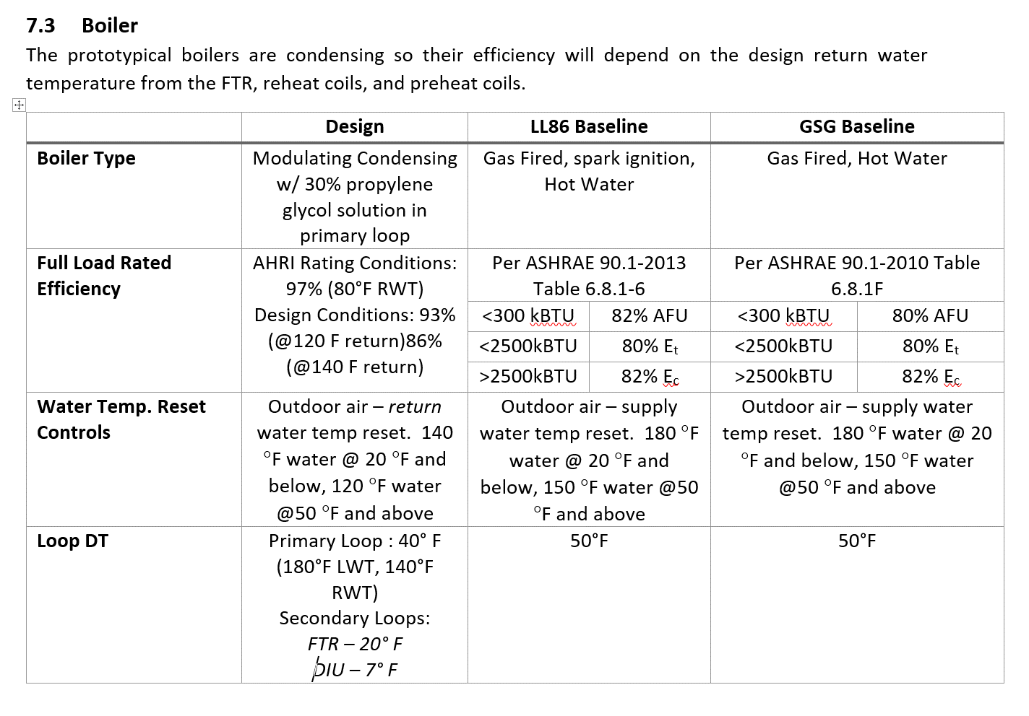

*Figure 10. SCA Boiler Performance Requirements*

The geothermal systems data performance indicated in the Geothermal Systems table under the Baseline Systems tab is based on experience and manufacturer’s efficiency data.

## Energy Consumption

The Energy Consumption tab within the *SCA Geothermal Feasibility Tool* displays the BIN analysis calculations performed based on Central Park, NY weather data from the BinMaker software tool to calculate the total energy consumption of each system type studied. BIN hours were separated into average school occupied hours and average school unoccupied hours, based on an occupied schedule of an average of 4.5 days per week, 7am-6pm on full days. From this, heating and cooling load profiles were developed for both occupied and unoccupied periods.

Annual kWh and annual therms are calculated for each system type based on load, hours, and equipment efficiencies. Energy usage for the heat pumps, chillers, boilers (burner electrical load and gas loads), pumps, and heat rejection systems were evaluated. Geothermal heat pump efficiencies were compensated for assumed heat exchangers for standing column and open well systems with manufacturer’s heat pump efficiency data. The geothermal system types were calculated with the assumption that these are variable flow well water systems.

## Energy Demand

The Energy Demand tab within the *SCA Geothermal Feasibility Tool* displays the monthly and annual cooling electric demand, monthly and annual heating electric demand and total plant monthly and annual electric demand calculated for each system studied based on the values inputted in the Summary tab and the Baseline Systems tab. With current monthly demand costs being high, this had a negative effect on geothermal heat pump heating energy. The current baseline condensing gas boilers have a relatively low monthly demand throughout the heating season.

## Energy Cost

The Energy Cost tab within the *SCA Geothermal Feasibility Tool* calculates the total energy cost of each system studied based on the total energy consumption calculated in the Energy Consumption tab and the total demand calculated in the Energy Demand tab along with the utility rates entered in the Summary tab.

## Capital Cost

The capital cost for each heating and cooling plant system type is variable depending on the particular system design and project bidding conditions. With the proposed design for geothermal equipment within the building being variable and assuming institutional level equipment being used, the majority of the cost difference between the geothermal options and baseline systems is in the well field or well water systems. The construction cost ranges for the various geothermal options are impacted by parameters such as the amount of well casing required for the particular site specific drilling conditions along with heat exchangers and pumping systems for standing column/ open loop systems. Well field construction costs were developed with the help of well field contractors familiar with installing various well field systems within the 5 boroughs.

An assumption was made that air handling systems within the building would meet SCA standards and have load reducing strategies such as energy recovery and demand control ventilation which is critical for reducing plant equipment and well field capacities.

The tool also assumes that SCA requirements for a perimeter radiation heating system is included in all system types in order to reduce off hours fan energy usage. Building fan energy usage is assumed to be similar for each system type and will be based on actual design.

## Annual Maintenance Cost

The Annual Maintenance Cost tab indicates the incremental low and high maintenance costs for each system studied per year. The air-cooled chiller maintenance costs were based on annual cleaning of the air-cooled condenser. The water-cooled chiller maintenance costs were based on the annual cleaning of the cooling tower and annual condenser water chemical treatment. The geothermal closed loop maintenance costs were based on minor water treatment required annually. The geothermal standing column system maintenance costs were based on heat exchanger and well pump maintenance costs. The geothermal open loop system maintenance costs were based on heat exchanger, water filtration, and well pump maintenance costs. The tool indicates a significant variance in maintenance costs for both standing column and open loop systems due to site specific water quality and actual system installation.

## Carbon Impact

The Carbon tab within the spreadsheet tool indicates the annual carbon dioxide emissions cost per system type studied. This is determined by using Energy Star’s CO2 emission rates for natural gas and electricity. In addition, LL6 dollar value per metric ton of carbon dioxide equivalent per year was used to determine this cost estimate.

## System Life Expectancy

The System Life Expectancy tab within the spreadsheet tool indicates the estimated low and high life expectancies of each system type studied. These values were taken from ASHRAE’s Life Expectancy Chart while the life expectancy on the geothermal heat pump systems were based on industry standards. NPV analysis for all systems are currently based on 20 years in the tool per LL6, so this specific system information is not yet factored into analysis. Factoring this in would further disadvantage geothermal systems.

## Net Present Value (Low)

The NPV (Low) tab within the SCA Geothermal Feasibility Tool spreadsheet indicates the low net present value analysis on each system type studied. The net present value calculations are based on the initial costs (capital costs) of each system type, the total annual costs (utility cost, maintenance cost, and carbon cost) of each system type, along with an assumed discount/interest rate of 5%.

## Net Present Value (High)

The NPV (High) tab within the *SCA Geothermal Feasibility Tool* spreadsheet indicates the high net present value analysis on each system type studied. The net present value calculations are based on the initial costs (capital costs) of each system type, the total annual costs (utility cost, maintenance cost, and carbon cost) of each system type, along with an assumed discount/interest rate of 5%. The high NPV calculations were developed using risk or lack of risk between the systems studied.

# Appendices