December 5, 2018

eQuest INPUT SUMMARY
FOR
ENERGY MODELS

ASHRAE 90.1-2013 & 2016 NYCECC eQuest Templates

by:
Vidaris, Inc.
50 Washington Street
Norwalk, CT 06854
Adrian Tuluca, RA
Senior Principal
Phone: 203-299-1411
Fax: 203-299-1656
E-mail: atuluca@vidaris.com

TABLE OF CONTENTS
1 Purpose 3
2 Definitions 3
3 Building Shell 3
4 Internal Loads 7
5 HVAC Thermal Zones 15
6 Air Side Systems 18
7 Water-Side HVAC 24
Appendix A. ECC Schedule Details 29
A1. Schedule for Typical Spaces, Extended Schedule 30
Appendix B. Medium School Schedule Details, based on PS 375Q 43
B1. Schedule for Typical Spaces, Based on PS 375Q 44
B2. All Schedules, Based on PS760 47

Purpose
The purpose of this document is to describe the default inputs for the for New York City School Construction Authority (SCA) project templates. Only systems included in the SCA Design requirements are included in this guide. Instructions on how to use the templates and other, more detailed modeling guidance will be provided in the SCA Modeling Template How-To Guide, which is issued separately.

Definitions
Proposed Design- Model of the building based on the design documents
LL86 Baseline- A model of the building described according to the Energy Cost Budget Method of ASHRAE 90.1-2013 with amendments per the 2016 New York City Energy Conservation Code.
GSG Baseline- A model of the building described by the Performance Rating Method (Appendix G) of ASHRAE 90.1-2010.

Building Shell

Opaque Envelope Construction Definitions
Masonry wall constructions have been included in the template as it is the specified predominate assembly type by the SCA design requirements. The constructions correspond to descriptions in DR 4.2.1 and are consistent with ASHRAE 90.1 2013 Appendix A. All typical envelope constructions are summarized in Table 1. All baseline constructions are in accordance with ASHRAE 90.1 2010 Table 5.5-4
Table 1. Opaque Envelope Construction Properties
Description | Proposed Design | GSG Baseline | LL86 Baseline
Exterior Wall | Masonry Wall w/ Gypboard  - Face Brick  - 3” rigid insulation (R-15)  - 6” CMU Backup  - 2-1/2” furring cavity  - 5/8” Gypboard  - U-0.122 BTU/Hr-ft²-°F | Steel Framed  - U-0.064 BTU/Hr-ft²-°F | Mass Wall  - Face Brick  - rigid insulation (R-9.5)  - 8” CMU Backup  - Air barrier  - 5/8” Gypboard  - U-0.104 BTU/Hr-ft²-°F
Exterior Wall | Masonry Wall  - Face Brick  - 3” rigid insulation (R-15)  - 6” CMU Backup  - U-0.140 BTU/Hr-ft²-°F | Steel Framed  - U-0.064 BTU/Hr-ft²-°F | Mass Wall  - Face Brick  - rigid insulation (R-9.5)  - 8” CMU Backup  - Air barrier  - 5/8” Gypboard  - U-0.104 BTU/Hr-ft²-°F
Roof | Roof  - 2” White Pavers with SRI > 0.78  - 6”Extruded polystyrene R5/inch  - Hot rubberized asphalt  - 4-6” Concrete  - U-0.032 BTU/Hr-ft²-°F | Roof  - 2” Gravel  - Polystyrene (R-20)  - Hot rubberized asphalt  - 8” Concrete  - U-0.048 BTU/Hr-ft²-°F | Roof  - 2” Gravel  - Polystyrene (R-30)  - Hot rubberized asphalt  - 8” MW Concrete  - U-0.032 BTU/Hr-ft²-°F
Slab On Grade | Unheated Floor  - 6” Concrete Slab  - 2” polystyrene insulation (R-10) installed 24” vertical  - F-Factor: 0.54  Heated Floor  - 6” Concrete Slab  - 2” polystyrene insulation (R-10) installed 24” vertical  - F-Factor: 0.90 | Unheated Floor  - 6” Concrete Slab  - F-Factor: 0.730  Heated Floor  - 6” Concrete Slab  - polystyrene insulation (R-15) installed 24” vertical  - F-Factor: 0.86 | Unheated Floor  - 6” Concrete Slab  - 3” polystyrene insulation (R-15) installed 24” vertical  F-Factor: 0.520  Heated Floor  - 6” Concrete Slab  - polystyrene insulation (R-20) installed 24” vertical  - F-Factor: 0.843
Exposed Floor | Project Specific Mass Floor  - 6” Concrete Slab  - 2” polystyrene insulation (R-10)  - U-0.076 BTU/Hr-ft²-°F | Steel Framed Floor  - U-0.038 BTU/Hr-ft²-°F | Mass Floor  - 6” Concrete Slab  - 3” rigid insulation (R-14.6)  - U-0.057 BTU/Hr-ft²-°F
Below Grade Walls | Wall  - 12” Concrete wall  - 2” polystyrene insulation (R-10)  - C-Factor: 0.116 | Wall  - 8” CMU  - 5/8” Gypsum board  C-Factor: 1.140 | Wall  - 8” CMU  - 1.5” rigid insulation (R-7.5)  - 5/8” Gypsum board  C-Factor: 0.119
Doors | Swinging Door <50% glazing  - Solid Steel Door  - U-0.60 BTU/Hr-ft²-°F  Non-swinging  - Roll Door  - U-1.50 BTU/Hr-ft²-°F | Swinging <50% glazing  - Solid Steel Door  - U-0.70 BTU/Hr-ft²-°F  Non-swinging  - Roll Door  - U-1.50 BTU/Hr-ft²-°F | Swinging <50% glazing  - Solid Steel Door  - U-0.50 BTU/Hr-ft²-°F  Non-swinging  - Roll Door  - U-0.50 BTU/Hr-ft²-°F

Window Definitions
Typical values for the proposed design windows have been included in the template up to the upper limit of 25% window to wall fraction. These values should be replaced with actual design values if they differ from the standard. The characteristics of the new or replacement typical punched window is taken from DR4.3.1. The characteristics of existing punched windows are taken from ASHRAE 90.1 Appendix A. The window details are given in Table 2
Table 2. Window Properties
Window Type |  | Proposed Design | GSG Baseline | LL86 Baseline
Typical Punched Window& Ribbon Windows, New & Replacement (FIXED PORTION) | Template Glass Type | GL-1-FIX | GL-ASH10-MF-AO | GL-ASH13-MF-AO
 | U-assembly, Fixed | 0.45 Btu/hr-ft²-F | 0.55 Btu/hr-ft²-F | 0.42 Btu/hr-ft²-F
 | SHGC | 0.38 | 0.40 | 0.40
 | Shading Coefficient | 0.44 | 0.465 | 0.465
 | Visible Transmittance | 68% | 44% | 44%
Typical Punched Window& Ribbon Windows, New & Replacement (OPERABLE PORTION) | Template Glass Type | GL-1-OP | GL-ASH10-MF-AO | GL-ASH13-MF-OP
 | U-assembly, Fixed | 0.45 Btu/hr-ft²-F | 0.55 Btu/hr-ft²-F | 0.50 Btu/hr-ft²-F
 | SHGC | 0.38 | 0.40 | 0.40
 | Shading Coefficient | 0.44 | 0.465 | 0.465
 | Visible Transmittance | 68% | 44% | 44%
Typical punched window, Existing, (Assumes Dual Pane) | Template Glass Type | GL-EXIST | GL-EXIST | GL-EXIST
 | U-assembly | 0.9 | Same as proposed | Same as proposed
 | SHGC | 0.68 | Same as proposed | Same as proposed
 | Shading Coefficient | 0.79 | Same as proposed | Same as proposed
 | Visible Transmittance | 66% | Same as proposed | Same as proposed
Storefront | Template Glass Type | Project specific | GL-ASH10-MF-CW | GL-ASH13-MF-CW
 | U-assembly | 0.50 | 0.50 Btu/hr-ft²-F | 0.42 Btu/hr-ft²-F
 | SHGC | 0.44 | 0.40 | 0.40
 | Shading Coefficient | 0.50 | 0.465 | 0.465
 | Visible Transmittance | 67% | 44% | 44%
Glass Block, steel framed | Template Glass Type | Project specific | GL-ASH10-MF-AO | GL-ASH13-MF-AO
 | U-assembly | 0.6 Btu/hr-ft²-F | 0.55 Btu/hr-ft²-F | 0.42 Btu/hr-ft²-F
 | SHGC | Project specific | 0.40 | 0.40
 | Shading Coefficient | Project specific | 0.465 | 0.465
 | Visible Transmittance | Project specific | 44% | 44%
Entrance Doors with >50% glazed area | Template Glass Type | GL-DOOR | GL-ASH10-DR | GL-ASH13-DR
 | U-assembly | 0.85 Btu/hr-ft2-F | 0.85 Btu/hr-ft2-F | 0.77 Btu/hr-ft2-F
 | SHGC | 0.40 | 0.40 | 0.40
 | Shading Coefficient | 0.465 | 0.465 | 0.465
 | Visible Transmittance | 68% | 44% | 44%
Skylight | Template Glass Type | GL-SKYLIGHT | GL-ASH10-SKY | GL-ASH13-SKY
 | U-assembly | 0.34 Btu/hr-ft2-F | 0.69 Btu/hr-ft2-F | 0.50 Btu/hr-ft2-F
 | SHGC | 0.28 | 0.39 | 0.40
 | Shading Coefficient | 0.325 | 0.45 | 0.465
 | Visible Transmittance | 31% | 43% | 44%

Internal Loads
This section describes the default internal loads included in the template. All inputs are identical in the design and baselines unless otherwise noted. Music rooms, technology classrooms, and lab classrooms uses the same values as classrooms unless otherwise noted.
Appendix A, B, & C each contain a set of schedules including those referenced in this section. Each of these appendices represents a different building type. Some of the schedules have the same name because they reference the same design conditions, but due to the building type the number of Full load equivalent hours will differ. Likewise not all building types will have all of the space types mentioned in this section. In the event that a project requires a specific space type that is not covered by the schedules in the appropriate building type, the modeler shall consult with the SCA to develop a custom schedule for the needed application.

Occupant Loads
The loads from people to the space are specified in Table 3. The occupancy schedules and occupant densities are specified in Table 4. The occupant densities are based on worst-case default values comparing the 2014 NYC Building Egress load requirements and Mechanical ventilation requirements. These values are acceptable for early in the design phase. When the mechanical engineer finalizes their ventilation calculations based upon actual programmatic requirements the design model values may need to be updated to properly account for the effect of demand control ventilation.
Table 3. Sensible loads from people by space type
Space Type | ASHRAE Fundamentals 2013 Activity Level | Sensible Heat Gain  (BTU/hr.-person) | Latent Heat Gain  (BTU/hr.-person)
Classrooms, Library | Moderately active Office Work | 250 | 200
Auditorium Seating | Seated at theater | 245 | 105
Auditorium Stage | Moderate Dance | 305 | 545
Cafeteria | (Lunch) Standing; walking | 250 | 200
Cafetorium | (Lunch) Standing; walking  Assembly Event – Seated at theater | 250  245 | 200  105
Gymnasium | (one period – 132 people) Athletic | 710 | 1090
Gymatorium | (one period – 132 people) Athletic  Assembly Event – Seated at theater | 710  245 | 1090  105
Kitchen | Sedentary Work | 275 | 275
Office | Moderately active Office Work | 250 | 200

Table 4. Occupancy & Equipment Loads by Space Type
Space Type | Zone Type | Default Area per Personª (ft2) | Occupancy Schedule | Equipment Power Density (W/ft2) | Equipment Schedule
Classroom (ages 5-8) | Conditioned | 23 | CLASS-OCC-YR | 1.60^{d} | CLASS-EQP-YR^{d}
Classroom (ages 9+) | Conditioned | 23 | CLASS-OCC-YR | 1.60^{d} | CLASS-EQP-YR^{d}
Auditorium | Conditioned | 11^{b} | AUDITOR-OCC-YR | 0.1 | AUD-EQP-YR
Corridor | Conditioned | ~ | NULL-OCC-YR | 0 | ALWAYS-OFF -YR
Office | Conditioned | 100 | OFFICE-OCC-YR | 11.33^{d} | OFFICE-EQP-YR^{d}
Lobby | Conditioned | 5.75 | NULL-OCC-YR | 0.1^{d} | LOBBY-EQP-YR^{d}
All Locker Rooms | Conditioned | 50 | NULL-OCC-YR | 0 | ALWAYS-OFF- YR
Storage | Conditioned | 300 | NULL-OCC-YR | 1.81^{d} | STORAGE-EQP-YR^{d}
Library - Stacks | Conditioned | 100 | CLASS-OCC-YR | 0.5 | LIB-EQP-YR
Library – Reading Area | Conditioned | 57.5 | CLASS-OCC-YR | 0.5 | LIB-EQP-YR
Computer Classroom | Conditioned | 23 | TECH-CLASS-OCC-YR | 2 | TECH-EQP-YR
Music Classroom | Conditioned | 23 | CLASS-OCC-YR | 0.29^{d} | MUSIC-EQP-YR^{d}
Mechanical | Conditioned | 300 | NULL-OCC-YR | 0 | N/A
Electrical | Conditioned | 300 | NULL-OCC-YR | 0 | N/A
IDF/MDF | Conditioned | 300 | NULL-OCC-YR | 26.5^{d} | DATA-EQP-YR
Gymnasium (class period) | Conditioned | 17.25 | GYM-OCC-YR | 0 | ALWAYS-OFF-YR
Conference Room | Conditioned | 100 | OFFICE-OCC-YR | 1.96^{d} | LOUNGE-EQP-Y^{d}
Gymnatorium (multiuse assembly) | Conditioned | 17.25 | GYM-OCC-YR | 0.25 | GYM-EQP-YR
Cafetorium (multiuse assembly) | Conditioned | 8.05 | CAFETERIA-OCC-YR | 0.25 | CAFE-EQP-YR
Cafeteria | Conditioned | 17.25 | CAFETERIA-OCC-YR | 0.25 | CAFE-EQP-YR
Kitchen/ Servery | Conditioned | 200 | KITCHEN-OCC-YR | 77.1 | KITCHEN-EQP-YR
Dance Studio/ Exercise | Conditioned | 50 | MP-OCC-YR | 0 | ALWAYS-OFF -YR
Stair | Conditioned | ~ | NULL-OCC-YR | 0 | ALWAYS-OFF -YR
Community rooms | Conditioned | 100 | OFFICE-OCC-YR | 1.96^{d} | LOUNGE-EQP-YR^{d}
Copy Rooms | Conditioned | 300 | NULL-OCC-YR | 4.5^{d} | COPY-EQP-YR^{d}
Exam Areas of Medical Suites/Clinics | Conditioned | 100 | OFFICE-OCC-YR | 9.07^{d} | NURSE-EQP-YR^{d}
Laboratory | Conditioned | 50 | SCI-LAB-OCC-YR | 2.48^{d} + 3.75^{c} | SCI-LAB-EQP-YR^{d}
Media Centers/ TV Studios | Conditioned | 23 | CLASS-OCC-YR | 1.25 | LIB-EQP-YR
Playroom | Conditioned | 23 | CLASS-OCC-YR | 0.26^{d} | MUSIC-EQP-YR^{d}
Records Room | Conditioned | 300 | NULL-OCC-YR | 0 | ALWAYS-OFF -YR
Workshop | Conditioned | 57.5 | OFFICE-OCC-YR | 7.42^{d} | SHOP-EQP-YR
Restrooms | Conditioned | 300 | NULL-OCC-YR | 0 | ALWAYS-OFF-F-YR
Staff lunch/ lounge | Conditioned | 100 | CAFETERIA-OCC-YR | 1.96^{d} | LOUNGE-EQP-YR^{d}
Resource Center/ Workrm | Conditioned | 100 | OFFICE-OCC-YR | 11.33^{d} | OFFICE-EQP-YR^{d}
Shaft | Unconditioned | ~ | N/A | 0 | N/A
Plenum | Plenum | ~ | N/A | 0 | N/A
ª Values are taken from 2014 NYC Egress requirements (Table 1004.1.1). Those values listed as “net” have been converted to “gross” assuming a 15% wall adjustment.
^{b} Density value for entire space including stage.
^{c} Add power density if space has fume hoods, assume sensible and latent contribution to space is 20% rest lost up hood.
^{d} Derived from the SCA LL31 Feasibility Study for Q375 - Reports for Phases 1 and 2

Equipment Loads
The default equipment power densities are given in Table 4. Kitchen cooking equipment will need to be added based on the actual design. The default source load assumption for the kitchen equipment is 18 Btu/hr-ft2. Table 5 details the default source loads and schedules for the kitchens and serveries.
Table 5. Kitchen and Servery Cooking Loads
Description | Value
Source Schedule | KITCHEN-EQP-YR
Source Type | Gas
Input Power (Btu/hr-ft2) | 758
Source Sensible HG (Ratio ) | 25%
Source Latent HG (Ratio ) | 25%

Elevator loads shall be project specific based upon height and speed. Load shall be modeled the same between the baseline and proposed design. Minimum program requirements are two elevators rated for 3500 lb each.

Lighting Loads
The default lighting power density by space type is given in Table 6.
Per ASHRAE 90.1-2013 Table 11.5.1#6, the lighting power or lighting power density for each thermal block should be input in the model as shown on the lighting plans. Inputting an average lighting power density by space type or by building is acceptable in earlier stages of the model / design when no plan exists. The same method (space-by-space or whole building average) shall be used in the design and baseline models. When using the space-by-space method all non-corridor RCR corrections shall be explicitly documents for review. Space-by-space is recommended where practical, to provide the SCA with better feedback on the breakdown of design lighting power.
Table 6 lists the default lighting power density and lighting controls. Savings due to lighting controls are accounted for in the lighting schedules, which are shown in Table 7. Where the lighting controls differ among the baselines and proposed design, the schedules give 10% reduction for “Automatic full Off” controls and 5% for “Automatic partial off”. These types of controls include the standard occupancy or vacancy sensor. The areas where savings should be demonstrated are marked in bold.
Table 6. Lighting Power Density by Space Type
Space Type | Model Input Lighting Power Density Parameter | Proposed Design |  | GSG Baseline (ASHRAE 90.1 2010) |  | LL86 Baseline (ASHRAE 90.1 2013)
 |  | Controls | LPD (W/sq ft ) | Controls | LPD* (W/sq ft ) | Controls | LPD* (W/sq ft )
Auditorium | AUD-LPD | Vacancy | 0.79 | Timer | 0.79 | Timer | 0.63
Cafeteria | CAFETERIA-LPD | Timer | 0.65 | Timer | 0.65 | Timer | 0.65
Cafetorium | CFTRM-LPD | Timer | 0.65 | Timer | 0.65 | Timer | 0.65
Classroom (ages 5-8) | CLASS-LPD | Vacancy | 0.5 | Vacancy | 1.24 | Vacancy | 1.24
Classroom (ages 9+) | CLASS-LPD | Vacancy | 0.5 | Vacancy | 1.24 | Vacancy | 1.24
Community rooms | COMMUN-LPD | Vacancy | 0.7 | Vacancy | 1.23 | Vacancy | 1.23
Computer Classroom | COMP-CLASS-LPD | Vacancy | 0.8 | Vacancy | 1.24 | Vacancy | 1.24
Conference Room | CONF-LPD | Vacancy | 0.7 | Vacancy | 1.23 | Vacancy | 1.23
Copy Rooms | COPY-LPD | Vacancy | 0.5 | Vacancy | 0.98 | Vacancy | 0.72
Corridor | CORR-LPD | Partial Vacancy | 0.66 | Timer | 0.66 | Partial Vacancy | 0.66
Dance studio/ Exercise | AUX-GYM-LPD | Vacancy | 0.8 | Timer | 1.2 | Timer | 1.2
Electrical | ELEC-LPD | Timer | 0.4 | Timer | 0.95 | Timer | 0.42
Nurse’s Office | NURSE-LPD | Timer | 0.8 | Timer | 1.66 | Timer | 1.66
Gym Locker Room | LOCKER-G-LPD | Partial Vacancy | 0.6 | Timer | 0.75 | Partial Vacancy | 0.75
Gymnasium | GYM-LPD | Vacancy | 0.8 | Timer | 1.2 | Timer | 1.2
Gymnatorium | GYMTRM-LPD | Vacancy | 0.8 | Timer | 1.2 | Timer | 1.2
Kitchen | KITCHEN-LPD | Timer | 0.8 | Timer | 0.99 | Timer | 1.21
Laboratory | LAB-CLASS-LPD | Vacancy | 1.0 | Timer | 1.28 | Partial Vacancy | 1.43
Library - General | LIB-GEN-LPD | Vacancy | 0.8 | Timer | 0.93 | Timer | 1.06
Library - Reading | LIB-READ-LPD | Vacancy | 0.8 | Timer | 0.93 | Timer | 1.06
Library - Stacks | LIB-STAC-LPD | Vacancy | 0.8 | Timer | 1.71 | Partial Vacancy | 1.71
Lobby | LOBBY-LPD | Partial Vacancy | 0.8 | Timer | 0.9 | Partial Vacancy | 0.9
MDF/IDF | DATA-LPD | Occupancy | 0.4 | Timer | 0.95 | Timer | 0.42
Mechanical | MECH-LPD | Timer | 0.4 | Timer | 0.95 | Timer | 0.42
Media Centers/ TV Studios | MEDIA-LPD | Timer | 1.1 | Timer | 1.24 | Timer | 1.24
Music Classroom | MUSIC-LPD | Vacancy | 0.5 | Vacancy | 1.24 | Vacancy | 1.24
Office | OFFICE-LPD | Vacancy | 0.6 | Vacancy | 1.1 | Vacancy | 1.0
Other Locker Room | LOCKER-O-LPD | Vacancy | 0.6 | Vacancy | 0.75 | Vacancy | 0.75
Playroom | PLAY-LPD | Vacancy | 0.8 | Timer | 1.2 | Timer | 1.2
Records Room | RECORDS-LPD | Vacancy | 0.8 | Vacancy | 0.98 | Vacancy | 0.98
Resource Center/ Workroom | RESOURCE-LPD | Vacancy | 0.8 | Vacancy | 1.23 | Vacancy | 1.23
Restrooms, other | RESTROOM-LPD | Partial Vacancy | 0.7 | Partial Vacancy | 0.98 | Partial Vacancy | 0.98
Restrooms, staff | RESTRM-PRIV-LPD | Vacancy | 0.7 | Vacancy | 0.98 | Vacancy | 0.98
Staff lunch/ lounge | LOUNGE-LPD | Vacancy | 0.65 | Vacancy | 0.73 | Vacancy | 0.73
Stair | STAIR-LPD | Partial Vacancy | 0.4 | Timer | 0.69 | Timer | 0.69
Storage | STORAGE-LPD | Vacancy | 0.4 | Vacancy | 0.63 | Vacancy | 0.63
Workshop | WORKSHOP-LPD | Timer | 0.9 | Timer | 1.59 | Timer | 1.59
*Does not include RCR Threshold allowances. Taking such allowances shall be properly documented.

Table 7. Lighting Schedules by Space Type
Space Type | Proposed Design | GSG Baseline (ASHRAE 90.1 2010) | LL86 Baseline (ASHRAE 90.1 2013)
Auditorium (No extended hrs) | AUD-LT-YR | AUD-LT-TIM-YR | AUD-LT-TIM-YR
Auditor. (Thu, Fri extnd hrs) | AUD-EXT-LT-YR | AUD-LT-E-TIM-YR | AUD-LT-E-TIM-YR
Cafeteria | CAFE-LT-YR | CAFE-LT-YR | CAFE-LT-YR
Cafetorium | MP-LT-TIM-YR | MP-LT-TIM-YR | MP-LT-TIM-YR
Classroom (ages 5-8) | CLASS-LT-YR | CLASS-LT-YR | CLASS-LT-YR
Classroom (ages 9+) | CLASS-LT-YR | CLASS-LT-YR | CLASS-LT-YR
Community rooms | OFFICE-LT-YR | OFFICE-LT-YR | OFFICE-LT-YR
Computer Classroom | CLASS-LT-YR | CLASS-LT-YR | CLASS-LT-YR
Conference Room | OFFICE-LT-YR | OFFICE-LT-YR | OFFICE-LT-YR
Copy Rooms | OFFICE-LT-YR | OFFICE-LT-YR | OFFICE-LT-YR
Corridor | CORR-LT-YR | CORR-LT-TIM-YR | CORR-LT-YR
Dance studio/ Exercise | MP-LT-YR | MP-LT-TIM-YR | MP-LT-TIM-YR
Electrical | MECH-LT-YR | MECH-LT-YR | MECH-LT-YR
Nurse’s Office | OFFICE-LT-YR | OFFICE-LT-YR | OFFICE-LT-YR
Gym Locker Room | GYM-LT-PV-YR | GYM-LT-TIM-YR | GYM-LT-PV-YR
Gymnasium (No extended hrs) | GYM-LT-YR | GYM-LT-TIM-YR | GYM-LT-TIM-YR
Gymnasium (Wed extnd hrs) | GYM-EXT-LT-YR | GYM-LT-E-TIM-YR | GYM-LT-E-TIM-YR
Gymnatorium | MP-LT-YR | MP-LT-TIM-YR | MP-LT-TIM-YR
Kitchen | KITCHEN-LT-YR | KITCHEN-LT-YR | KITCHEN-LT-YR
Laboratory | SCI-LT-YR | SCI-LT-TIM-YR | SCI-LT-TIM-YR
Library - General | CLASS-LT-YR | CLASS-LT-TIM-YR | CLASS-LT-TIM-YR
Library - Reading | CLASS-LT-YR | CLASS-LT-TIM-YR | CLASS-LT-TIM-YR
Library - Stacks | CLASS-LT-YR | CLASS-LT-TIM-YR | CLASS-LT-PV-YR
Lobby | CORR-LT-YR | CORR-LT-TIM-YR | CORR-LT-YR
MDF/IDF | MECH-LT-V-YR | MECH-LT-YR | MECH-LT-YR
Mechanical | MECH-LT-YR | MECH-LT-YR | MECH-LT-YR
Media Centers/ TV Studios | CLASS-LT-YR | CLASS-LT-YR | CLASS-LT-YR
Music Classroom | CLASS-LT-YR | CLASS-LT-YR | CLASS-LT-YR
Office | OFFICE-LT-YR | OFFICE-LT-YR | OFFICE-LT-YR
Other Locker Room | CLASS-LT-YR | CLASS-LT-YR | CLASS-LT-YR
Playroom | CLASS-LT-YR | CLASS-LT-TIM-YR | CLASS-LT-TIM-YR
Records Room | STORAGE-LT-YR | STORAGE-LT-YR | STORAGE-LT-YR
Resource Center/ Workroom | OFFICE-LT-YR | OFFICE-LT-YR | OFFICE-LT-YR
Restrooms, other | RESTRM-LT-PV-YR | RESTRM-LT-PV-YR | RESTRM-LT-PV-YR
Restrooms, staff | RESTROOM-LT-YR | RESTROOM-LT-YR | RESTROOM-LT-YR
Staff lunch/ lounge | LOUNGE-LT-YR | LOUNGE-LT-YR | LOUNGE-LT-YR
Stair | CORR-LT-YR | CORR-LT-TIM-YR | CORR-LT-TIM-YR
Storage | STORAGE-LT-YR | STORAGE-LT-YR | STORAGE-LT-YR
Workshop | OFFICE-LT-YR | OFFICE-LT-YR | OFFICE-LT-YR
Daylighting requirements and controls are covered in Table 8. The SCA DR requires daylight harvesting in all rooms with windows. Daylighting in the baseline is provided in spaces that comply with ASHRAE 90.1-2010 9.4.1.4 & 9.4.1.5 or 2014 NYC ECC Section C405.2.2.3.2.
The daylight illuminance settings shown in Table 8 are based on the DR 7.2.1B minimum illuminance requirements and 2014 NYC ECC respectively. These values are provided in the Code to assist the modeler and do not represent mandatory illuminance levels. The eQuest daylighting algorithm for California Title 24-2008 can be used to place the sensors and determine the controlled load.
Table 8. Lighting Daylight Controls by Space Type
Space Type | Minimum Foot Candles for Daylighting Control
 | Design | ASHRAE 90.1-2010 /2013 Baseline (GSG & LL86)
Classroom (ages 5-8) | 40 | 50
Classroom (ages 9+) | 40 | 50
Auditorium (No extended hours) | 40 | 35
Auditorium (Thu, Fri extended hrs) | 40 | 35
Gymnasium (No extended hours) | 30 | 35
Gymnasium (Wed extended hrs) | 30 | 35
Cafetorium | 30/40 | 35
Corridor | 20 @ 18” AFF | 35
Office | 40 | 50
Lobby | 30 | 35
Gym Locker Room | 20 @ 18” AFF | 35
Other Locker Room | 20 @ 18” AFF | 35
Storage | 30 | 35
Library - Reading | 40 | 50
Library - Stacks | 20@ 18” AFF | 50
Computer Classroom | 40 | 50
Music Classroom | 40 | 50
Mechanical | 30 | ~
Electrical | 30 | ~
MDF/IDF | 30 | ~
Conference Room | 40 | 50
Gymnatorium | 30/40 | 35
Cafeteria | 30 | 35
Kitchen | 50 | 50
Dance studio/ Exercise Room | 40 | 35
Stair | 20 | 35
Community rooms | 50 | 50
Copy Rooms | 40 | 50
Exam Areas of Medical Suites/Clinics | 50 | 50
Laboratory | 50 | 50
Media Centers/ TV Studios | 30/40 | ~
Playroom | 30 | 50
Records Room | 20 @ 18” AFF | 50
Workshop | 50 | 50
Restrooms | ~ | 35
Staff lunch/ lounge | 30 | 50
Resource Center/ Workroom | 30/50 | 50

Infiltration Loads
The amount infiltration will depend on the building geometry. General guidance is given in Table 9.
Table 9. Infiltration Defaults
Description | Value
Infiltration Method | Air Change
Schedule | HVAC System Dependent, See Table 12
Air Changes/Hour | 0.15, typical spaces with 1 major dimension on an exterior wall  0.10, cafeterias, auditoriums, and other deep spaces with at least 1 major dimension on an exterior wall  0.05, spaces with limited area on exterior walls  0.0, interior zones with no exterior walls
Infiltration Flow | Default

HVAC Thermal Zones
This section describes the default values for the HVAC zones. All schedule details can be found in Appendix A. All inputs are identical in the design and baselines unless otherwise noted.

Temperature Setpoints
The heating and cooling schedules for each zone, along with the design temperatures are shown in Table 10. The System Types are described in more detail in Section 6.
Table 10. Heating/Cooling Schedules & System Assignments by Space Type
Space Type | System Type | Heating |  | Cooling |  | Heating Schedule | Cooling Schedule
 |  | Set point | Set back | Set point | Set back
Classroom (ages 5-8) | CLASS-SYS | 72 | 60 | 75 | 85 | CLASS-HT-YR | CLASS-CL-YR
Classroom (ages 9+) | CLASS-SYS | 72 | 60 | 75 | 85 | CLASS-HT-YR | CLASS-CL-YR
District 75 Classrooms | CLASS-SYS | 72 | 60 | 75 | 85 | CLASS-HT-YR | CLASS-CL-YR
Auditorium | AUDITOR-SYS | 72 | 60 | 78 | 85 | AUD-HT-YR | AUD-CL-YR
Gymnasium | GYM-SYS | 72 | 60 | 75 | 85 | GYM-HT-YR | GYM-CL-YR
Corridor | CLASS-SYS/  CORRIDOR-SYS | 72 | 60 | 78 | 85 | CORR-HT-YR | CORR-CL-YR
Office | CLASS-SYS | 72 | 60 | 75 | 85 | OFFICE-HT-YR | OFFICE-CL-YR
Lobby | CLASS-SYS/  CORRIDOR-SYS | 72 | 60 | 78 | 85 | CORR-HT-YR | CORR-CL-YR
Gym Locker Room | GYM-SYS | 72 | 60 | 78 | 85 | GYM-HT-YR | GYM-CL-YR
Other Locker Room | CLASS-SYS | 72 | 60 | 78 | 85 | CLASS-HT-YR | CLASS-CL-YR
Storage | * | 60 | 60 | NR | NR | HT-60-YR | NA
Library | CLASS-SYS | 72 | 60 | 75 | 85 | CLASS-HT-YR | CLASS-CL-YR
Computer Classroom | CLASS-SYS | 72 | 60 | 75 | 85 | CLASS-HT-YR | CLASS-CL-YR
Mechanical | HEAT-ONLY-SYS | 60 | 60 | NR | NR | HT-60-YR | NA
Electrical/EMR | DATA-SYS | 60 | 60 | 85 | 85 | HT-60-YR | CL-85-YR
Data | DATA-SYS | 60 | 60 | 85 | 85 | HT-60-YR | CL-85-YR
Conference Room | CLASS-SYS | 72 | 60 | 78 | 85 | OFFICE-HT-YR | OFFICE-CL-YR
Gymnatorium | MP-SYS | 72 | 60 | 75 | 85 | MP-HT-YR | CLASS-CL-YR
Cafeteria | K/C-SYS | 72 | 60 | 75 | 85 | CAFE-HT-YR | CAFE-CL-YR
Kitchen | K/C-SYS | 65 | 60 | 78 | 85 | KITCHEN-HT-YR | KITCHEN-CL-YR
Dance studio/ Exercise Room | AUX-GYM-SYS | 72 | 60 | 78 | 85 | AUX-GYM-HT-YR | AUX-GYM-CL-YR
Stair | HEAT-ONLY-SYS | 60 | 60 | NR | NR | HT-60-YR | NA
Community rooms | CLASS-SYS | 72 | 60 | 78 | 85 | CLASS-HT-YR | CLASS-CL-YR
Copy Rooms | CLASS-SYS | 72 | 60 | 78 | 85 | CLASS-HT-YR | CLASS-CL-YR
Exam Areas of Medical Suites/Clinics | CLASS-SYS | 72 | 60 | 78 | 85 | CLASS-HT-YR | CLASS-CL-YR
Laboratory | CLASS-SYS | 72 | 60 | 75 | 85 | CLASS-HT-YR | CLASS-CL-YR
Media Centers/ TV Studios | CLASS-SYS | 72 | 60 | 75 | 85 | CLASS-HT-YR | CLASS-CL-YR
Playroom | CLASS-SYS | 72 | 60 | 75 | 85 | CLASS-HT-YR | CLASS-CL-YR
Records Room | CLASS-SYS | 72 | 60 | 78 | 85 | CLASS-HT-YR | CLASS-CL-YR
Workshop | CLASS-SYS | 72 | 60 | 78 | 85 | CLASS-HT-YR | CLASS-CL-YR
Restrooms | CLASS-SYS | 60 | 60 | 85 | 85 | HT-60-YR | CL-85-YR
Staff lunch/ lounge | CLASS-SYS | 72 | 60 | 75 | 85 | CLASS-HT-YR | CLASS-CL-YR
Resource Center/ Workroom | CLASS-SYS | 72 | 60 | 75 | 85 | CLASS-HT-YR | CLASS-CL-YR
* Storage rooms may be served indirectly by any system type and should be assigned based on their location in the proposed design.

Ventilation Loads
The ASHRAE 90.1-2010, Appendix G does not allow the GSG Baseline to have higher design ventilation rates than required by code. The 2014 New York City Mechanical Code requirements are given in Table 1Table 11 and should be used for both baselines and the proposed design until the mechanical engineer can provide a copy of the final ventilation calculation. For the final model the actual ventilation air in the Proposed Design and the LL86 Baseline should match the design documents, while the GSG baseline should match the code required ventilation.
In the template, a combined value tied to the occupancy is assigned to zones with both cfm/person and cfm/area requirements. Non-transition spaces served by CLASS-SYS will have occupancy sensor based ventilation controls. This is reflected by reducing the outside air per person by 10%, the estimated amount of time any space would be unoccupied during the hours of operation. This reduction is also taken in the baseline in spaces which require demand controlled ventilation.
Table 11. Ventilation Requirements by Space Type
Space Type | Default Area per Personª (ft2) | Outdoor flow (cfm per Person) | Outdoor flow (cfm per ft²) | Exhaust (cfm per ft²)
Classroom (ages 5-8) | 23 | 10 | 0.12
Classroom (ages 9+) | 23 | 10 | 0.12
Auditorium | 11^{b} | 5 | 0.06
Corridor | ~ | 0 | 0.06
Office | 100 | 5 | 0.06
Lobby | 5.75 | 5 | 0.06
All Locker Rooms | 50 | 0 | 0 | 0.5
Storage | 300 | 0 | 0.12
Library | 100 | 5 | 0.12
Computer Classroom | 57.5 | 10 | 0.12
Music Classroom | 23 | 10 | 0.06
Mechanical | 23 | 0 | 0.06
Electrical | 300 | 0 | 0.06
IDF/MDF | 300 | 0 | 0.06
Gymnasium (class period) | 300 | 20 | 0.06
Conference Room | 17.25 | 5 | 0.06
Gymnatorium (multiuse assembly) | 100 | 7.5 | 0.06
Cafetorium (multiuse assembly) | 17.25 | 7.5 | 0.18
Cafeteria | 8.05 | 7.5 | 0.18
Kitchen/ Servery | 17.25 | 0 | 0 | 0.7
Dance Studio/ Exercise | 200 | 20 | 0.06
Stair | 50 | 0 | 0.06
Community rooms | ~ | 7.5 | 0.18
Copy Rooms | 100 | 5 | 0.06 | 0.5
Exam Areas of Medical Suites/Clinics | 300 | 15 | 0
Laboratory | 100 | 10 | 0.18 | 1
Media Centers/ TV Studios | 23 | 10 | 0.12
Playroom | 23 | 10 | 0.12
Records Room | 23 | 0 | 0.12
Workshop | 300 | 10 | 0.18 | 0.5
Restrooms | 300 | 0 | 0 | 50-70 cfm/fixture
Staff lunch/ lounge | 100 | 7.5 | 0.18
Resource Center/ Workrm | 100 | 5 | 0.06
Shaft | 23
Plenum | 23
ª Values are taken from 2014 NYC Egress requirements (Table 1004.1.1). Those values listed as “net” have been converted to “gross” assuming a 15% wall adjustment.
^{b} Density value for entire space including stage.
Note: Exhaust air is provided via transfer air. Additional outside air is not required in these spaces for ventilation.

Air Side Systems
This section describes the default system types provided in the template. It may be necessary to model more than one of any type of system, and not all systems apply to all buildings. All schedule details can be found in Appendix A. All inputs are identical in the design and baselines unless otherwise noted.

General Schedules
The fan, outside air, and infiltration schedules are given in Table 12.
Table 12. System Fan and Outside Air Schedules
System Type | Typical Space Types | Fan Schedule | Outside Air Schedule | Infiltration Schedule
CLASS-SYS | Classrooms, offices, corridors | CLASS-FAN-SCH | CLASS-OA-SCH | SCHOOL-INF
GYM-SYS | High school gymnasium | GYM-FAN-SCH | GYM-OA-SCH | GYM-INF-SCH
CORRIDOR-SYS | Corridors in additions to unimproved buildings | CLASS-FAN-SCH | CLASS-OA-SCH | SCHOOL-INF-SCH
HEAT-ONLY-SYS | Mechanical spaces, stairs, vestibules | ALWAYS-OFF-F/D-YR | NO-OA-SCH | NO-INF-SCH
DATA-SYS | Data rooms, EMR | DATA-FAN-SCH | NO-OA-SCH | NO-INF-SCH
MP-SYS | Gymnatoriums, multipurpose | MP-FAN-SCH | MP-OA-SCH | SCHOOL-INF-SCH
AUX-GYM | Exercise rooms | AUX-GYM-FAN-SCH | AUX-GYM-OA-SCH | AUX-GYM-INF-SCH
K/C-SYS | Kitchens & cafeterias | CAFE-FAN-SCH | CAFE-OA-SCH | K/C-INF-SCH
AUDITOR-SYS | Auditorium | AUDFAN-SCH | AUD-OA-SCH | SCHOOL-INF

Inputs for CLASS-SYS

Class System Typical Inputs
The classrooms are served by central air handlers with terminal variable air volume units. All heating and cooling is provided by a boiler and chiller plant in new construction, and where necessary due to design restrictions DX-cooling & indirect gas furnace in major renovations. The terminal units shall be variable air volume boxes. Perimeter spaces shall be served by fin tube radiation (FTR) (eQuest input baseboards).
 | Design | LL86 Baseline |  | GSG Baseline
eQuest System Type | Variable Air Volume | System Type #4: Packaged Variable Air Volume with reheat |  | Buildings > 150,000 ft2  Variable Air Volume  Buildings < 150,000 ft2  Packaged Variable Air Volume
Fan Control | Variable Air Volume | Variable Air Volume |  | Variable Air Volume
Minimum Flow Ratio | Outdoor Air Flow Rate | 30% |  | 30%
Cooling Efficiency, Packaged DX Cases only | EER 0.2 higher than ASHRAE 90.1-2010 for existing construction applications.  For new construction applications not applicable, cooling from chiller plant. | Per ASHRAE 90.1-2013 Table 6.8.1-1 |  | Per ASHRAE 90.1-2010 Table 6.8.1A
 |  | Max Capacity | EER | Max Capacity |  | EER
 |  | 65 kBtu/h | 14.0 SEER | 65 kBtu/h |  | 13.0 SEER
 |  | 135 kBtu/h | 12.7 IEER | 135 kBtu/h |  | 11.0
 |  | 240 kBtu/h | 12.4 IEER | 240 kBtu/h |  | 10.8
 |  | 760 kBtu/h | 11.4 IEER | 760 kBtu/h |  | 9.8
 |  | > 760 kBtu/h | 11.0 IEER | > 760 kBtu/h |  | 9.5
 |  |  |  | Buildings >150,000 ft2 will take cooling from the chiller(s)
Heating Efficiency | NA- heating from boiler | NA – heating from boiler |  | Per ASHRAE 90.1-2010 Table 6.8.1E
 |  |  |  | Max Capacity | Efficiency
 |  |  |  | 225 kBtu/h | 80% Et
 |  |  |  | > 225 kBtu/h | 80% Et
Cooling Available | When Chiller runs | As needed |  | As needed
Economizer Controls | Differential- Enthalpy | For systems >54 kBTUh |  | No required for Climate Zone 4a
Demand Controlled Ventilation? | Yes, Both space and return CO₂ sensors. | Where required by Section 6.4.3.8. In general these are spaces larger than 500 sq ft and design occupancy density smaller than 40 sq ft / person, exceptions exist. |  | Where required by Section 6.4.3.9. In general these are spaces larger than 500 sq ft and design occupancy density smaller than 25 sq ft / person, though exceptions exist.
Economizer Control? | Differential-Enthalpy | Differential-Enthalpy with fixed upper drybulb limit of 75 °F |  | n/a
Heat Recovery Efficiency | 75% | 50% |  | 50%
Supply Air Reset Controls | Reset supply temp up 65 °F when all boxes are at minimum. | 5°F higher than design supply airflow under minimal cooling load |  | 5°F higher than design supply airflow under minimal cooling load
Dehumidification | Each space equipped with humidistat that overrides supply air temperature set point. | Override supply air reset controls to meet humidistat setpoint. Reheat only when at box minimum. |  | Override supply air reset controls to meet humidistat setpoint. Reheat only when at box minimum.

Class System Fan Power
The default design fan power is approximately 9” of total static on the central air handling unit. The actual fan power may be much less depending on those features needed for the design. More details are included in the How-To Guide.
The following credits are from ASHRAE 90.1, Table 6.5.3.1.1B and are applied to the baselines in the default templates. Additional fan credits may be available for return/exhaust airflow control devices or sound attenuation sections.
Fan power credits:
Device Credit | Adjustment | Airstream Credit Applied
Fully Ducted Return | 0.5 in w.c. | Return
MERV filters <9 | 0.0 in w.c. | No credit
MERV 9-12 filters | 0.5 in w.c. | Project specific pre-filter on OA
MERV 13-15 filters | 0.9 in w.c. | Supply Airflow
Carbon filter | Clean filter pressure drop | Project Specific, Outdoor Air
Energy Recovery Device #1 (preheat) | 2.2 x ER Effectiveness – 0.5 in w.c. | OA and Exhaust/Relief air (fan power credit is applied to both airstreams)
Energy Recovery Device #2 (reheat) | 2.2 x ER Effectiveness – 0.5 in w.c. | Project Specific, Supply and Return (fan power credit is applied to both airstreams)
Sound attenuation section | 0.15 in w.c. | Project Specific, Supply

Inputs for CORRIDOR-SYS
This system is only applicable to corridors serving additions which are connected to existing buildings without envelope renovations. All other corridors will be served by the CLASS-SYS.
 | Design |  | LL86 Baseline |  | GSG Baseline
eQuest System Type | Packaged Variable Air Volume |  | Packaged Variable Air Volume |  | NA- no corridor system. Corridors included with CLASS-SYS regardless of design
Fan Control | Variable Air Volume |  | Variable Air Volume
Minimum Flow Ratio | 30% |  | 30%
Cooling Efficiency | EER 0.2 higher than ASHRAE 90.1-2010 for existing construction applications |  | Per ASHRAE 90.1-2013 Table 6.8.1-1
 | Max Capacity | EER | Max Capacity | EER
 | 65 kBtu/h | 13.2 SEER | 65 kBtu/h | 14.0 SEER
 | 135 kBtu/h | 11.2 | 135 kBtu/h | 12.7 IEER
 | 240 kBtu/h | 11.0 | 240 kBtu/h | 12.4 IEER
 | 760 kBtu/h | 10.0 | 760 kBtu/h | 11.4 IEER
 | > 760 kBtu/h | 9.7 | > 760 kBtu/h | 11.0 IEER
 | For new construction NA – cooling from chiller
Heating Efficiency | NA- heating from boiler |  | NA- heating from boiler
Cooling Available | When Chiller runs |  | As needed
Demand Controlled Ventilation? | No |  | No
Economizer Control? | Differential-Enthalpy |  | Differential-Enthalpy with fixed upper drybulb limit of 75 °F |  | None (not required)
Heat Recovery Efficiency | 70% |  | 50%
Fan Power Credits |  |  | Fully ducted return  MERV 13 filters  Heat recovery device

Inputs for GYM-SYS, MP-SYS, AUDITOR-SYS, AUX-GYM-SYS
 | Design | LL86 Baseline |  | GSG Baseline
eQuest System Type | Variable Air Volume (Single Zone) | Packaged Single Zone DX (modeled as PTAC with PSZ efficiencies) |  | Packaged Single Zone DX (modeled as PTAC with PSZ efficiencies)
Fan Control | Variable Air Volume | Constant Volume, Two-Speed for units greater than 65k BTUh cooling capacity |  | Constant Volume
Minimum Flow Ratio | Outdoor Air Flow Rate | 100% (66% where two speed) |  | 100%
Cooling Efficiency | NA- cooling from chiller | Per ASHRAE 90.1-2013 Table 6.8.1-1 |  | Per ASHRAE 90.1-2010 Table 6.8.1A
 |  | Max Capacity | EER | Max Capacity |  | EER
 |  | 65 kBtu/h | 14.0 SEER | 65 kBtu/h |  | 13.0 SEER
 |  | 135 kBtu/h | 12.7 IEER | 135 kBtu/h |  | 11.0
 |  | 240 kBtu/h | 12.2 IEER | 240 kBtu/h |  | 10.8
 |  | 760 kBtu/h | 11.4 IEER | 760 kBtu/h |  | 9.8
 |  | > 760 kBtu/h | 11.0 IEER | > 760 kBtu/h |  | 9.5
Heating Efficiency | NA- heating from boiler | Per ASHRAE 90.1 2013 Table 6.8.1-5 |  | Per ASHRAE 90.1-2010 Table 6.8.1E
 |  | Max Capacity | Efficiency | Max Capacity | Efficiency
 |  | 225 kBtu/h | 80% Et | 225 kBtu/h | 80% Et
 |  | > 225 kBtu/h | 81% Et | > 225 kBtu/h | 80% Et
Cooling Available | When Chiller runs | As needed |  | As needed
Demand Controlled Ventilation? | Yes, CO₂-based | Where required by Section 6.4.3.8. |  | No
Economizer Control? | Differential-Enthalpy | Differential Enthalpy with fixed dry-bulb temp of 75 °F |  | None (not required)
Heat Recovery Efficiency | 75% | 50% |  | 50%
Fan Power Credits |  | Fully ducted return  MERV 13 filters  Heat recovery device |  | Fully ducted return  MERV 13 filters  Heat recovery device

Inputs for K/C-SYS
This system serves the cafeteria and the kitchen, and provides make-up air to the kitchen hood. The design team may elect to use demand controlled ventilation instead of or in addition to energy recovery. It is important to note that demand control ventilation is only available when the kitchen hood is off, otherwise the outdoor air rate is fixed to meet the kitchen make-up air requirements. Energy is not recovered from the air exhausted through the kitchen hood in the design.

 | Design | LL86 Baseline |  | GSG Baseline
eQuest System Type | Variable Air Volume (Single Zone) | Packaged Single Zone DX (modeled as PTAC with PSZ efficiencies) |  | Packaged Single Zone DX (modeled as PTAC with PSZ efficiencies)
Fan Control | Variable Volume | Constant Volume, Two-Speed for units greater than 65k BTUh cooling capacity |  | Constant Volume
Minimum Flow Ratio | Kitchen Hood Exhaust Rate or, if KX off, Cafeteria demand control outdoor air rate | 100% (66% where two speed) |  | 100%
Cooling Efficiency | NA- cooling from chiller | Per ASHRAE 90.1-2013 Table 6.8.1-1 |  | Per ASHRAE 90.1-2010 Table 6.8.1A
 |  | Max Capacity | EER | Max Capacity |  | EER
 |  | 65 kBtu/h | 14.0 SEER | 65 kBtu/h |  | 13.0 SEER
 |  | 135 kBtu/h | 12.7 IEER | 135 kBtu/h |  | 11.0
 |  | 240 kBtu/h | 12.2 IEER | 240 kBtu/h |  | 10.8
 |  | 760 kBtu/h | 11.4 IEER | 760 kBtu/h |  | 9.8
 |  | > 760 kBtu/h | 11.0 IEER | > 760 kBtu/h |  | 9.5
Heating Efficiency | NA- heating from boiler | Per ASHRAE 90.1-2013 Table 6.8.1-5 |  | Per ASHRAE 90.1-2010 Table 6.8.1E
 |  | Max Capacity | Efficiency | Max Capacity | Efficiency
 |  | 225 kBtu/h | 80% Et | 225 kBtu/h | 80% Et
 |  | > 225 kBtu/h | 80% Et | > 225 kBtu/h | 80% Et
Cooling Available | When chiller runs | As needed |  | As needed
Demand Controlled Ventilation? | Yes, CO₂-based when kitchen hood off | No due to make-up air requirements |  | No
Economizer Control? | Differential-Enthalpy | Differential Enthalpy with fixed dry-bulb temp of 75 °F |  | None (not required)
Heat Recovery Efficiency | 75% | 50% |  | 50%
Fan Power Credits |  | Fully ducted return  MERV 13 filters  Heat recovery device |  | Fully ducted return  MERV 13 filters  Heat recovery device

Inputs for DATA-SYS
This system type is intended to serve spaces that require minimal heating and may require year-round cooling, such as data rooms, electrical rooms, or elevator machine rooms. The standard proposed design is an air source heat pump with electric back-up. Since these units typically do not provide much heating, the heating source and efficiency are of little consequence.
 | Design |  |  | LL86 Baseline |  | GSG Baseline
System Type | (modeled as PTAC with PSZ-HP efficiencies) Proposed system a single zone split heat pump |  |  | Packaged Single Zone DX (modeled as PTAC with PSZ-HP efficiencies) |  | (modeled as PTAC with PSZ-AC efficiencies)
Fan Control | Constant Volume |  |  | Constant Volume |  | Constant Volume
Minimum Flow Ratio | 100% |  |  | 100% |  | 100%
Cooling Efficiency | Per ASHRAE 90.1-2010 Table 6.8.1B (split system) |  |  | Per ASHRAE 90.1-2013 Table 6.8. 1-2 (split system) |  | Per ASHRAE 90.1-2010 Table 6.8.1A
 | Max Capacity |  | EER | Max Capacity | EER | Max Capacity | EER
 | 65 kBtu/h |  | 13.0 SEER | 65 kBtu/h | 14.0 SEER | 65 kBtu/h | 13.0 SEER
 | 135 kBtu/h |  | 10.8 | 135 kBtu/h | 12.0 IEER | 135 kBtu/h | 11.0
 | 240 kBtu/h |  | 10.4 | 240 kBtu/h | 11.4 IEER | 240 kBtu/h | 10.8
 |  |  |  |  |  | 760 kBtu/h | 9.8
 | > 240 kBtu/h |  | 9.3 | > 240 kBtu/h | 9.4 IEER | > 760 kBtu/h | 9.5
Heating Efficiency* | Per ASHRAE 90.1-2013 Table 6.8.1-2 (heating mode 47 F design) |  |  | Per ASHRAE 90.1-2013 Table 6.8.1-2 (heating mode 47 F design) |  | Per ASHRAE 90.1-2010 Table 6.8.1E
 | Max Capacity | Efficiency |  | Max Capacity | Efficiency | Max Capacity | Efficiency
 | 65 kBtu/h | 8.2 HSPF |  | 65 kBtu/h | 8.2 HSPF | 225 kBtu/h | 80% Et
 | 135 kBtu/h | 3.3 COP |  | 135 kBtu/h | 3.3 COP
 | >135 kBtu/h | 3.2 COP |  | >135 kBtu/h | 3.2 COP | >225 kBtu/h | 80% Et
Cooling Available | As needed |  |  | As needed |  | As needed
Demand Controlled Ventilation? | No |  |  | No |  | No
Economizer Control? | No |  |  | No |  | No
Heat Recovery Efficiency | NA |  |  | NA |  | NA
Fan Power Credits |  |  |  | None |  | None

Water-Side HVAC

General
No stand-by equipment shall be included in the model. For chilled water loops, primary pumps shall be attached to the chiller, and secondary pumps, if present, shall be attached to the loop. For hot water loops with primary-only pumps, the pumps shall be attached to the loop. If the hot water loop has primary and secondary pumps, the primary pumps shall be attached to the boiler and the secondary pumps shall be attached to the loop.

Chiller
The proposed chillers have a 30% propylene glycol solution. The modeled efficiency reflects a 10% reduction of performance efficiency due to the propylene glycol. The proposed design is an air-cooled chiller thus LL86 baseline does not use chillers, so no information is provided in this section.
 | Design | GSG Baseline
Type | Air cooled w/ 30% propylene glycol solution in primary loop | Size Dependent
 |  | Max Capacity | Type
 |  | 300 tons | 1 screw chiller
 |  | 600 tons | 2 screw chillers
 |  | > 600 tons | 2 centrifugal
Full Load Cooling Efficiency | AHRI Rating Conditions:  X kW/ton  Design Conditions 1.297 kW/ton (adjusted for 30% propylene glycol) | Size Dependent, per ASHRAE 90.1-2010 Table 6.8.1C, Path A
 |  | Chiller Capacity | Efficiency
 |  | 75 tons | 0.780 kW/ton
 |  | 150 tons | 0.775 kW/ton
 |  | 300 tons | 0.680 kW/ton
 |  | 600 tons | 0.576 kW/ton
 |  | > 600 tons | 0.570 kW/ton
Integrate/ Normalized Part Load Value (Cooling Efficiency) | AHRI Rating Conditions (IPLV):  X kW/ton  Design Conditions (NPLV):  0.884 kW/ton | Size Dependent, per ASHRAE 90.1-2010 Table 6.8.1C, Path A
 |  | Chiller Capacity | Efficiency
 |  | 75 tons | 0.630 kW/ton
 |  | 150 tons | 0.615 kW/ton
 |  | 300 tons | 0.580 kW/ton
 |  | 600 tons | 0.549 kW/ton
 |  | > 600 tons | 0.539 kW/ton
Loop DT | 12°F (44 °F LWT, 56 °F EWT) | 12°F(44 °F LWT, 56 °F EWT)
Water Temp. Reset Controls | Demand Reset | Outdoor air – supply water temp reset. 44 °F water @ 80 °F and above, 54 °F water @ 60 °F and below
Oversizing Factor | Sized per Design Documents | 100%

Boiler
The standard proposed design boilers are condensing so their efficiency will depend on the design return water temperature from the FTR, reheat coils, and preheat coils.
 | Design | LL86 Baseline |  | GSG Baseline
Boiler Type | Modulating Condensing w/ 30% propylene glycol solution in primary loop | Gas Fired, spark ignition, Hot Water |  | Gas Fired, Hot Water
Full Load Rated Efficiency | AHRI Rating Conditions: 97% (80°F RWT)  Design Conditions: 93% (@120 F return)86% (@140 F return) | Per ASHRAE 90.1-2013 Table 6.8.1-6 |  | Per ASHRAE 90.1-2010 Table 6.8.1F
 |  | <300 kBTU | 82% AFU | <300 kBTU | 80% AFU
 |  | <2500kBTU | 80% E_{t} | <2500kBTU | 80% E_{t}
 |  | >2500kBTU | 82% E_{c} | >2500kBTU | 82% E_{c}
Water Temp. Reset Controls | Outdoor air – return water temp reset. 140 °F water @ 20 °F and below, 120 °F water @50 °F and above | Outdoor air – supply water temp reset. 180 °F water @ 20 °F and below, 150 °F water @50 °F and above |  | Outdoor air – supply water temp reset. 180 °F water @ 20 °F and below, 150 °F water @50 °F and above
Loop DT | Primary Loop : 40° F (180°F LWT, 140°F RWT)  Secondary Loops:  FTR – 20° F  DIU – 7° F  Air Handler – 40° F | 50°F |  | 50°F
Oversizing Factor | Sized per Design Documents | 100% |  | 100%

Pump
 | Design | LL86 Baseline | GSG Baseline
Hot Water Loop
Pump Configuration | Project specific | Match Proposed Design, unless no hot water plant in proposed, then Primary only. | Primary Only
Pump Power Density | Project specific (typical total value 35 W/gpm) | Match Proposed Design unless no hot water plant, then 19 W/gpm | 19 W / gpm
Flow Controls | Project specific, at minimum variable speed drives on primary and secondary pumps | Variable speed drives as required by 6.5.4.2  Two-way valves on coils. | Variable speed drives for buildings over 120,000 sq ft. Otherwise ride pump curve. Two-way valves on coils.
Chilled Water Loop
Pump Configuration | Project specific | n/a DX cooling | Primary / Secondary
Pump Power Density | Project specific (typical total value 50 W/gpm) | n/a DX cooling | 22 W / gpm split between the primary and secondary. Split power evenly if no proposed plant, otherwise
Flow Controls | Project specific, at minimum variable speed drives on primary and secondary pumps | n/a DX cooling | Constant speed primary pumps, variable speed secondary pumps. Two-way valves on coils
Condenser Water Loop
Pump Configuration | n/a air cooled chiller | n/a DX cooling | One pump per chiller
Pump Power Density | n/a air cooled chiller | n/a DX cooling | 19 W/gpm
Flow Controls | n/a air cooled chiller | n/a DX cooling | Constant speed
Water Source Heat Pump Loop
 | Project specific | Single pump matching proposed design pump power density unless no water source heat pump, then 22 W / gpm. Pump shall be variable flow, with VFD as required by 6.5.4.4  (No temperature reset controls) | None (always chiller/boiler or air cooled heat pump)

Heat Rejection
Applicable to GSG Baseline > 150,000 ft2 only.
 | Design | LL86 Baseline | GSG Baseline
Cooling Tower Type | Project Specific (not typical) | n/a | Two Speed – Axial Fan, open tower
Rating Conditions | n/a | n/a | 85 deg F leaving water temp, or a 10 deg F approach to design day wet bulb temperature, whichever is smaller
Reset Controls | n/a | n/a | Reset leaving water temp down to 70 deg F minimum.  (Modeled as a wet-bulb reset schedule)
Fan Sizing | n/a | n/a | Assume 3 gpm / ton design cooling, Table 6.8.1G 38.2 gpm/ Hp

- ECC Schedule Details

Schedule for Typical Spaces, Extended Schedule
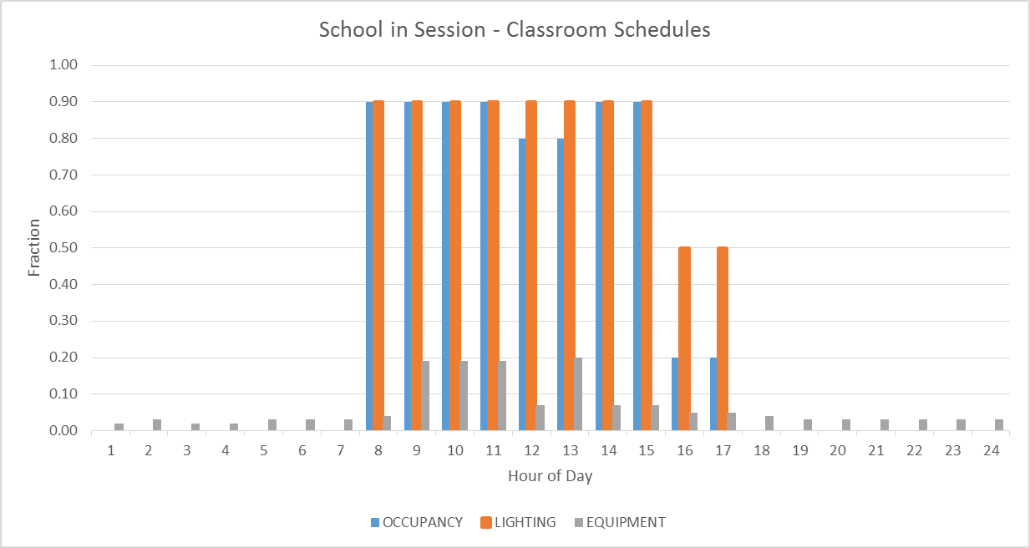

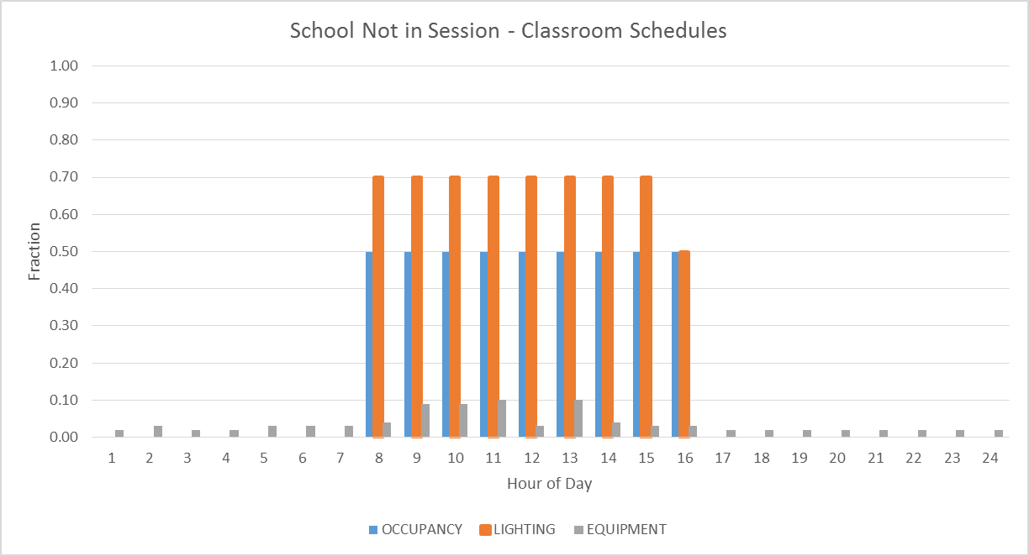
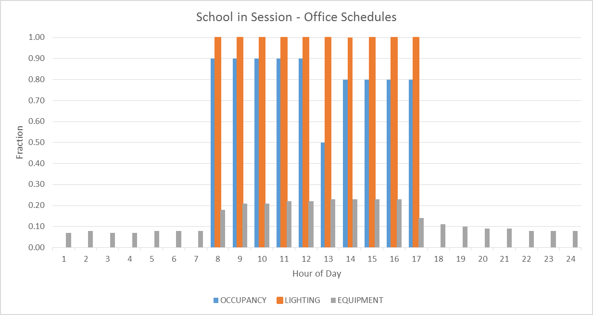

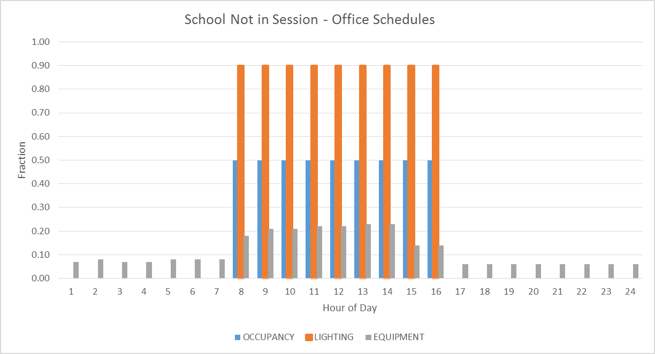
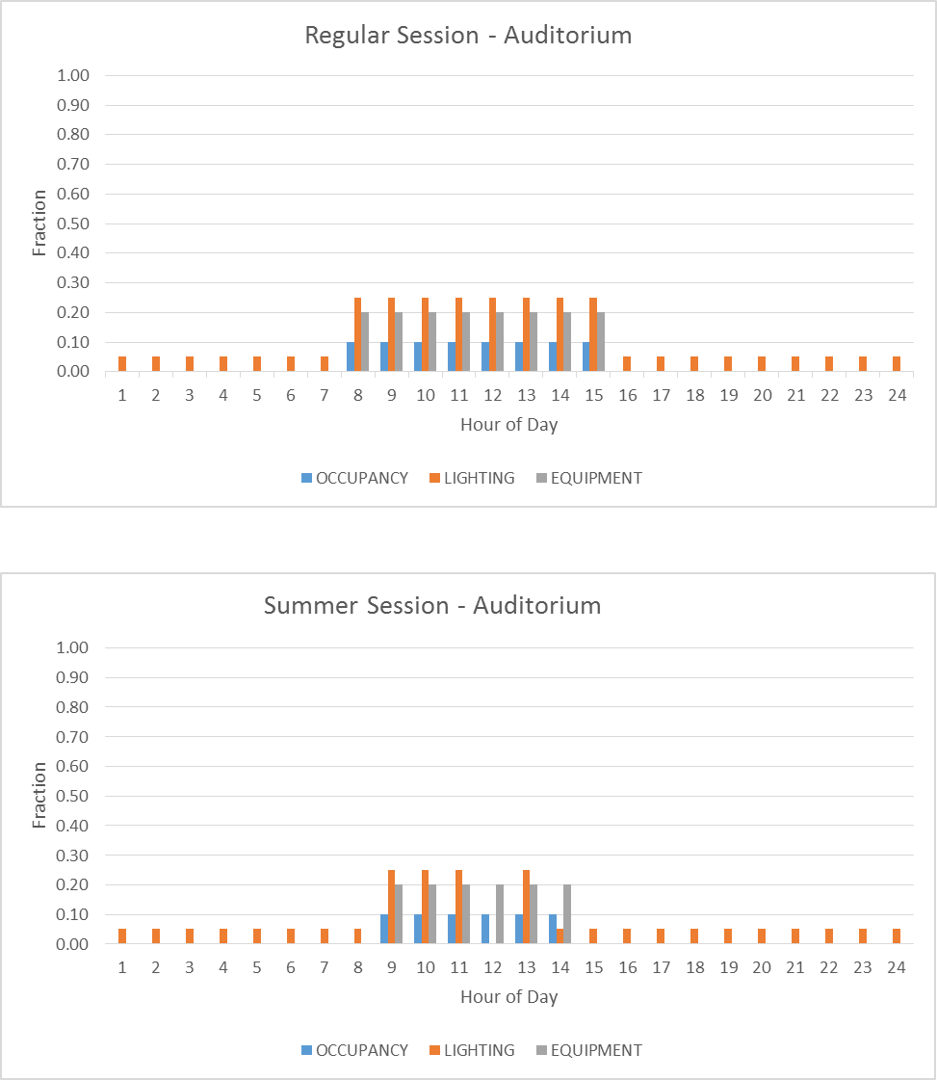
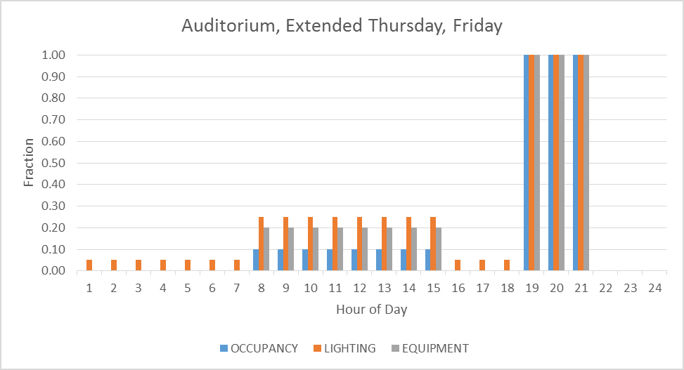
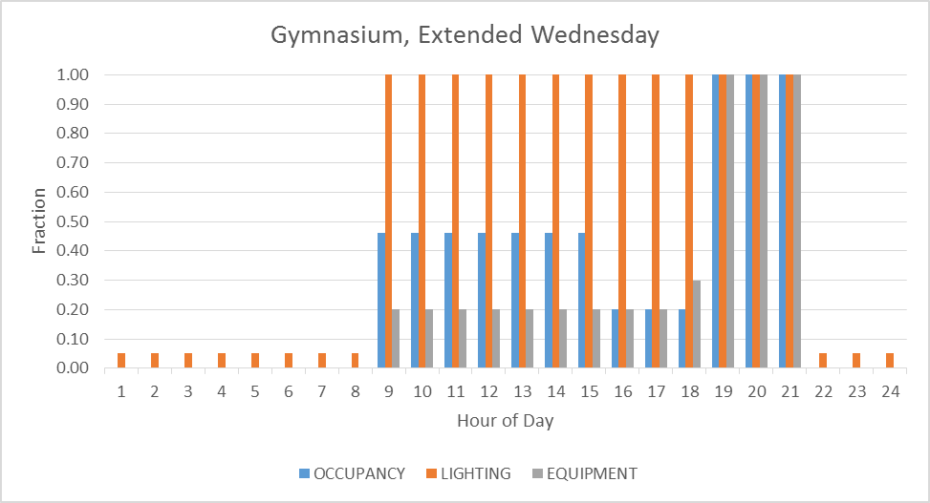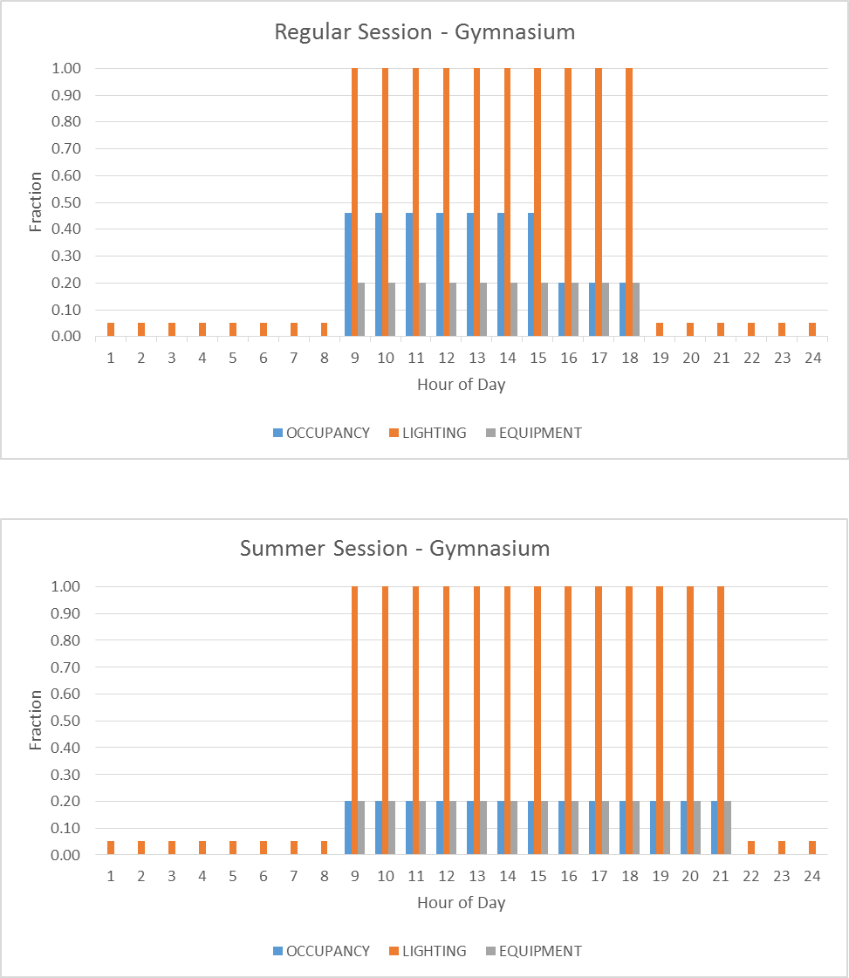
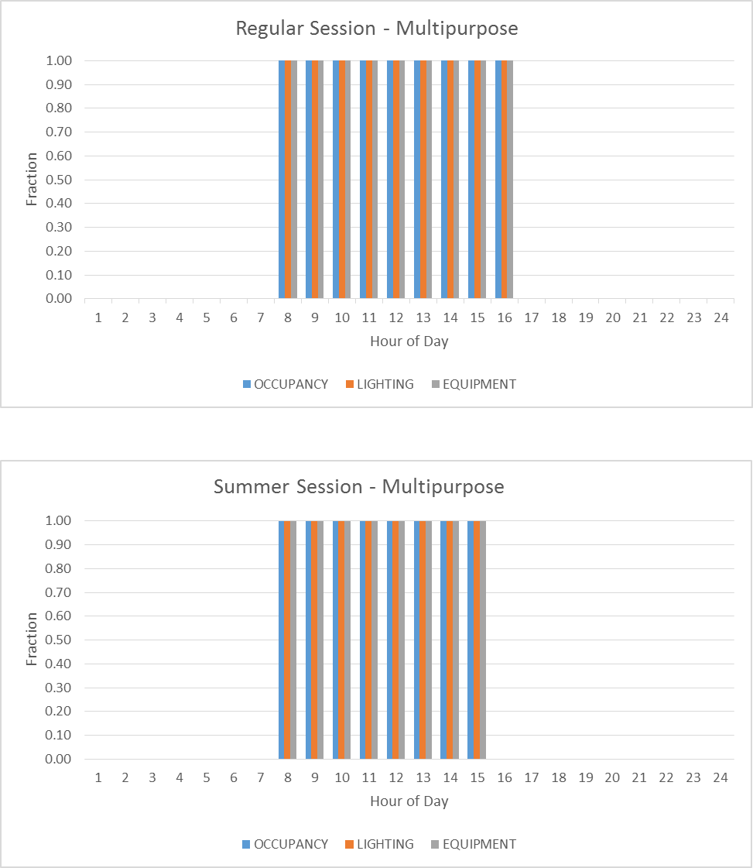

Schedule Name | Effective | 12-1 am | 1-2 am | 2-3 am | 3-4 am | 4-5 am | 5-6 am | 6-7 am | 7-8am | 8-9 am | 9-10 am | 10-11 am | 11-noon | noon-1 pm | 1-2 pm | 2-3 pm | 3-4 pm | 4-5 pm | 5-6pm | 6-7pm | 7-8pm | 8-9pm | 9-10 pm | 10-11 pm | 11-12 mid
ALWAYS-OFF-FAN | All days | 0 | 0 | 0 | 0 | 0 | 0 | 0 | 0 | 0 | 0 | 0 | 0 | 0 | 0 | 0 | 0 | 0 | 0 | 0 | 0 | 0 | 0 | 0 | 0
ALWAYS-OFF-F-YR | All days | 0 | 0 | 0 | 0 | 0 | 0 | 0 | 0 | 0 | 0 | 0 | 0 | 0 | 0 | 0 | 0 | 0 | 0 | 0 | 0 | 0 | 0 | 0 | 0
ALWAYS-OFF-MCR | All days | 0 | 0 | 0 | 0 | 0 | 0 | 0 | 0 | 0 | 0 | 0 | 0 | 0 | 0 | 0 | 0 | 0 | 0 | 0 | 0 | 0 | 0 | 0 | 0
ALWAYS-ON-FAN | All days | 1 | 1 | 1 | 1 | 1 | 1 | 1 | 1 | 1 | 1 | 1 | 1 | 1 | 1 | 1 | 1 | 1 | 1 | 1 | 1 | 1 | 1 | 1 | 1
ALWAYS-ON-F-YR | All days | 1 | 1 | 1 | 1 | 1 | 1 | 1 | 1 | 1 | 1 | 1 | 1 | 1 | 1 | 1 | 1 | 1 | 1 | 1 | 1 | 1 | 1 | 1 | 1
AUD-AUX-EQP-YR | Regular, M-W | 0 | 0 | 0 | 0 | 0 | 0 | 0 | 0.2 | 0.2 | 0.2 | 0.2 | 0.2 | 0.2 | 0.2 | 0.2 | 0 | 0 | 0 | 0 | 0 | 0 | 0 | 0 | 0
AUD-AUX-EQP-YR | Regular, Th-Fri | 0 | 0 | 0 | 0 | 0 | 0 | 0 | 0.2 | 0.2 | 0.2 | 0.2 | 0.2 | 0.2 | 0.2 | 0.2 | 0 | 0 | 0 | 1 | 1 | 1 | 0 | 0 | 0
AUD-EXT-EQP-YR | Summer | 0 | 0 | 0 | 0 | 0 | 0 | 0 | 0 | 0.2 | 0.2 | 0.2 | 0.2 | 0.2 | 0.2 | 0 | 0 | 0 | 0 | 0 | 0 | 0 | 0 | 0 | 0
AUD-EXT-LT-YR | Regular, M-W | 0.05 | 0.05 | 0.05 | 0.05 | 0.05 | 0.05 | 0.05 | 0.25 | 0.25 | 0.25 | 0.25 | 0.25 | 0.25 | 0.25 | 0.25 | 0.05 | 0.05 | 0.05 | 0.05 | 0.05 | 0.05 | 0.05 | 0.05 | 0.05
AUD-EXT-LT-YR | Regular, Th-Fri | 0.05 | 0.05 | 0.05 | 0.05 | 0.05 | 0.05 | 0.05 | 0.25 | 0.25 | 0.25 | 0.25 | 0.25 | 0.25 | 0.25 | 0.25 | 0.05 | 0.05 | 0.05 | 1 | 1 | 1 | 0 | 0 | 0
AUD-EXT-LT-YR | Summer | 0.05 | 0.05 | 0.05 | 0.05 | 0.05 | 0.05 | 0.05 | 0.05 | 0.25 | 0.25 | 0.25 | 0 | 0.25 | 0.05 | 0.05 | 0.05 | 0.05 | 0.05 | 0.05 | 0.05 | 0.05 | 0.05 | 0.05 | 0.05
AUD-EXT-OCC-YR | Regular, M-W | 0 | 0 | 0 | 0 | 0 | 0 | 0 | 0.1 | 0.1 | 0.1 | 0.1 | 0.1 | 0.1 | 0.1 | 0.1 | 0 | 0 | 0 | 0 | 0 | 0 | 0 | 0 | 0
AUD-EXT-OCC-YR | Regular, Th-Fri | 0 | 0 | 0 | 0 | 0 | 0 | 0 | 0.1 | 0.1 | 0.1 | 0.1 | 0.1 | 0.1 | 0.1 | 0.1 | 0 | 0 | 0 | 1 | 1 | 1 | 0 | 0 | 0
AUD-EXT-OCC-YR | Summer | 0 | 0 | 0 | 0 | 0 | 0 | 0 | 0 | 0.1 | 0.1 | 0.1 | 0.1 | 0.1 | 0.1 | 0 | 0 | 0 | 0 | 0 | 0 | 0 | 0 | 0 | 0
AUD-CL-YR | Regular | 85 | 85 | 85 | 85 | 85 | 85 | 85 | 78 | 78 | 78 | 78 | 78 | 78 | 78 | 78 | 85 | 85 | 85 | 78 | 78 | 78 | 85 | 85 | 85
AUD-CL-YR | Heating Season | 85 | 85 | 85 | 85 | 85 | 85 | 85 | 85 | 78 | 78 | 78 | 78 | 78 | 78 | 85 | 85 | 85 | 85 | 85 | 85 | 85 | 85 | 85 | 85
AUD-EQP-YR | Regular | 0 | 0 | 0 | 0 | 0 | 0 | 0 | 0.2 | 0.2 | 0.2 | 0.2 | 0.2 | 0.2 | 0.2 | 0.2 | 0 | 0 | 0 | 0 | 0 | 0 | 0 | 0 | 0
AUD-EQP-YR | Summer | 0 | 0 | 0 | 0 | 0 | 0 | 0 | 0 | 0.2 | 0.2 | 0.2 | 0.2 | 0.2 | 0.2 | 0 | 0 | 0 | 0 | 0 | 0 | 0 | 0 | 0 | 0
AUD-FAN-SCH | Regular, M-W | 0 | 0 | 0 | 0 | -999 | -999 | -999 | 1 | 1 | 1 | 1 | 1 | 1 | 1 | 1 | 0 | 0 | 0 | 0 | 0 | 0 | 0 | 0 | 0
AUD-FAN-SCH | Regular, Th-Fri | 0 | 0 | 0 | 0 | -999 | -999 | -999 | 1 | 1 | 1 | 1 | 1 | 1 | 1 | 1 | 0 | 0 | 0 | 1 | 1 | 1 | 0 | 0 | 0
AUD-FAN-SCH | Summer | 0 | 0 | 0 | 0 | -999 | -999 | -999 | -999 | 1 | 1 | 1 | 1 | 1 | 1 | 1 | 0 | 0 | 0 | 0 | 0 | 0 | 0 | 0 | 0
AUD-HT-YR | Heating Season | 60 | 60 | 60 | 60 | 60 | 60 | 60 | 72 | 72 | 72 | 72 | 72 | 72 | 72 | 72 | 60 | 60 | 60 | 60 | 60 | 60 | 60 | 60 | 60
AUD-LT-YR | Regular | 0.05 | 0.05 | 0.05 | 0.05 | 0.05 | 0.05 | 0.05 | 0.25 | 0.25 | 0.25 | 0.25 | 0.25 | 0.25 | 0.25 | 0.25 | 0.05 | 0.05 | 0.05 | 0.05 | 0.05 | 0.05 | 0.05 | 0.05 | 0.05
AUD-LT-YR | Summer | 0.05 | 0.05 | 0.05 | 0.05 | 0.05 | 0.05 | 0.05 | 0.05 | 0.25 | 0.25 | 0.25 | 0 | 0.25 | 0.05 | 0.05 | 0.05 | 0.05 | 0.05 | 0.05 | 0.05 | 0.05 | 0.05 | 0.05 | 0.05
AUD-OA-SCH | Regular, M-W | 0 | 0 | 0 | 0 | 0 | 0 | 0 | -999 | -999 | -999 | -999 | -999 | -999 | -999 | -999 | 0 | 0 | 0 | 0 | 0 | 0 | 0 | 0 | 0
AUD-OA-SCH | Regular, Th-Fri | 0 | 0 | 0 | 0 | 0 | 0 | 0 | -999 | -999 | -999 | -999 | -999 | -999 | -999 | -999 | 0 | 0 | 0 | -999 | -999 | -999 | 0 | 0 | 0
AUD-OA-SCH | Summer | 0 | 0 | 0 | 0 | 0 | 0 | 0 | -999 | -999 | -999 | -999 | -999 | -999 | -999 | -999 | 0 | 0 | 0 | 0 | 0 | 0 | 0 | 0 | 0
AUD-OCC-YR | Regular | 0 | 0 | 0 | 0 | 0 | 0 | 0 | 0.1 | 0.1 | 0.1 | 0.1 | 0.1 | 0.1 | 0.1 | 0.1 | 0 | 0 | 0 | 0 | 0 | 0 | 0 | 0 | 0
AUD-OCC-YR | Summer | 0 | 0 | 0 | 0 | 0 | 0 | 0 | 0 | 0.1 | 0.1 | 0.1 | 0.1 | 0.1 | 0.1 | 0 | 0 | 0 | 0 | 0 | 0 | 0 | 0 | 0 | 0
AUX-GYM-CL-YR | Regular | 85 | 85 | 85 | 85 | 85 | 85 | 85 | 85 | 78 | 78 | 78 | 78 | 78 | 78 | 78 | 78 | 78 | 78 | 85 | 85 | 85 | 85 | 85 | 85
AUX-GYM-CL-YR | Summer | 85 | 85 | 85 | 85 | 85 | 85 | 85 | 85 | 78 | 78 | 78 | 78 | 78 | 78 | 78 | 78 | 78 | 85 | 85 | 85 | 85 | 85 | 85 | 85
AUX-GYM-FAN-SCH | Regular | 0 | 0 | 0 | 0 | -999 | -999 | -999 | -999 | 1 | 1 | 1 | 1 | 1 | 1 | 1 | 1 | 1 | 1 | 0 | 0 | 0 | 0 | 0 | 0
AUX-GYM-FAN-SCH | Summer | 0 | 0 | 0 | 0 | -999 | -999 | -999 | -999 | 1 | 1 | 1 | 1 | 1 | 1 | 1 | 1 | 1 | 0 | 0 | 0 | 0 | 0 | 0 | 0
AUX-GYM-HT-YR | Heating Season | 60 | 60 | 60 | 60 | 60 | 60 | 60 | 60 | 72 | 72 | 72 | 72 | 72 | 72 | 72 | 72 | 72 | 72 | 60 | 60 | 60 | 60 | 60 | 60
AUX-GYM-OA-SCH | Regular | 0 | 0 | 0 | 0 | 0 | 0 | 0 | 0 | -999 | -999 | -999 | -999 | -999 | -999 | -999 | -999 | -999 | -999 | 0 | 0 | 0 | 0 | 0 | 0
AUX-GYM-OA-SCH | Summer | 0 | 0 | 0 | 0 | 0 | 0 | 0 | 0 | -999 | -999 | -999 | -999 | -999 | -999 | -999 | -999 | -999 | 0 | 0 | 0 | 0 | 0 | 0 | 0
CAFE-CL-YR | Regular | 85 | 85 | 85 | 85 | 85 | 85 | 85 | 78 | 78 | 78 | 78 | 78 | 78 | 78 | 78 | 78 | 85 | 85 | 85 | 85 | 85 | 85 | 85 | 85
CAFE-CL-YR | Summer | 85 | 85 | 85 | 85 | 85 | 85 | 85 | 78 | 78 | 78 | 78 | 78 | 78 | 78 | 78 | 78 | 85 | 85 | 85 | 85 | 85 | 85 | 85 | 85
CAFE-EQP-YR | Regular | 0 | 0 | 0 | 0 | 0 | 0 | 0 | 0.5 | 0.2 | 0.2 | 0.2 | 1 | 1 | 1 | 0.2 | 0.2 | 0 | 0 | 0 | 0 | 0 | 0 | 0 | 0
CAFE-EQP-YR | Summer | 0 | 0 | 0 | 0 | 0 | 0 | 0 | 0.2 | 0.2 | 0.2 | 0.2 | 0.75 | 0.75 | 0.75 | 0.2 | 0.2 | 0 | 0 | 0 | 0 | 0 | 0 | 0 | 0
CAFE-FAN-SCH | Regular | 0 | 0 | 0 | 0 | -999 | -999 | -999 | 1 | 1 | 1 | 1 | 1 | 1 | 1 | 1 | 1 | 0 | 0 | 0 | 0 | 0 | 0 | 0 | 0
CAFE-FAN-SCH | Summer | 0 | 0 | 0 | 0 | -999 | -999 | -999 | 1 | 1 | 1 | 1 | 1 | 1 | 1 | 1 | 1 | 0 | 0 | 0 | 0 | 0 | 0 | 0 | 0
CAFE-HT-YR | Heating Season | 60 | 60 | 60 | 60 | 60 | 60 | 60 | 72 | 72 | 72 | 72 | 72 | 72 | 72 | 72 | 72 | 60 | 60 | 60 | 60 | 60 | 60 | 60 | 60
CAFE-LT-YR | Regular | 0.05 | 0.05 | 0.05 | 0.05 | 0.05 | 0.05 | 0.05 | 1 | 0.5 | 0.5 | 0.5 | 1 | 1 | 1 | 0.5 | 0.5 | 0.05 | 0.05 | 0.05 | 0.05 | 0.05 | 0.05 | 0.05 | 0.05
CAFE-LT-YR | Summer | 0.05 | 0.05 | 0.05 | 0.05 | 0.05 | 0.05 | 0.05 | 1 | 0.5 | 0.5 | 0.5 | 1 | 1 | 1 | 0.5 | 0.5 | 0.05 | 0.05 | 0.05 | 0.05 | 0.05 | 0.05 | 0.05 | 0.05
CAFE-OA-SCH | Regular | 0 | 0 | 0 | 0 | 0 | 0 | 0 | -999 | -999 | -999 | -999 | -999 | -999 | -999 | -999 | -999 | 0 | 0 | 0 | 0 | 0 | 0 | 0 | 0
CAFE-OA-SCH | Summer | 0 | 0 | 0 | 0 | 0 | 0 | 0 | -999 | -999 | -999 | -999 | -999 | -999 | -999 | -999 | -999 | 0 | 0 | 0 | 0 | 0 | 0 | 0 | 0
CAFE-OCC-YR | Regular | 0 | 0 | 0 | 0 | 0 | 0 | 0 | 1 | 0.1 | 0.1 | 0.1 | 1 | 1 | 1 | 0.1 | 0.1 | 0 | 0 | 0 | 0 | 0 | 0 | 0 | 0
CAFE-OCC-YR | Summer | 0 | 0 | 0 | 0 | 0 | 0 | 0 | 0.5 | 0.1 | 0.1 | 0.1 | 0.5 | 0.5 | 0.5 | 0.1 | 0.1 | 0 | 0 | 0 | 0 | 0 | 0 | 0 | 0
CL-85-YR | All days | 85 | 85 | 85 | 85 | 85 | 85 | 85 | 85 | 85 | 85 | 85 | 85 | 85 | 85 | 85 | 85 | 85 | 85 | 85 | 85 | 85 | 85 | 85 | 85
CLASS-AUX-LT-YR | Regular | 0.05 | 0.05 | 0.05 | 0.05 | 0.05 | 0.05 | 0.05 | 0.05 | 0.05 | 0.05 | 0.05 | 0.05 | 0.4 | 0.4 | 0.4 | 0.4 | 0.05 | 0.05 | 0.05 | 0.05 | 0.05 | 0.05 | 0.05 | 0.05
CLASS-AUX-LT-YR | Summer | 0.05 | 0.05 | 0.05 | 0.05 | 0.05 | 0.05 | 0.05 | 0.05 | 0.05 | 0.05 | 0.05 | 0.05 | 0.05 | 0.05 | 0.05 | 0.05 | 0.05 | 0.05 | 0.05 | 0.05 | 0.05 | 0.05 | 0.05 | 0.05
CLASS-CL-YR | Cooling Season | 85 | 85 | 85 | 85 | 85 | 85 | 85 | 78 | 78 | 78 | 78 | 78 | 78 | 78 | 78 | 78 | 78 | 78 | 85 | 85 | 85 | 85 | 85 | 85
CLASS-EQP-YR | Regular | 0.02 | 0.03 | 0.02 | 0.02 | 0.03 | 0.03 | 0.03 | 0.04 | 0.19 | 0.19 | 0.19 | 0.07 | 0.20 | 0.07 | 0.07 | 0.05 | 0.05 | 0.04 | 0.03 | 0.03 | 0.03 | 0.03 | 0.03 | 0.03
CLASS-EQP-YR | Summer | 0.02 | 0.03 | 0.02 | 0.02 | 0.03 | 0.03 | 0.03 | 0.04 | 0.09 | 0.09 | 0.10 | 0.03 | 0.10 | 0.04 | 0.03 | 0.03 | 0.02 | 0.02 | 0.02 | 0.02 | 0.02 | 0.02 | 0.02 | 0.02
CLASS-FAN-SCH | Regular | 0 | 0 | 0 | 0 | -999 | -999 | -999 | 1 | 1 | 1 | 1 | 1 | 1 | 1 | 1 | 1 | 1 | 1 | 0 | 0 | 0 | 0 | 0 | 0
CLASS-FAN-SCH | Summer | 0 | 0 | 0 | 0 | -999 | -999 | -999 | 1 | 1 | 1 | 1 | 1 | 1 | 1 | 1 | 1 | 1 | 1 | 0 | 0 | 0 | 0 | 0 | 0
CLASS-HT-YR | Heating Season | 60 | 60 | 60 | 60 | 60 | 60 | 60 | 72 | 72 | 72 | 72 | 72 | 72 | 72 | 72 | 72 | 72 | 72 | 60 | 60 | 60 | 60 | 60 | 60
CLASS-LT-YR | Regular | 0.05 | 0.05 | 0.05 | 0.05 | 0.05 | 0.05 | 0.05 | 0.9 | 0.9 | 0.9 | 0.9 | 0.9 | 0.9 | 0.9 | 0.9 | 0.5 | 0.5 | 0.5 | 0.05 | 0.05 | 0.05 | 0.05 | 0.05 | 0.05
CLASS-LT-YR | Summer | 0.05 | 0.05 | 0.05 | 0.05 | 0.05 | 0.05 | 0.05 | 0.5 | 0.7 | 0.7 | 0.7 | 0.7 | 0.7 | 0.7 | 0.7 | 0.05 | 0.05 | 0.05 | 0.05 | 0.05 | 0.05 | 0.05 | 0.05 | 0.05
CLASS-OA-SCH | Regular | 0 | 0 | 0 | 0 | 0 | 0 | 0 | -999 | -999 | -999 | -999 | -999 | -999 | -999 | -999 | -999 | -999 | -999 | 0 | 0 | 0 | 0 | 0 | 0
CLASS-OA-SCH | Summer | 0 | 0 | 0 | 0 | 0 | 0 | 0 | -999 | -999 | -999 | -999 | -999 | -999 | -999 | -999 | -999 | -999 | -999 | 0 | 0 | 0 | 0 | 0 | 0
CLASS-OCC-YR | Regular | 0 | 0 | 0 | 0 | 0 | 0 | 0 | 0.1 | 0.9 | 0.9 | 0.9 | 0.8 | 0.8 | 0.9 | 0.9 | 0.2 | 0.2 | 0.2 | 0 | 0 | 0 | 0 | 0 | 0
CLASS-OCC-YR | Summer | 0 | 0 | 0 | 0 | 0 | 0 | 0 | 0.1 | 0.5 | 0.5 | 0.5 | 0.5 | 0.5 | 0.5 | 0.5 | 0 | 0 | 0 | 0 | 0 | 0 | 0 | 0 | 0
CL-DATA | All days | 85 | 85 | 85 | 85 | 85 | 85 | 85 | 85 | 85 | 85 | 85 | 85 | 85 | 85 | 85 | 85 | 85 | 85 | 85 | 85 | 85 | 85 | 85 | 85
CL-MECH | All days | 95 | 95 | 95 | 95 | 95 | 95 | 95 | 95 | 95 | 95 | 95 | 95 | 95 | 95 | 95 | 95 | 95 | 95 | 95 | 95 | 95 | 95 | 95 | 95
CL-RESTRM | Regular | 95 | 95 | 95 | 95 | 95 | 95 | 95 | 95 | 95 | 95 | 95 | 95 | 95 | 95 | 95 | 95 | 95 | 95 | 95 | 95 | 95 | 95 | 95 | 95
CL-RESTRM | Summer | 85 | 85 | 85 | 85 | 85 | 85 | 85 | 78 | 78 | 78 | 78 | 78 | 78 | 78 | 78 | 78 | 78 | 85 | 85 | 85 | 85 | 85 | 85 | 85
CL-STOR | All days | 90 | 90 | 90 | 90 | 90 | 90 | 90 | 90 | 90 | 90 | 90 | 90 | 90 | 90 | 90 | 90 | 90 | 90 | 90 | 90 | 90 | 90 | 90 | 90
COOLOFF | All days | 0 | 0 | 0 | 0 | 0 | 0 | 0 | 0 | 0 | 0 | 0 | 0 | 0 | 0 | 0 | 0 | 0 | 0 | 0 | 0 | 0 | 0 | 0 | 0
COOL-ON-YR | All days | 1 | 1 | 1 | 1 | 1 | 1 | 1 | 1 | 1 | 1 | 1 | 1 | 1 | 1 | 1 | 1 | 1 | 1 | 1 | 1 | 1 | 1 | 1 | 1
COOLSEASON-DATA | All days | 1 | 1 | 1 | 1 | 1 | 1 | 1 | 1 | 1 | 1 | 1 | 1 | 1 | 1 | 1 | 1 | 1 | 1 | 1 | 1 | 1 | 1 | 1 | 1
COPY-EQP-YR | Regular | 0.04 | 0.04 | 0.04 | 0.04 | 0.04 | 0.04 | 0.04 | 0.04 | 0.05 | 0.05 | 0.06 | 0.06 | 0.06 | 0.06 | 0.06 | 0.06 | 0.06 | 0.05 | 0.05 | 0.04 | 0.04 | 0.04 | 0.04 | 0.04
COPY-EQP-YR | Summer | 0.04 | 0.04 | 0.04 | 0.04 | 0.04 | 0.04 | 0.04 | 0.04 | 0.05 | 0.05 | 0.06 | 0.06 | 0.06 | 0.06 | 0.06 | 0.06 | 0.03 | 0.03 | 0.03 | 0.03 | 0.03 | 0.03 | 0.03 | 0.03
CORR-CL-YR | Regular | 85 | 85 | 85 | 85 | 85 | 85 | 85 | 78 | 78 | 78 | 78 | 78 | 78 | 78 | 78 | 78 | 78 | 78 | 85 | 85 | 85 | 85 | 85 | 85
CORR-CL-YR | Summer | 85 | 85 | 85 | 85 | 85 | 85 | 85 | 78 | 78 | 78 | 78 | 78 | 78 | 78 | 78 | 78 | 78 | 78 | 85 | 85 | 85 | 85 | 85 | 85
CORR-HT-YR | Heating Season | 60 | 60 | 60 | 60 | 60 | 60 | 60 | 72 | 72 | 72 | 72 | 72 | 72 | 72 | 72 | 72 | 72 | 72 | 60 | 60 | 60 | 60 | 60 | 60
CORR-LT-YR | Regular | 0.05 | 0.05 | 0.05 | 0.05 | 0.05 | 0.05 | 0.05 | 1 | 1 | 1 | 1 | 1 | 1 | 1 | 1 | 1 | 1 | 1 | 0.05 | 0.05 | 0.05 | 0.05 | 0.05 | 0.05
CORR-LT-YR | Summer | 0.05 | 0.05 | 0.05 | 0.05 | 0.05 | 0.05 | 0.05 | 1 | 1 | 1 | 1 | 1 | 1 | 1 | 1 | 1 | 1 | 1 | 0.05 | 0.05 | 0.05 | 0.05 | 0.05 | 0.05
DATA-EQP-YR | Regular | 0.15 | 0.15 | 0.15 | 0.15 | 0.15 | 0.15 | 0.15 | 0.9 | 0.9 | 0.9 | 0.9 | 0.9 | 0.9 | 0.9 | 0.9 | 0.9 | 0.9 | 0.9 | 0.15 | 0.15 | 0.15 | 0.15 | 0.15 | 0.15
DATA-EQP-YR | Summer | 0.15 | 0.15 | 0.15 | 0.15 | 0.15 | 0.15 | 0.15 | 0.75 | 0.75 | 0.75 | 0.75 | 0.75 | 0.75 | 0.75 | 0.75 | 0.75 | 0.75 | 0.15 | 0.15 | 0.15 | 0.15 | 0.15 | 0.15 | 0.15
DATA-FAN-SCH | All days | 0 | 0 | 0 | 0 | 0 | 0 | 0 | 0 | 0 | 0 | 0 | 0 | 1 | 0 | 0 | 0 | 0 | 0 | 0 | 0 | 0 | 0 | 0 | 0
DHWSCH | All days | 0.01 | 0.01 | 0.01 | 0.01 | 0.01 | 0.01 | 0.1 | 0.3 | 0.3 | 0.2 | 0.2 | 0.5 | 0.5 | 0.3 | 0.2 | 0.2 | 0.1 | 0.1 | 0.1 | 0.1 | 0.01 | 0.01 | 0.01 | 0.01
GYM-EXT-EQP-YR | Regular, M,Tu,Th,Fri | 0 | 0 | 0 | 0 | 0 | 0 | 0 | 0 | 0.2 | 0.2 | 0.2 | 0.2 | 0.2 | 0.2 | 0.2 | 0.2 | 0.2 | 0.2 | 0 | 0 | 0 | 0 | 0 | 0
GYM-EXT-EQP-YR | Regular, W | 0 | 0 | 0 | 0 | 0 | 0 | 0 | 0 | 0.2 | 0.2 | 0.2 | 0.2 | 0.2 | 0.2 | 0.2 | 0.2 | 0.2 | 0.3 | 1 | 1 | 1 | 0 | 0 | 0
GYM-EXT-EQP-YR | Summer | 0 | 0 | 0 | 0 | 0 | 0 | 0 | 0 | 0.2 | 0.2 | 0.2 | 0.2 | 0.2 | 0.2 | 0.2 | 0.2 | 0.2 | 0.2 | 0.2 | 0.2 | 0.2 | 0 | 0 | 0
GYM-EXT-LT-YR | Regular, M,Tu,Th,Fri | 0.05 | 0.05 | 0.05 | 0.05 | 0.05 | 0.05 | 0.05 | 0.05 | 1 | 1 | 1 | 1 | 1 | 1 | 1 | 1 | 1 | 1 | 0.05 | 0.05 | 0.05 | 0.05 | 0.05 | 0.05
GYM-EXT-LT-YR | Regular, W | 0.05 | 0.05 | 0.05 | 0.05 | 0.05 | 0.05 | 0.05 | 0.05 | 1 | 1 | 1 | 1 | 1 | 1 | 1 | 1 | 1 | 1 | 1 | 1 | 1 | 0.05 | 0.05 | 0.05
GYM-EXT-LT-YR | Summer | 0.05 | 0.05 | 0.05 | 0.05 | 0.05 | 0.05 | 0.05 | 0.05 | 0.05 | 0.05 | 0.05 | 0.05 | 0.05 | 0.05 | 0.05 | 0.05 | 0.05 | 0.05 | 0.05 | 0.05 | 0.05 | 0.05 | 0.05 | 0.05
GYM-EXT-OCC-YR | Regular, M,Tu,Th,Fri | 0 | 0 | 0 | 0 | 0 | 0 | 0 | 0 | 0.46 | 0.46 | 0.46 | 0.46 | 0.46 | 0.46 | 0.46 | 0.2 | 0.2 | 0.2 | 0 | 0 | 0 | 0 | 0 | 0
GYM-EXT-OCC-YR | Regular, W | 0 | 0 | 0 | 0 | 0 | 0 | 0 | 0 | 0.46 | 0.46 | 0.46 | 0.46 | 0.46 | 0.46 | 0.46 | 0.2 | 0.2 | 0.2 | 1 | 1 | 1 | 0 | 0 | 0
GYM-EXT-OCC-YR | Summer | 0 | 0 | 0 | 0 | 0 | 0 | 0 | 0 | 0.2 | 0.2 | 0.2 | 0.2 | 0.2 | 0.2 | 0.2 | 0.2 | 0.2 | 0.2 | 0.2 | 0.2 | 0.2 | 0 | 0 | 0
GYM-CL-YR | Regular, M,Tu,Th,Fri | 85 | 85 | 85 | 85 | 85 | 85 | 85 | 85 | 78 | 78 | 78 | 78 | 78 | 78 | 78 | 78 | 78 | 78 | 85 | 85 | 85 | 85 | 85 | 85
GYM-CL-YR | Regular, W | 85 | 85 | 85 | 85 | 85 | 85 | 85 | 85 | 78 | 78 | 78 | 78 | 78 | 78 | 78 | 78 | 78 | 78 | 78 | 78 | 78 | 85 | 85 | 85
GYM-EXT-CL-YR | Regular, W | 85 | 85 | 85 | 85 | 85 | 85 | 85 | 85 | 78 | 78 | 78 | 78 | 78 | 78 | 78 | 78 | 78 | 78 | 78 | 78 | 78 | 85 | 85 | 85
GYM-CL-YR | Summer | 85 | 85 | 85 | 85 | 85 | 85 | 85 | 85 | 78 | 78 | 78 | 78 | 78 | 78 | 78 | 78 | 78 | 78 | 78 | 78 | 78 | 85 | 85 | 85
GYM-EQP-YR | Regular | 0 | 0 | 0 | 0 | 0 | 0 | 0 | 0 | 0.2 | 0.2 | 0.2 | 0.2 | 0.2 | 0.2 | 0.2 | 0.2 | 0.2 | 0.2 | 0 | 0 | 0 | 0 | 0 | 0
GYM-EQP-YR | Summer | 0 | 0 | 0 | 0 | 0 | 0 | 0 | 0 | 0.2 | 0.2 | 0.2 | 0.2 | 0.2 | 0.2 | 0.2 | 0.2 | 0.2 | 0.2 | 0.2 | 0.2 | 0.2 | 0 | 0 | 0
GYM-FAN-SCH | Regular, M,Tu,Th,Fri | 0 | 0 | 0 | 0 | -999 | -999 | -999 | -999 | 1 | 1 | 1 | 1 | 1 | 1 | 1 | 1 | 1 | 1 | 0 | 0 | 0 | 0 | 0 | 0
GYM-FAN-SCH | Regular, W | 0 | 0 | 0 | 0 | -999 | -999 | -999 | -999 | 1 | 1 | 1 | 1 | 1 | 1 | 1 | 1 | 1 | 1 | 1 | 1 | 1 | 0 | 0 | 0
GYM-FAN-SCH | Summer | 0 | 0 | 0 | 0 | -999 | -999 | -999 | -999 | 1 | 1 | 1 | 1 | 1 | 1 | 1 | 1 | 1 | 1 | 1 | 1 | 1 | 0 | 0 | 0
GYM-HT-YR | Heating Season | 60 | 60 | 60 | 60 | 60 | 60 | 60 | 60 | 72 | 72 | 72 | 72 | 72 | 72 | 72 | 72 | 72 | 72 | 60 | 60 | 60 | 60 | 60 | 60
GYM-EXT-HT-YR | Heating Season, W | 60 | 60 | 60 | 60 | 60 | 60 | 60 | 60 | 72 | 72 | 72 | 72 | 72 | 72 | 72 | 72 | 72 | 72 | 72 | 72 | 72 | 60 | 60 | 60
GYM-LT-YR | Regular | 0.05 | 0.05 | 0.05 | 0.05 | 0.05 | 0.05 | 0.05 | 0.05 | 1 | 1 | 1 | 1 | 1 | 1 | 1 | 1 | 1 | 1 | 0.05 | 0.05 | 0.05 | 0.05 | 0.05 | 0.05
GYM-LT-YR | Summer | 0.05 | 0.05 | 0.05 | 0.05 | 0.05 | 0.05 | 0.05 | 0.05 | 1 | 1 | 1 | 1 | 1 | 1 | 1 | 1 | 1 | 1 | 1 | 1 | 1 | 0.05 | 0.05 | 0.05
GYM-OA-SCH | Regular, M,Tu,Th,Fri | 0 | 0 | 0 | 0 | 0 | 0 | 0 | 0 | -999 | -999 | -999 | -999 | -999 | -999 | -999 | -999 | -999 | -999 | 0 | 0 | 0 | 0 | 0 | 0
GYM-OA-SCH | Regular, W | 0 | 0 | 0 | 0 | 0 | 0 | 0 | 0 | -999 | -999 | -999 | -999 | -999 | -999 | -999 | -999 | -999 | -999 | -999 | -999 | -999 | 0 | 0 | 0
GYM-OA-SCH | Summer | 0 | 0 | 0 | 0 | 0 | 0 | 0 | 0 | -999 | -999 | -999 | -999 | -999 | -999 | -999 | -999 | -999 | -999 | -999 | -999 | -999 | 0 | 0 | 0
GYM-OCC-YR | Regular | 0 | 0 | 0 | 0 | 0 | 0 | 0 | 0 | 0.46 | 0.46 | 0.46 | 0.46 | 0.46 | 0.46 | 0.46 | 0.2 | 0.2 | 0.2 | 0 | 0 | 0 | 0 | 0 | 0
GYM-OCC-YR | Summer | 0 | 0 | 0 | 0 | 0 | 0 | 0 | 0 | 0.2 | 0.2 | 0.2 | 0.2 | 0.2 | 0.2 | 0.2 | 0.2 | 0.2 | 0.2 | 0.2 | 0.2 | 0.2 | 0 | 0 | 0
HT-60-YR | All days | 60 | 60 | 60 | 60 | 60 | 60 | 60 | 60 | 60 | 60 | 60 | 60 | 60 | 60 | 60 | 60 | 60 | 60 | 60 | 60 | 60 | 60 | 60 | 60
HT-DATA | All days | 60 | 60 | 60 | 60 | 60 | 60 | 60 | 60 | 60 | 60 | 60 | 60 | 60 | 60 | 60 | 60 | 60 | 60 | 60 | 60 | 60 | 60 | 60 | 60
HT-RESTRM | Heating Season | 60 | 60 | 60 | 60 | 60 | 60 | 60 | 72 | 72 | 72 | 72 | 72 | 72 | 72 | 72 | 72 | 72 | 60 | 60 | 60 | 60 | 60 | 60 | 60
KITCHEN-CL-YR | Regular | 85 | 85 | 85 | 85 | 85 | 85 | 85 | 78 | 78 | 78 | 78 | 78 | 78 | 78 | 85 | 85 | 85 | 85 | 85 | 85 | 85 | 85 | 85 | 85
KITCHEN-CL-YR | Summer | 85 | 85 | 85 | 85 | 85 | 85 | 85 | 78 | 78 | 78 | 78 | 78 | 78 | 78 | 85 | 85 | 85 | 85 | 85 | 85 | 85 | 85 | 85 | 85
KITCHEN-EQP-YR | Regular | 0.14 | 0.14 | 0.14 | 0.15 | 0.14 | 0.14 | 0.14 | 0.17 | 0.18 | 0.31 | 0.31 | 0.21 | 0.21 | 0.20 | 0.18 | 0.15 | 0.14 | 0.14 | 0.14 | 0.14 | 0.14 | 0.14 | 0.14 | 0.14
KITCHEN-EQP-YR | Summer | 0.14 | 0.14 | 0.14 | 0.15 | 0.14 | 0.14 | 0.14 | 0.17 | 0.18 | 0.31 | 0.31 | 0.21 | 0.21 | 0.20 | 0.18 | 0.15 | 0.14 | 0.14 | 0.14 | 0.14 | 0.14 | 0.14 | 0.14 | 0.14
KITCHEN-HT-YR | Heating Season | 60 | 60 | 60 | 60 | 60 | 60 | 60 | 65 | 65 | 65 | 65 | 65 | 65 | 65 | 60 | 60 | 60 | 60 | 60 | 60 | 60 | 60 | 60 | 60
KITCHEN-INF | Regular | 1.5 | 1.5 | 1.5 | 1.5 | 1.5 | 1.5 | 1.5 | 1 | 1 | 1 | 1 | 1 | 1 | 1 | 1.5 | 1.5 | 1.5 | 1.5 | 1.5 | 1.5 | 1.5 | 1.5 | 1.5 | 1.5
KITCHEN-INF | Summer | 1.5 | 1.5 | 1.5 | 1.5 | 1.5 | 1.5 | 1.5 | 1 | 1 | 1 | 1 | 1 | 1 | 1 | 1.5 | 1.5 | 1.5 | 1.5 | 1.5 | 1.5 | 1.5 | 1.5 | 1.5 | 1.5
KITCHEN-LT-YR | Regular | 0.05 | 0.05 | 0.05 | 0.05 | 0.05 | 0.05 | 0.05 | 1 | 1 | 1 | 1 | 1 | 1 | 1 | 0.05 | 0.05 | 0.05 | 0.05 | 0.05 | 0.05 | 0.05 | 0.05 | 0.05 | 0.05
KITCHEN-LT-YR | Summer | 0.05 | 0.05 | 0.05 | 0.05 | 0.05 | 0.05 | 0.05 | 1 | 1 | 1 | 1 | 1 | 1 | 1 | 0.05 | 0.05 | 0.05 | 0.05 | 0.05 | 0.05 | 0.05 | 0.05 | 0.05 | 0.05
KITCHEN-OCC-YR | Regular | 0 | 0 | 0 | 0 | 0 | 0 | 0 | 1 | 1 | 1 | 1 | 1 | 1 | 1 | 0 | 0 | 0 | 0 | 0 | 0 | 0 | 0 | 0 | 0
KITCHEN-OCC-YR | Summer | 0 | 0 | 0 | 0 | 0 | 0 | 0 | 1 | 1 | 1 | 1 | 1 | 1 | 1 | 0 | 0 | 0 | 0 | 0 | 0 | 0 | 0 | 0 | 0
KITHW-SCH | All days | 0.05 | 0.05 | 0.05 | 0.05 | 0.05 | 0.05 | 0.05 | 0.05 | 0.05 | 0.05 | 0.05 | 0.4 | 0.4 | 0.4 | 0.05 | 0.05 | 0.05 | 0.05 | 0.05 | 0.05 | 0.05 | 0.05 | 0.05 | 0.05
KIT-SOURCE-YR | Regular | 0 | 0 | 0 | 0 | 0 | 0 | 0 | 0.27 | 0.27 | 0.29 | 0.29 | 0.27 | 0.27 | 0 | 0 | 0 | 0 | 0 | 0 | 0 | 0 | 0 | 0 | 0
KIT-SOURCE-YR | Summer | 0 | 0 | 0 | 0 | 0 | 0 | 0 | 0.27 | 0.27 | 0.29 | 0.29 | 0.27 | 0.27 | 0 | 0 | 0 | 0 | 0 | 0 | 0 | 0 | 0 | 0 | 0
LIB-EQP-YR | Regular | 0.05 | 0.05 | 0.05 | 0.05 | 0.05 | 0.05 | 0.05 | 1.00 | 1.00 | 1.00 | 1.00 | 1.00 | 1.00 | 1.00 | 1.00 | 1.00 | 1.00 | 0.05 | 0.05 | 0.05 | 0.05 | 0.05 | 0.05 | 0.05
LIB-EQP-YR | Summer | 0.05 | 0.05 | 0.05 | 0.05 | 0.05 | 0.05 | 0.05 | 1.00 | 1.00 | 1.00 | 1.00 | 1.00 | 1.00 | 1.00 | 1.00 | 1.00 | 0.05 | 0.05 | 0.05 | 0.05 | 0.05 | 0.05 | 0.05 | 0.05
LOBBY-EQP-YR | Regular | 0.01 | 0.01 | 0.01 | 0.01 | 0.01 | 0.02 | 0.02 | 0.42 | 0.45 | 0.46 | 0.51 | 0.75 | 0.79 | 0.59 | 0.59 | 0.59 | 0.59 | 0.38 | 0.02 | 0.01 | 0.01 | 0.01 | 0.01 | 0.01
LOBBY-EQP-YR | Summer | 0.01 | 0.01 | 0.01 | 0.01 | 0.01 | 0.02 | 0.02 | 0.42 | 0.45 | 0.46 | 0.51 | 0.75 | 0.79 | 0.59 | 0.59 | 0.59 | 0.30 | 0.19 | 0.02 | 0.01 | 0.01 | 0.01 | 0.01 | 0.01
LOUNGE-EQP-YR | Regular | 0.02 | 0.02 | 0.02 | 0.02 | 0.02 | 0.02 | 0.02 | 0.10 | 0.13 | 0.13 | 0.13 | 0.42 | 0.43 | 0.13 | 0.13 | 0.05 | 0.04 | 0.02 | 0.02 | 0.02 | 0.02 | 0.02 | 0.02 | 0.02
LOUNGE-EQP-YR | Summer | 0.02 | 0.02 | 0.02 | 0.02 | 0.02 | 0.02 | 0.02 | 0.10 | 0.13 | 0.13 | 0.13 | 0.42 | 0.43 | 0.13 | 0.05 | 0.05 | 0.01 | 0.01 | 0.01 | 0.01 | 0.01 | 0.01 | 0.01 | 0.01
MECH-LT-YR | Regular | 0.05 | 0.05 | 0.05 | 0.05 | 0.05 | 0.05 | 0.05 | 0.05 | 0.05 | 1 | 0.05 | 0.05 | 0.05 | 0.05 | 0.05 | 0.05 | 0.05 | 0.05 | 0.05 | 0.05 | 0.05 | 0.05 | 0.05 | 0.05
MECH-LT-YR | Summer | 0.05 | 0.05 | 0.05 | 0.05 | 0.05 | 0.05 | 0.05 | 0.05 | 0.05 | 1 | 0.05 | 0.05 | 0.05 | 0.05 | 0.05 | 0.05 | 0.05 | 0.05 | 0.05 | 0.05 | 0.05 | 0.05 | 0.05 | 0.05
MP-EQP-YR | Regular | 0 | 0 | 0 | 0 | 0 | 0 | 0 | 1 | 1 | 1 | 1 | 1 | 1 | 1 | 1 | 1 | 0 | 0 | 0 | 0 | 0 | 0 | 0 | 0
MP-EQP-YR | Summer | 0 | 0 | 0 | 0 | 0 | 0 | 0 | 1 | 1 | 1 | 1 | 1 | 1 | 1 | 1 | 0 | 0 | 0 | 0 | 0 | 0 | 0 | 0 | 0
MP-HT-YR | Heating Season | 60 | 60 | 60 | 60 | 60 | 60 | 60 | 72 | 72 | 72 | 72 | 72 | 72 | 72 | 72 | 60 | 60 | 60 | 60 | 60 | 60 | 60 | 60 | 60
MP-LT-YR | Regular | 0.05 | 0.05 | 0.05 | 0.05 | 0.05 | 0.05 | 0.05 | 1 | 1 | 1 | 1 | 1 | 1 | 1 | 1 | 1 | 0.05 | 0.05 | 0.05 | 0.05 | 0.05 | 0.05 | 0.05 | 0.05
MP-LT-YR | Summer | 0.05 | 0.05 | 0.05 | 0.05 | 0.05 | 0.05 | 0.05 | 1 | 1 | 1 | 1 | 1 | 1 | 1 | 1 | 0.05 | 0.05 | 0.05 | 0.05 | 0.05 | 0.05 | 0.05 | 0.05 | 0.05
MP-OCC-YR | Regular | 0 | 0 | 0 | 0 | 0 | 0 | 0 | 1 | 1 | 1 | 1 | 1 | 1 | 1 | 1 | 1 | 0 | 0 | 0 | 0 | 0 | 0 | 0 | 0
MP-OCC-YR | Summer | 0 | 0 | 0 | 0 | 0 | 0 | 0 | 1 | 1 | 1 | 1 | 1 | 1 | 1 | 1 | 0 | 0 | 0 | 0 | 0 | 0 | 0 | 0 | 0
MUSIC-EQP-YR | Regular | 0.02 | 0.03 | 0.02 | 0.02 | 0.03 | 0.03 | 0.03 | 0.04 | 0.19 | 0.19 | 0.19 | 0.07 | 0.20 | 0.07 | 0.07 | 0.05 | 0.05 | 0.04 | 0.03 | 0.03 | 0.03 | 0.03 | 0.03 | 0.03
MUSIC-EQP-YR | Summer | 0.02 | 0.03 | 0.02 | 0.02 | 0.03 | 0.03 | 0.03 | 0.04 | 0.09 | 0.09 | 0.10 | 0.03 | 0.10 | 0.04 | 0.03 | 0.03 | 0.02 | 0.02 | 0.02 | 0.02 | 0.02 | 0.02 | 0.02 | 0.02
NO-OA-SCH | All days | 0 | 0 | 0 | 0 | 0 | 0 | 0 | 0 | 0 | 0 | 0 | 0 | 0 | 0 | 0 | 0 | 0 | 0 | 0 | 0 | 0 | 0 | 0 | 0
NULL-OCC-YR | All days | 0 | 0 | 0 | 0 | 0 | 0 | 0 | 0 | 0 | 0 | 0 | 0 | 0 | 0 | 0 | 0 | 0 | 0 | 0 | 0 | 0 | 0 | 0 | 0
NURSE-OCC-YR | Regular | 0.04 | 0.04 | 0.04 | 0.04 | 0.04 | 0.04 | 0.04 | 0.07 | 0.10 | 0.10 | 0.10 | 0.10 | 0.10 | 0.10 | 0.10 | 0.08 | 0.06 | 0.05 | 0.05 | 0.04 | 0.04 | 0.04 | 0.04 | 0.04
NURSE-OCC-YR | Summer | 0.04 | 0.04 | 0.04 | 0.04 | 0.04 | 0.04 | 0.04 | 0.05 | 0.08 | 0.08 | 0.08 | 0.08 | 0.08 | 0.08 | 0.08 | 0.08 | 0.04 | 0.04 | 0.04 | 0.04 | 0.04 | 0.04 | 0.04 | 0.04
OFFICE-CL-YR | Regular | 85 | 85 | 85 | 85 | 85 | 85 | 85 | 75 | 75 | 75 | 75 | 75 | 75 | 75 | 75 | 75 | 75 | 75 | 85 | 85 | 85 | 85 | 85 | 85
OFFICE-CL-YR | Summer | 85 | 85 | 85 | 85 | 85 | 85 | 85 | 75 | 75 | 75 | 75 | 75 | 75 | 75 | 75 | 75 | 75 | 75 | 85 | 85 | 85 | 85 | 85 | 85
OFFICE-EQP-YR | Regular | 0.07 | 0.08 | 0.07 | 0.07 | 0.08 | 0.08 | 0.08 | 0.18 | 0.21 | 0.21 | 0.22 | 0.22 | 0.23 | 0.23 | 0.23 | 0.23 | 0.14 | 0.11 | 0.10 | 0.09 | 0.09 | 0.08 | 0.08 | 0.08
OFFICE-EQP-YR | Summer | 0.07 | 0.08 | 0.07 | 0.07 | 0.08 | 0.08 | 0.08 | 0.18 | 0.21 | 0.21 | 0.22 | 0.22 | 0.23 | 0.23 | 0.14 | 0.14 | 0.06 | 0.06 | 0.06 | 0.06 | 0.06 | 0.06 | 0.06 | 0.06
OFFICE-FAN-SCH | Regular | 0 | 0 | 0 | 0 | -999 | -999 | -999 | 1 | 1 | 1 | 1 | 1 | 1 | 1 | 1 | 1 | 1 | 1 | 0 | 0 | 0 | 0 | 0 | 0
OFFICE-FAN-SCH | Summer | 0 | 0 | 0 | 0 | -999 | -999 | -999 | 1 | 1 | 1 | 1 | 1 | 1 | 1 | 1 | 1 | 1 | 1 | 0 | 0 | 0 | 0 | 0 | 0
OFFICE-HT-YR | Heating Season | 60 | 60 | 60 | 60 | 60 | 60 | 60 | 72 | 72 | 72 | 72 | 72 | 72 | 72 | 72 | 72 | 72 | 72 | 60 | 60 | 60 | 60 | 60 | 60
OFFICE-LT-YR | Regular | 0 | 0 | 0 | 0 | 0 | 0 | 0 | 1 | 1 | 1 | 1 | 1 | 1 | 1 | 1 | 1 | 1 | 0.5 | 0.1 | 0.1 | 0 | 0 | 0 | 0
OFFICE-LT-YR | Summer | 0 | 0 | 0 | 0 | 0 | 0 | 0 | 0.9 | 0.9 | 0.9 | 0.9 | 0.9 | 0.9 | 0.9 | 0.9 | 0.9 | 0.9 | 0.5 | 0.1 | 0.1 | 0 | 0 | 0 | 0
OFFICE-OA-SCH | Regular | 0 | 0 | 0 | 0 | 0 | 0 | 0 | -999 | -999 | -999 | -999 | -999 | -999 | -999 | -999 | -999 | -999 | -999 | 0 | 0 | 0 | 0 | 0 | 0
OFFICE-OA-SCH | Summer | 0 | 0 | 0 | 0 | 0 | 0 | 0 | -999 | -999 | -999 | -999 | -999 | -999 | -999 | -999 | -999 | -999 | -999 | 0 | 0 | 0 | 0 | 0 | 0
OFFICE-OCC-YR | Regular | 0 | 0 | 0 | 0 | 0 | 0 | 0 | 0.9 | 0.9 | 0.9 | 0.9 | 0.9 | 0.5 | 0.8 | 0.8 | 0.8 | 0.8 | 0.5 | 0 | 0 | 0 | 0 | 0 | 0
OFFICE-OCC-YR | Summer | 0 | 0 | 0 | 0 | 0 | 0 | 0 | 0.5 | 0.5 | 0.5 | 0.5 | 0.5 | 0.5 | 0.5 | 0.5 | 0.5 | 0.5 | 0 | 0 | 0 | 0 | 0 | 0 | 0
RESTROOM-LT-YR | Regular | 0.05 | 0.05 | 0.05 | 0.05 | 0.05 | 0.05 | 0.05 | 1 | 1 | 1 | 1 | 1 | 1 | 1 | 1 | 1 | 1 | 1 | 0.05 | 0.05 | 0.05 | 0.05 | 0.05 | 0.05
RESTROOM-LT-YR | Summer | 0.05 | 0.05 | 0.05 | 0.05 | 0.05 | 0.05 | 0.05 | 1 | 1 | 1 | 1 | 1 | 1 | 1 | 1 | 1 | 1 | 1 | 0.05 | 0.05 | 0.05 | 0.05 | 0.05 | 0.05
SCHOOL-INF | Regular | 1.5 | 1.5 | 1.5 | 1.5 | 1.5 | 1.5 | 1.5 | 1 | 1 | 1 | 1 | 1 | 1 | 1 | 1 | 1 | 1 | 1.5 | 1.5 | 1.5 | 1.5 | 1.5 | 1.5 | 1.5
SCHOOL-INF | Summer | 1.5 | 1.5 | 1.5 | 1.5 | 1.5 | 1.5 | 1.5 | 1 | 1 | 1 | 1 | 1 | 1 | 1 | 1 | 1 | 1 | 1.5 | 1.5 | 1.5 | 1.5 | 1.5 | 1.5 | 1.5
SCI-AUX-EQP-YR | Regular | 0 | 0 | 0 | 0 | 0 | 0 | 0 | 0 | 1 | 1 | 1 | 1 | 1 | 1 | 0 | 0 | 0 | 0 | 0 | 0 | 0 | 0 | 0 | 0
SCI-AUX-EQP-YR | Summer | 0 | 0 | 0 | 0 | 0 | 0 | 0 | 0 | 1 | 1 | 1 | 1 | 0 | 0 | 0 | 0 | 0 | 0 | 0 | 0 | 0 | 0 | 0 | 0
SCI-EQP-YR | Regular | 0.21 | 0.21 | 0.21 | 0.21 | 0.21 | 0.21 | 0.21 | 0.21 | 0.31 | 0.31 | 0.31 | 0.23 | 0.31 | 0.23 | 0.23 | 0.22 | 0.22 | 0.22 | 0.21 | 0.21 | 0.21 | 0.21 | 0.21 | 0.21
SCI-EQP-YR | Summer | 0.04 | 0.04 | 0.04 | 0.04 | 0.04 | 0.05 | 0.05 | 0.05 | 0.09 | 0.09 | 0.09 | 0.05 | 0.09 | 0.05 | 0.05 | 0.04 | 0.04 | 0.04 | 0.04 | 0.04 | 0.04 | 0.04 | 0.04 | 0.04
SCI-LT-YR | Regular | 0.05 | 0.05 | 0.05 | 0.05 | 0.05 | 0.05 | 0.05 | 1 | 1 | 1 | 1 | 1 | 1 | 1 | 1 | 0.05 | 0.05 | 0.05 | 0.05 | 0.05 | 0.05 | 0.05 | 0.05 | 0.05
SCI-LT-YR | Summer | 0.05 | 0.05 | 0.05 | 0.05 | 0.05 | 0.05 | 0.05 | 1 | 1 | 1 | 1 | 1 | 1 | 1 | 1 | 0.05 | 0.05 | 0.05 | 0.05 | 0.05 | 0.05 | 0.05 | 0.05 | 0.05
SCI-OCC-YR | Regular | 0 | 0 | 0 | 0 | 0 | 0 | 0 | 0.25 | 1 | 1 | 1 | 1 | 1 | 1 | 1 | 0 | 0 | 0 | 0 | 0 | 0 | 0 | 0 | 0
SCI-OCC-YR | Summer | 0 | 0 | 0 | 0 | 0 | 0 | 0 | 0.25 | 1 | 1 | 1 | 1 | 1 | 1 | 1 | 0 | 0 | 0 | 0 | 0 | 0 | 0 | 0 | 0
SHOP-EQP-YR | Regular | 0.00 | 0.00 | 0.00 | 0.00 | 0.00 | 0.00 | 0.00 | 0.00 | 1.00 | 1.00 | 1.00 | 1.00 | 1.00 | 1.00 | 1.00 | 1.00 | 0.00 | 0.00 | 0.00 | 0.00 | 0.00 | 0.00 | 0.00 | 0.00
SHOP-EQP-YR | Summer | 0.00 | 0.00 | 0.00 | 0.00 | 0.00 | 0.00 | 0.00 | 0.00 | 0.00 | 0.00 | 0.00 | 0.00 | 0.00 | 0.00 | 0.00 | 0.00 | 0.00 | 0.00 | 0.00 | 0.00 | 0.00 | 0.00 | 0.00 | 0.00
STORAGE-LT-YR | Regular | 0.05 | 0.05 | 0.05 | 0.05 | 0.05 | 0.05 | 0.05 | 0.5 | 0.5 | 0.5 | 0.5 | 0.5 | 0.5 | 0.5 | 0.5 | 0.5 | 0.05 | 0.05 | 0.05 | 0.05 | 0.05 | 0.05 | 0.05 | 0.05
STORAGE-LT-YR | Summer | 0.05 | 0.05 | 0.05 | 0.05 | 0.05 | 0.05 | 0.05 | 0.5 | 0.5 | 0.5 | 0.5 | 0.5 | 0.5 | 0.5 | 0.5 | 0.5 | 0.05 | 0.05 | 0.05 | 0.05 | 0.05 | 0.05 | 0.05 | 0.05
STORAGE-EQP-YR | All days | 0.02 | 0.02 | 0.02 | 0.02 | 0.02 | 0.02 | 0.02 | 0.02 | 0.02 | 0.02 | 0.02 | 0.02 | 0.02 | 0.02 | 0.02 | 0.02 | 0.02 | 0.02 | 0.02 | 0.02 | 0.02 | 0.02 | 0.02 | 0.02
TECH-EQP-YR | Regular | 0.1 | 0.1 | 0.1 | 0.1 | 0.1 | 0.1 | 0.1 | 1 | 1 | 1 | 1 | 1 | 1 | 1 | 1 | 0.1 | 0.1 | 0.1 | 0.1 | 0.1 | 0.1 | 0.1 | 0.1 | 0.1
TECH-EQP-YR | Summer | 0.1 | 0.1 | 0.1 | 0.1 | 0.1 | 0.1 | 0.1 | 1 | 1 | 1 | 1 | 1 | 1 | 1 | 1 | 0.1 | 0.1 | 0.1 | 0.1 | 0.1 | 0.1 | 0.1 | 0.1 | 0.1
TECH-LT-YR | Regular | 0.05 | 0.05 | 0.05 | 0.05 | 0.05 | 0.05 | 0.05 | 1 | 1 | 1 | 1 | 1 | 1 | 1 | 1 | 0.05 | 0.05 | 0.05 | 0.05 | 0.05 | 0.05 | 0.05 | 0.05 | 0.05
TECH-LT-YR | Summer | 0.05 | 0.05 | 0.05 | 0.05 | 0.05 | 0.05 | 0.05 | 1 | 1 | 1 | 1 | 1 | 1 | 1 | 1 | 0.05 | 0.05 | 0.05 | 0.05 | 0.05 | 0.05 | 0.05 | 0.05 | 0.05
TECH-OCC-YR | Regular | 0 | 0 | 0 | 0 | 0 | 0 | 0 | 0.1 | 1 | 1 | 1 | 1 | 1 | 1 | 1 | 0 | 0 | 0 | 0 | 0 | 0 | 0 | 0 | 0
TECH-OCC-YR | Summer | 0 | 0 | 0 | 0 | 0 | 0 | 0 | 0.1 | 0.5 | 0.5 | 0.5 | 0.5 | 0.5 | 0.5 | 0.5 | 0 | 0 | 0 | 0 | 0 | 0 | 0 | 0 | 0
TOTHW-SCH | All days | 0.05 | 0.05 | 0.05 | 0.05 | 0.05 | 0.05 | 0.3 | 0.5 | 0.4 | 0.3 | 0.3 | 0.35 | 0.4 | 0.35 | 0.35 | 0.3 | 0.3 | 0.5 | 0.5 | 0.4 | 0.35 | 0.45 | 0.3 | 0.05

- Medium School Schedule Details, based on PS 375Q

  - Schedule for Typical Spaces, Based on PS 375Q

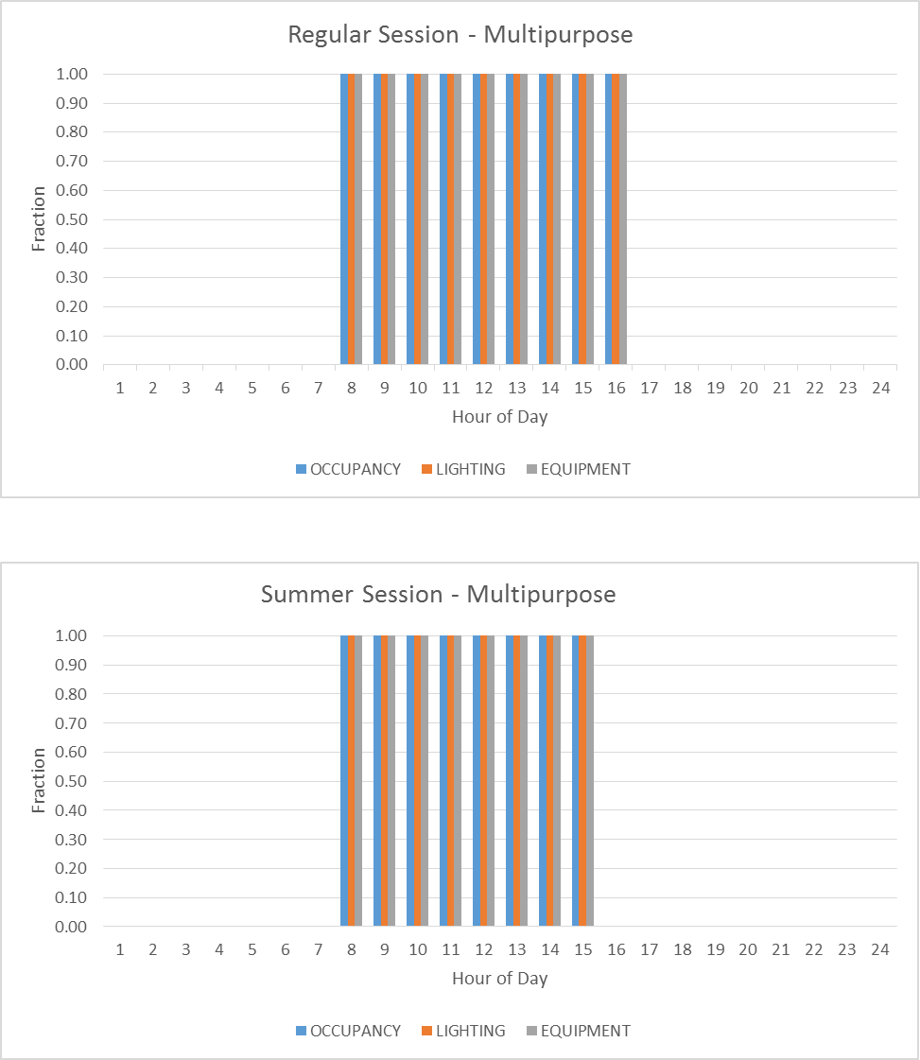

  - All Schedules, Based on PS760

Schedule Name | Effective | 12-1 am | 1-2 am | 2-3 am | 3-4 am | 4-5 am | 5-6 am | 6-7 am | 7-8am | 8-9 am | 9-10 am | 10-11 am | 11-noon | noon-1 pm | 1-2 pm | 2-3 pm | 3-4 pm | 4-5 pm | 5-6pm | 6-7pm | 7-8pm | 8-9pm | 9-10 pm | 10-11 pm | 11-12 mid
ALWAYS-OFF-F-YR | All days | 0 | 0 | 0 | 0 | 0 | 0 | 0 | 0 | 0 | 0 | 0 | 0 | 0 | 0 | 0 | 0 | 0 | 0 | 0 | 0 | 0 | 0 | 0 | 0
ALWAYS-OFF-MCR | All days | 0 | 0 | 0 | 0 | 0 | 0 | 0 | 0 | 0 | 0 | 0 | 0 | 0 | 0 | 0 | 0 | 0 | 0 | 0 | 0 | 0 | 0 | 0 | 0
ALWAYS-ON-FAN | All days | 1 | 1 | 1 | 1 | 1 | 1 | 1 | 1 | 1 | 1 | 1 | 1 | 1 | 1 | 1 | 1 | 1 | 1 | 1 | 1 | 1 | 1 | 1 | 1
ALWAYS-ON-F-YR | All days | 1 | 1 | 1 | 1 | 1 | 1 | 1 | 1 | 1 | 1 | 1 | 1 | 1 | 1 | 1 | 1 | 1 | 1 | 1 | 1 | 1 | 1 | 1 | 1
AUD-AUX-EQP-YR | Regular M-W | 0 | 0 | 0 | 0 | 0 | 0 | 0 | 0 | 0 | 0 | 0 | 0 | 0 | 0 | 0 | 0 | 0 | 0 | 0 | 0 | 0 | 0 | 0 | 0
AUD-AUX-EQP-YR | Regular , Th-Fri | 0 | 0 | 0 | 0 | 0 | 0 | 0 | 0 | 0 | 0 | 0 | 0 | 0 | 0 | 0 | 0 | 0 | 0 | 1 | 1 | 1 | 0 | 0 | 0
AUD-AUX-EQP-YR | Summer | 0 | 0 | 0 | 0 | 0 | 0 | 0 | 0 | 0 | 0 | 0 | 0 | 0 | 0 | 0 | 0 | 0 | 0 | 0 | 0 | 0 | 0 | 0 | 0
AUD-AUX-LT-YR | Regular M-W | 0.05 | 0.05 | 0.05 | 0.05 | 0.05 | 0.05 | 0.05 | 0.05 | 0.05 | 0.05 | 0.05 | 0.05 | 0.05 | 0.05 | 0.05 | 0.05 | 0.05 | 0.05 | 0.05 | 0.05 | 0.05 | 0.05 | 0.05 | 0.05
AUD-AUX-LT-YR | Regular , Th-Fri | 0.05 | 0.05 | 0.05 | 0.05 | 0.05 | 0.05 | 0.05 | 0.05 | 0.05 | 0.05 | 0.05 | 0.05 | 0.05 | 0.05 | 0.05 | 0.05 | 0.05 | 0.05 | 1 | 1 | 1 | 0 | 0 | 0
AUD-AUX-LT-YR | Summer | 0.05 | 0.05 | 0.05 | 0.05 | 0.05 | 0.05 | 0.05 | 0.05 | 0.05 | 0.05 | 0.05 | 0.05 | 0.05 | 0.05 | 0.05 | 0.05 | 0.05 | 0.05 | 0.05 | 0.05 | 0.05 | 0.05 | 0.05 | 0.05
AUD-AUX-OCC-YR | Regular M-W | 0 | 0 | 0 | 0 | 0 | 0 | 0 | 0 | 0 | 0 | 0 | 0 | 0 | 0 | 0 | 0 | 0 | 0 | 0 | 0 | 0 | 0 | 0 | 0
AUD-AUX-OCC-YR | Regular , Th-Fri | 0 | 0 | 0 | 0 | 0 | 0 | 0 | 0 | 0 | 0 | 0 | 0 | 0 | 0 | 0 | 0 | 0 | 0 | 1 | 1 | 1 | 0 | 0 | 0
AUD-AUX-OCC-YR | Summer | 0 | 0 | 0 | 0 | 0 | 0 | 0 | 0 | 0 | 0 | 0 | 0 | 0 | 0 | 0 | 0 | 0 | 0 | 0 | 0 | 0 | 0 | 0 | 0
AUD-CL-YR | Regular , M-W | 85 | 85 | 85 | 85 | 85 | 85 | 85 | 78 | 78 | 78 | 78 | 78 | 78 | 78 | 78 | 85 | 85 | 85 | 85 | 85 | 85 | 85 | 85 | 85
AUD-CL-YR | Regular , Th-Fri | 85 | 85 | 85 | 85 | 85 | 85 | 85 | 78 | 78 | 78 | 78 | 78 | 78 | 78 | 78 | 85 | 85 | 85 | 78 | 78 | 78 | 85 | 85 | 85
AUD-CL-YR | Summer | 85 | 85 | 85 | 85 | 85 | 85 | 85 | 85 | 78 | 78 | 78 | 78 | 78 | 78 | 85 | 85 | 85 | 85 | 85 | 85 | 85 | 85 | 85 | 85
AUD-EQP-YR | Regular | 0 | 0 | 0 | 0 | 0 | 0 | 0 | 0.2 | 0.2 | 0.2 | 0.2 | 0.2 | 0.2 | 0.2 | 0.2 | 0 | 0 | 0 | 0 | 0 | 0 | 0 | 0 | 0
AUD-EQP-YR | Summer | 0 | 0 | 0 | 0 | 0 | 0 | 0 | 0 | 0.2 | 0.2 | 0.2 | 0.2 | 0.2 | 0.2 | 0 | 0 | 0 | 0 | 0 | 0 | 0 | 0 | 0 | 0
AUD-FAN-SCH | Regular M-W | 0 | 0 | 0 | 0 | -999 | -999 | -999 | 1 | 1 | 1 | 1 | 1 | 1 | 1 | 1 | 0 | 0 | 0 | 0 | 0 | 0 | 0 | 0 | 0
AUD-FAN-SCH | Regular , Th-Fri | 0 | 0 | 0 | 0 | -999 | -999 | -999 | 1 | 1 | 1 | 1 | 1 | 1 | 1 | 1 | 0 | 0 | 0 | 1 | 1 | 1 | 0 | 0 | 0
AUD-FAN-SCH | Summer | 0 | 0 | 0 | 0 | -999 | -999 | -999 | -999 | 1 | 1 | 1 | 1 | 1 | 1 | 1 | 0 | 0 | 0 | 0 | 0 | 0 | 0 | 0 | 0
AUD-HT-YR | Heating Season, M-W | 60 | 60 | 60 | 60 | 60 | 60 | 60 | 72 | 72 | 72 | 72 | 72 | 72 | 72 | 72 | 60 | 60 | 60 | 60 | 60 | 60 | 60 | 60 | 60
AUD-HT-YR | Heating Season, T-F | 60 | 60 | 60 | 60 | 60 | 60 | 60 | 72 | 72 | 72 | 72 | 72 | 72 | 72 | 72 | 60 | 60 | 60 | 72 | 72 | 72 | 60 | 60 | 60
AUD-LT-YR | Regular | 0 | 0 | 0 | 0 | 0 | 0 | 0 | 0.25 | 0.25 | 0.25 | 0.25 | 0.25 | 0.25 | 0.25 | 0.25 | 0 | 0 | 0 | 0 | 0 | 0 | 0 | 0 | 0
AUD-LT-YR | Summer | 0 | 0 | 0 | 0 | 0 | 0 | 0 | 0 | 0.25 | 0.25 | 0.25 | 0.25 | 0.25 | 0.25 | 0 | 0 | 0 | 0 | 0 | 0 | 0 | 0 | 0 | 0
AUD-OA-SCH | Regular M-W | 0 | 0 | 0 | 0 | 0 | 0 | 0 | -999 | -999 | -999 | -999 | -999 | -999 | -999 | -999 | 0 | 0 | 0 | 0 | 0 | 0 | 0 | 0 | 0
AUD-OA-SCH | Regular , Th-Fri | 0 | 0 | 0 | 0 | 0 | 0 | 0 | -999 | -999 | -999 | -999 | -999 | -999 | -999 | -999 | 0 | 0 | 0 | -999 | -999 | -999 | 0 | 0 | 0
AUD-OA-SCH | Summer | 0 | 0 | 0 | 0 | 0 | 0 | 0 | -999 | -999 | -999 | -999 | -999 | -999 | -999 | -999 | 0 | 0 | 0 | 0 | 0 | 0 | 0 | 0 | 0
AUD-OCC-YR | Regular | 0 | 0 | 0 | 0 | 0 | 0 | 0 | 0.1 | 0.1 | 0.1 | 0.1 | 0.1 | 0.1 | 0.1 | 0.1 | 0 | 0 | 0 | 0 | 0 | 0 | 0 | 0 | 0
AUD-OCC-YR | Summer | 0 | 0 | 0 | 0 | 0 | 0 | 0 | 0 | 0.1 | 0.1 | 0.1 | 0.1 | 0.1 | 0.1 | 0 | 0 | 0 | 0 | 0 | 0 | 0 | 0 | 0 | 0
AUX-GYM-1-CL-YR | Regular | 85 | 85 | 85 | 85 | 85 | 85 | 85 | 78 | 78 | 78 | 78 | 78 | 78 | 78 | 78 | 78 | 85 | 85 | 85 | 85 | 85 | 85 | 85 | 85
AUX-GYM-1-CL-YR | Summer | 85 | 85 | 85 | 85 | 85 | 85 | 85 | 78 | 78 | 78 | 78 | 78 | 78 | 78 | 78 | 85 | 85 | 85 | 85 | 85 | 85 | 85 | 85 | 85
AUX-GYM-1-HT-YR | Heating Season | 60 | 60 | 60 | 60 | 60 | 60 | 60 | 72 | 72 | 72 | 72 | 72 | 72 | 72 | 72 | 72 | 60 | 60 | 60 | 60 | 60 | 60 | 60 | 60
AUX-GYM-CL-YR | Regular | 85 | 85 | 85 | 85 | 85 | 85 | 85 | 85 | 78 | 78 | 78 | 78 | 78 | 78 | 78 | 78 | 78 | 78 | 85 | 85 | 85 | 85 | 85 | 85
AUX-GYM-CL-YR | Summer | 85 | 85 | 85 | 85 | 85 | 85 | 85 | 85 | 78 | 78 | 78 | 78 | 78 | 78 | 78 | 78 | 78 | 85 | 85 | 85 | 85 | 85 | 85 | 85
AUX-GYM-FAN-SCH | Regular | 0 | 0 | 0 | 0 | -999 | -999 | -999 | -999 | 1 | 1 | 1 | 1 | 1 | 1 | 1 | 1 | 1 | 1 | 0 | 0 | 0 | 0 | 0 | 0
AUX-GYM-FAN-SCH | Summer | 0 | 0 | 0 | 0 | -999 | -999 | -999 | -999 | 1 | 1 | 1 | 1 | 1 | 1 | 1 | 1 | 1 | 0 | 0 | 0 | 0 | 0 | 0 | 0
AUX-GYM-HT-YR | Heating Season | 60 | 60 | 60 | 60 | 60 | 60 | 60 | 60 | 72 | 72 | 72 | 72 | 72 | 72 | 72 | 72 | 72 | 72 | 60 | 60 | 60 | 60 | 60 | 60
AUX-GYM-OA-SCH | Regular | 0 | 0 | 0 | 0 | 0 | 0 | 0 | 0 | -999 | -999 | -999 | -999 | -999 | -999 | -999 | -999 | -999 | -999 | 0 | 0 | 0 | 0 | 0 | 0
AUX-GYM-OA-SCH | Summer | 0 | 0 | 0 | 0 | 0 | 0 | 0 | 0 | -999 | -999 | -999 | -999 | -999 | -999 | -999 | -999 | -999 | 0 | 0 | 0 | 0 | 0 | 0 | 0
CAFE-CL-YR | Regular | 85 | 85 | 85 | 85 | 85 | 85 | 85 | 78 | 78 | 78 | 78 | 78 | 78 | 78 | 78 | 78 | 78 | 85 | 85 | 85 | 85 | 85 | 85 | 85
CAFE-CL-YR | Summer | 85 | 85 | 85 | 85 | 85 | 85 | 85 | 78 | 78 | 78 | 78 | 78 | 78 | 78 | 78 | 78 | 78 | 85 | 85 | 85 | 85 | 85 | 85 | 85
CAFE-EQP-YR | Regular | 0 | 0 | 0 | 0 | 0 | 0 | 0 | 0.5 | 0.2 | 0.2 | 0.2 | 1 | 1 | 1 | 0.2 | 0.2 | 0 | 0 | 0 | 0 | 0 | 0 | 0 | 0
CAFE-EQP-YR | Summer | 0 | 0 | 0 | 0 | 0 | 0 | 0 | 0.2 | 0.2 | 0.2 | 0.2 | 0.75 | 0.75 | 0.75 | 0.2 | 0.2 | 0 | 0 | 0 | 0 | 0 | 0 | 0 | 0
CAFE-FAN-SCH | Regular | 0 | 0 | 0 | 0 | -999 | -999 | -999 | 1 | 1 | 1 | 1 | 1 | 1 | 1 | 1 | 1 | 1 | 0 | 0 | 0 | 0 | 0 | 0 | 0
CAFE-FAN-SCH | Summer | 0 | 0 | 0 | 0 | -999 | -999 | -999 | 1 | 1 | 1 | 1 | 1 | 1 | 1 | 1 | 1 | 1 | 0 | 0 | 0 | 0 | 0 | 0 | 0
CAFE-HT-YR | Heating Season | 60 | 60 | 60 | 60 | 60 | 60 | 60 | 72 | 72 | 72 | 72 | 72 | 72 | 72 | 72 | 72 | 72 | 60 | 60 | 60 | 60 | 60 | 60 | 60
CAFE-LT-YR | Regular | 0.05 | 0.05 | 0.05 | 0.05 | 0.05 | 0.05 | 0.05 | 1 | 0.5 | 0.5 | 0.5 | 1 | 1 | 1 | 0.5 | 0.5 | 0.05 | 0.05 | 0.05 | 0.05 | 0.05 | 0.05 | 0.05 | 0.05
CAFE-LT-YR | Summer | 0.05 | 0.05 | 0.05 | 0.05 | 0.05 | 0.05 | 0.05 | 1 | 0.5 | 0.5 | 0.5 | 1 | 1 | 1 | 0.5 | 0.5 | 0.05 | 0.05 | 0.05 | 0.05 | 0.05 | 0.05 | 0.05 | 0.05
CAFE-OA-SCH | Regular | 0 | 0 | 0 | 0 | 0 | 0 | 0 | -999 | -999 | -999 | -999 | -999 | -999 | -999 | -999 | -999 | -999 | 0 | 0 | 0 | 0 | 0 | 0 | 0
CAFE-OA-SCH | Summer | 0 | 0 | 0 | 0 | 0 | 0 | 0 | -999 | -999 | -999 | -999 | -999 | -999 | -999 | -999 | -999 | -999 | 0 | 0 | 0 | 0 | 0 | 0 | 0
CAFE-OCC-YR | Regular | 0 | 0 | 0 | 0 | 0 | 0 | 0 | 1 | 0.1 | 0.1 | 0.1 | 1 | 1 | 1 | 0.1 | 0.1 | 0 | 0 | 0 | 0 | 0 | 0 | 0 | 0
CAFE-OCC-YR | Summer | 0 | 0 | 0 | 0 | 0 | 0 | 0 | 0.5 | 0.1 | 0.1 | 0.1 | 0.5 | 0.5 | 0.5 | 0.1 | 0.1 | 0 | 0 | 0 | 0 | 0 | 0 | 0 | 0
CL-85-YR | All days | 85 | 85 | 85 | 85 | 85 | 85 | 85 | 85 | 85 | 85 | 85 | 85 | 85 | 85 | 85 | 85 | 85 | 85 | 85 | 85 | 85 | 85 | 85 | 85
CLASS-AUX-LT-YR | Regular | 0 | 0 | 0 | 0 | 0 | 0 | 0 | 0 | 0 | 0 | 0 | 0 | 0.4 | 0.4 | 0.4 | 0.4 | 0 | 0 | 0 | 0 | 0 | 0 | 0 | 0
CLASS-AUX-LT-YR | Summer | 0.05 | 0.05 | 0.05 | 0.05 | 0.05 | 0.05 | 0.05 | 0.05 | 0.05 | 0.05 | 0.05 | 0.05 | 0.05 | 0.05 | 0.05 | 0.05 | 0.05 | 0.05 | 0.05 | 0.05 | 0.05 | 0.05 | 0.05 | 0.05
CLASS-CL-YR | Regular | 85 | 85 | 85 | 85 | 85 | 85 | 85 | 78 | 78 | 78 | 78 | 78 | 78 | 78 | 78 | 78 | 78 | 85 | 85 | 85 | 85 | 85 | 85 | 85
CLASS-CL-YR | Summer | 85 | 85 | 85 | 85 | 85 | 85 | 85 | 78 | 78 | 78 | 78 | 78 | 78 | 78 | 78 | 78 | 78 | 85 | 85 | 85 | 85 | 85 | 85 | 85
CLASS-EQP-YR | Regular | 0.02 | 0.03 | 0.02 | 0.02 | 0.03 | 0.03 | 0.03 | 0.04 | 0.19 | 0.19 | 0.19 | 0.07 | 0.20 | 0.07 | 0.07 | 0.05 | 0.05 | 0.04 | 0.03 | 0.03 | 0.03 | 0.03 | 0.03 | 0.03
CLASS-EQP-YR | Summer | 0.02 | 0.03 | 0.02 | 0.02 | 0.03 | 0.03 | 0.03 | 0.04 | 0.09 | 0.09 | 0.10 | 0.03 | 0.10 | 0.04 | 0.03 | 0.03 | 0.02 | 0.02 | 0.02 | 0.02 | 0.02 | 0.02 | 0.02 | 0.02
CLASS-FAN-SCH | Regular | 0 | 0 | 0 | 0 | -999 | -999 | -999 | 1 | 1 | 1 | 1 | 1 | 1 | 1 | 1 | 1 | 1 | 0 | 0 | 0 | 0 | 0 | 0 | 0
CLASS-FAN-SCH | Summer | 0 | 0 | 0 | 0 | -999 | -999 | -999 | 1 | 1 | 1 | 1 | 1 | 1 | 1 | 1 | 1 | 1 | 0 | 0 | 0 | 0 | 0 | 0 | 0
CLASS-HT-YR | Heating Season | 60 | 60 | 60 | 60 | 60 | 60 | 60 | 72 | 72 | 72 | 72 | 72 | 72 | 72 | 72 | 72 | 72 | 60 | 60 | 60 | 60 | 60 | 60 | 60
CLASS-LT-YR | Regular | 0 | 0 | 0 | 0 | 0 | 0 | 0 | 0.9 | 0.9 | 0.9 | 0.9 | 0.9 | 0.9 | 0.9 | 0.9 | 0.5 | 0.5 | 0 | 0 | 0 | 0 | 0 | 0 | 0
CLASS-LT-YR | Summer | 0 | 0 | 0 | 0 | 0 | 0 | 0 | 0.7 | 0.7 | 0.7 | 0.7 | 0.7 | 0.7 | 0.7 | 0.7 | 0.5 | 0 | 0 | 0 | 0 | 0 | 0 | 0 | 0
CLASS-OA-SCH | Regular | 0 | 0 | 0 | 0 | 0 | 0 | 0 | -999 | -999 | -999 | -999 | -999 | -999 | -999 | -999 | -999 | -999 | 0 | 0 | 0 | 0 | 0 | 0 | 0
CLASS-OA-SCH | Summer | 0 | 0 | 0 | 0 | 0 | 0 | 0 | -999 | -999 | -999 | -999 | -999 | -999 | -999 | -999 | -999 | -999 | 0 | 0 | 0 | 0 | 0 | 0 | 0
CLASS-OCC-YR | Regular | 0 | 0 | 0 | 0 | 0 | 0 | 0 | 0.9 | 0.9 | 0.9 | 0.9 | 0.8 | 0.8 | 0.9 | 0.9 | 0.2 | 0.2 | 0 | 0 | 0 | 0 | 0 | 0 | 0
CLASS-OCC-YR | Summer | 0 | 0 | 0 | 0 | 0 | 0 | 0 | 0.5 | 0.5 | 0.5 | 0.5 | 0.5 | 0.5 | 0.5 | 0.5 | 0.5 | 0 | 0 | 0 | 0 | 0 | 0 | 0 | 0
CL-DATA | All days | 85 | 85 | 85 | 85 | 85 | 85 | 85 | 85 | 85 | 85 | 85 | 85 | 85 | 85 | 85 | 85 | 85 | 85 | 85 | 85 | 85 | 85 | 85 | 85
CL-MECH | All days | 95 | 95 | 95 | 95 | 95 | 95 | 95 | 95 | 95 | 95 | 95 | 95 | 95 | 95 | 95 | 95 | 95 | 95 | 95 | 95 | 95 | 95 | 95 | 95
CL-RESTRM | Cooling Season | 85 | 85 | 85 | 85 | 85 | 85 | 85 | 78 | 78 | 78 | 78 | 78 | 78 | 78 | 78 | 78 | 78 | 85 | 85 | 85 | 85 | 85 | 85 | 85
CL-STOR | All days | 90 | 90 | 90 | 90 | 90 | 90 | 90 | 90 | 90 | 90 | 90 | 90 | 90 | 90 | 90 | 90 | 90 | 90 | 90 | 90 | 90 | 90 | 90 | 90
COPY-EQP-YR | Regular | 0.04 | 0.04 | 0.04 | 0.04 | 0.04 | 0.04 | 0.04 | 0.04 | 0.05 | 0.05 | 0.06 | 0.06 | 0.06 | 0.06 | 0.06 | 0.06 | 0.06 | 0.05 | 0.05 | 0.04 | 0.04 | 0.04 | 0.04 | 0.04
COPY-EQP-YR | Summer | 0.04 | 0.04 | 0.04 | 0.04 | 0.04 | 0.04 | 0.04 | 0.04 | 0.05 | 0.05 | 0.06 | 0.06 | 0.06 | 0.06 | 0.06 | 0.06 | 0.03 | 0.03 | 0.03 | 0.03 | 0.03 | 0.03 | 0.03 | 0.03
CORR-CL-YR | Regular | 85 | 85 | 85 | 85 | 85 | 85 | 85 | 78 | 78 | 78 | 78 | 78 | 78 | 78 | 78 | 78 | 78 | 85 | 85 | 85 | 85 | 85 | 85 | 85
CORR-CL-YR | Summer | 85 | 85 | 85 | 85 | 85 | 85 | 85 | 78 | 78 | 78 | 78 | 78 | 78 | 78 | 78 | 78 | 78 | 85 | 85 | 85 | 85 | 85 | 85 | 85
CORR-HT-YR | Heating Season | 60 | 60 | 60 | 60 | 60 | 60 | 60 | 72 | 72 | 72 | 72 | 72 | 72 | 72 | 72 | 72 | 72 | 60 | 60 | 60 | 60 | 60 | 60 | 60
CORR-LT-YR | Regular | 0.05 | 0.05 | 0.05 | 0.05 | 0.05 | 0.05 | 0.05 | 1 | 1 | 1 | 1 | 1 | 1 | 1 | 1 | 1 | 1 | 0.05 | 0.05 | 0.05 | 0.05 | 0.05 | 0.05 | 0.05
CORR-LT-YR | Summer | 0.05 | 0.05 | 0.05 | 0.05 | 0.05 | 0.05 | 0.05 | 1 | 1 | 1 | 1 | 1 | 1 | 1 | 1 | 1 | 0.05 | 0.05 | 0.05 | 0.05 | 0.05 | 0.05 | 0.05 | 0.05
DATA-EQP-YR | Regular | 0.15 | 0.15 | 0.15 | 0.15 | 0.15 | 0.15 | 0.15 | 0.9 | 0.9 | 0.9 | 0.9 | 0.9 | 0.9 | 0.9 | 0.9 | 0.9 | 0.9 | 0.15 | 0.15 | 0.15 | 0.15 | 0.15 | 0.15 | 0.15
DATA-EQP-YR | Summer | 0.15 | 0.15 | 0.15 | 0.15 | 0.15 | 0.15 | 0.15 | 0.75 | 0.75 | 0.75 | 0.75 | 0.75 | 0.75 | 0.75 | 0.75 | 0.75 | 0.15 | 0.15 | 0.15 | 0.15 | 0.15 | 0.15 | 0.15 | 0.15
DATA-FAN-SCH | All days | 0 | 0 | 0 | 0 | 0 | 0 | 0 | 0 | 0 | 0 | 0 | 0 | 1 | 0 | 0 | 0 | 0 | 0 | 0 | 0 | 0 | 0 | 0 | 0
GYM-AUX-EQP-YR | Regular , W | 0 | 0 | 0 | 0 | 0 | 0 | 0 | 0 | 0 | 0 | 0 | 0 | 0 | 0 | 1 | 0 | 0 | 0 | 0 | 0 | 0 | 0 | 0 | 0
GYM-AUX-EQP-YR | Regular , Other | 0 | 0 | 0 | 0 | 0 | 0 | 0 | 0 | 0 | 0 | 0 | 0 | 0 | 0 | 0 | 0 | 0 | 0 | 0 | 0 | 0 | 0 | 0 | 0
GYM-AUX-EQP-YR | Summer | 0 | 0 | 0 | 0 | 0 | 0 | 0 | 0 | 0 | 0 | 0 | 0 | 0 | 0 | 0 | 0 | 0 | 0 | 0 | 0 | 0 | 0 | 0 | 0
GYM-AUX-LT-YR | Regular , W | 0 | 0 | 0 | 0 | 0 | 0 | 0 | 0 | 0 | 0 | 0 | 0 | 0 | 0 | 1 | 0 | 0 | 0 | 0 | 0 | 0 | 0 | 0 | 0
GYM-AUX-LT-YR | Regular , Other | 0.05 | 0.05 | 0.05 | 0.05 | 0.05 | 0.05 | 0.05 | 0.05 | 0.05 | 0.05 | 0.05 | 0.05 | 0.05 | 0.05 | 0.05 | 0.05 | 0.05 | 0.05 | 0.05 | 0.05 | 0.05 | 0.05 | 0.05 | 0.05
GYM-AUX-LT-YR | Summer | 0.05 | 0.05 | 0.05 | 0.05 | 0.05 | 0.05 | 0.05 | 0.05 | 0.05 | 0.05 | 0.05 | 0.05 | 0.05 | 0.05 | 0.05 | 0.05 | 0.05 | 0.05 | 0.05 | 0.05 | 0.05 | 0.05 | 0.05 | 0.05
GYM-AUX-OCC-YR | Regular , W | 0 | 0 | 0 | 0 | 0 | 0 | 0 | 0 | 0 | 0 | 0 | 0 | 0 | 0 | 1 | 0 | 0 | 0 | 0 | 0 | 0 | 0 | 0 | 0
GYM-AUX-OCC-YR | Regular , Other | 0 | 0 | 0 | 0 | 0 | 0 | 0 | 0 | 0 | 0 | 0 | 0 | 0 | 0 | 0 | 0 | 0 | 0 | 0 | 0 | 0 | 0 | 0 | 0
GYM-CL-YR | Regular | 85 | 85 | 85 | 85 | 85 | 85 | 85 | 85 | 78 | 78 | 78 | 78 | 78 | 78 | 78 | 78 | 78 | 85 | 85 | 85 | 85 | 85 | 85 | 85
GYM-CL-YR | Summer | 85 | 85 | 85 | 85 | 85 | 85 | 85 | 85 | 78 | 78 | 78 | 78 | 78 | 78 | 78 | 78 | 85 | 85 | 85 | 85 | 85 | 85 | 85 | 85
GYM-EQP-YR | Regular | 0 | 0 | 0 | 0 | 0 | 0 | 0 | 0 | 0.2 | 0.2 | 0.2 | 0.2 | 0.2 | 0.2 | 0.2 | 0.2 | 0.2 | 0 | 0 | 0 | 0 | 0 | 0 | 0
GYM-EQP-YR | Summer | 0 | 0 | 0 | 0 | 0 | 0 | 0 | 0 | 0.2 | 0.2 | 0.2 | 0.2 | 0.2 | 0.2 | 0.2 | 0.2 | 0 | 0 | 0 | 0 | 0 | 0 | 0 | 0
GYM-FAN-SCH | Regular | 0 | 0 | 0 | 0 | -999 | -999 | -999 | -999 | 1 | 1 | 1 | 1 | 1 | 1 | 1 | 1 | 1 | 1 | 0 | 0 | 0 | 0 | 0 | 0
GYM-FAN-SCH | Summer | 0 | 0 | 0 | 0 | -999 | -999 | -999 | -999 | 1 | 1 | 1 | 1 | 1 | 1 | 1 | 1 | 0 | 0 | 0 | 0 | 0 | 0 | 0 | 0
GYM-HT-YR | Heating Season | 60 | 60 | 60 | 60 | 60 | 60 | 60 | 60 | 72 | 72 | 72 | 72 | 72 | 72 | 72 | 72 | 72 | 60 | 60 | 60 | 60 | 60 | 60 | 60
GYM-LT-YR | Regular | 0 | 0 | 0 | 0 | 0 | 0 | 0 | 0 | 1 | 1 | 1 | 1 | 1 | 1 | 1 | 1 | 1 | 0 | 0 | 0 | 0 | 0 | 0 | 0
GYM-LT-YR | Summer | 0 | 0 | 0 | 0 | 0 | 0 | 0 | 0 | 1 | 1 | 1 | 1 | 1 | 1 | 1 | 1 | 0 | 0 | 0 | 0 | 0 | 0 | 0 | 0
GYM-OA-SCH | Regular | 0 | 0 | 0 | 0 | 0 | 0 | 0 | 0 | -999 | -999 | -999 | -999 | -999 | -999 | -999 | -999 | -999 | 0 | 0 | 0 | 0 | 0 | 0 | 0
GYM-OA-SCH | Summer | 0 | 0 | 0 | 0 | 0 | 0 | 0 | 0 | -999 | -999 | -999 | -999 | -999 | -999 | -999 | -999 | 0 | 0 | 0 | 0 | 0 | 0 | 0 | 0
GYM-OCC-YR | Regular | 0 | 0 | 0 | 0 | 0 | 0 | 0 | 0 | 0.46 | 0.46 | 0.46 | 0.46 | 0.46 | 0.46 | 0.46 | 0.2 | 0.2 | 0 | 0 | 0 | 0 | 0 | 0 | 0
GYM-OCC-YR | Summer | 0 | 0 | 0 | 0 | 0 | 0 | 0 | 0 | 0.2 | 0.2 | 0.2 | 0.2 | 0.2 | 0.2 | 0.2 | 0.2 | 0 | 0 | 0 | 0 | 0 | 0 | 0 | 0
HT-60-YR | All days | 60 | 60 | 60 | 60 | 60 | 60 | 60 | 60 | 60 | 60 | 60 | 60 | 60 | 60 | 60 | 60 | 60 | 60 | 60 | 60 | 60 | 60 | 60 | 60
HT-DATA | All days | 60 | 60 | 60 | 60 | 60 | 60 | 60 | 60 | 60 | 60 | 60 | 60 | 60 | 60 | 60 | 60 | 60 | 60 | 60 | 60 | 60 | 60 | 60 | 60
HT-RESTRM | Heating Season | 60 | 60 | 60 | 60 | 60 | 60 | 60 | 72 | 72 | 72 | 72 | 72 | 72 | 72 | 72 | 72 | 72 | 60 | 60 | 60 | 60 | 60 | 60 | 60
KITCHEN-CL-YR | Regular | 85 | 85 | 85 | 85 | 85 | 85 | 85 | 78 | 78 | 78 | 78 | 78 | 78 | 78 | 85 | 85 | 85 | 85 | 85 | 85 | 85 | 85 | 85 | 85
KITCHEN-CL-YR | Summer | 85 | 85 | 85 | 85 | 85 | 85 | 85 | 78 | 78 | 78 | 78 | 78 | 78 | 78 | 85 | 85 | 85 | 85 | 85 | 85 | 85 | 85 | 85 | 85
KITCHEN-EQP-YR | Regular | 0.14 | 0.14 | 0.14 | 0.15 | 0.14 | 0.14 | 0.14 | 0.17 | 0.18 | 0.31 | 0.31 | 0.21 | 0.21 | 0.20 | 0.18 | 0.15 | 0.14 | 0.14 | 0.14 | 0.14 | 0.14 | 0.14 | 0.14 | 0.14
KITCHEN-EQP-YR | Summer | 0.14 | 0.14 | 0.14 | 0.15 | 0.14 | 0.14 | 0.14 | 0.17 | 0.18 | 0.31 | 0.31 | 0.21 | 0.21 | 0.20 | 0.18 | 0.15 | 0.14 | 0.14 | 0.14 | 0.14 | 0.14 | 0.14 | 0.14 | 0.14
KITCHEN-HT-YR | Heating Season | 60 | 60 | 60 | 60 | 60 | 60 | 60 | 65 | 65 | 65 | 65 | 65 | 65 | 65 | 60 | 60 | 60 | 60 | 60 | 60 | 60 | 60 | 60 | 60
KITCHEN-INF | Regular | 1.5 | 1.5 | 1.5 | 1.5 | 1.5 | 1.5 | 1.5 | 1 | 1 | 1 | 1 | 1 | 1 | 1 | 1.5 | 1.5 | 1.5 | 1.5 | 1.5 | 1.5 | 1.5 | 1.5 | 1.5 | 1.5
KITCHEN-INF | Summer | 1.5 | 1.5 | 1.5 | 1.5 | 1.5 | 1.5 | 1.5 | 1 | 1 | 1 | 1 | 1 | 1 | 1 | 1.5 | 1.5 | 1.5 | 1.5 | 1.5 | 1.5 | 1.5 | 1.5 | 1.5 | 1.5
KITCHEN-LT-YR | Regular | 0.05 | 0.05 | 0.05 | 0.05 | 0.05 | 0.05 | 0.05 | 1 | 1 | 1 | 1 | 1 | 1 | 1 | 0.05 | 0.05 | 0.05 | 0.05 | 0.05 | 0.05 | 0.05 | 0.05 | 0.05 | 0.05
KITCHEN-LT-YR | Summer | 0.05 | 0.05 | 0.05 | 0.05 | 0.05 | 0.05 | 0.05 | 1 | 1 | 1 | 1 | 1 | 1 | 1 | 0.05 | 0.05 | 0.05 | 0.05 | 0.05 | 0.05 | 0.05 | 0.05 | 0.05 | 0.05
KITCHEN-OCC-YR | Regular | 0 | 0 | 0 | 0 | 0 | 0 | 0 | 1 | 1 | 1 | 1 | 1 | 1 | 1 | 0 | 0 | 0 | 0 | 0 | 0 | 0 | 0 | 0 | 0
KITCHEN-OCC-YR | Summer | 0 | 0 | 0 | 0 | 0 | 0 | 0 | 1 | 1 | 1 | 1 | 1 | 1 | 1 | 0 | 0 | 0 | 0 | 0 | 0 | 0 | 0 | 0 | 0
KIT-SOURCE-YR | Regular | 0 | 0 | 0 | 0 | 0 | 0 | 0 | 0.27 | 0.27 | 0.29 | 0.29 | 0.27 | 0.27 | 0 | 0 | 0 | 0 | 0 | 0 | 0 | 0 | 0 | 0 | 0
KIT-SOURCE-YR | Summer | 0 | 0 | 0 | 0 | 0 | 0 | 0 | 0.27 | 0.27 | 0.29 | 0.29 | 0.27 | 0.27 | 0 | 0 | 0 | 0 | 0 | 0 | 0 | 0 | 0 | 0 | 0
LIB-EQP-YR | Regular | 0.05 | 0.05 | 0.05 | 0.05 | 0.05 | 0.05 | 0.05 | 1.00 | 1.00 | 1.00 | 1.00 | 1.00 | 1.00 | 1.00 | 1.00 | 1.00 | 1.00 | 0.05 | 0.05 | 0.05 | 0.05 | 0.05 | 0.05 | 0.05
LIB-EQP-YR | Summer | 0.05 | 0.05 | 0.05 | 0.05 | 0.05 | 0.05 | 0.05 | 1.00 | 1.00 | 1.00 | 1.00 | 1.00 | 1.00 | 1.00 | 1.00 | 1.00 | 0.05 | 0.05 | 0.05 | 0.05 | 0.05 | 0.05 | 0.05 | 0.05
LOBBY-EQP-YR | Regular | 0.01 | 0.01 | 0.01 | 0.01 | 0.01 | 0.02 | 0.02 | 0.42 | 0.45 | 0.46 | 0.51 | 0.75 | 0.79 | 0.59 | 0.59 | 0.59 | 0.59 | 0.38 | 0.02 | 0.01 | 0.01 | 0.01 | 0.01 | 0.01
LOBBY-EQP-YR | Summer | 0.01 | 0.01 | 0.01 | 0.01 | 0.01 | 0.02 | 0.02 | 0.42 | 0.45 | 0.46 | 0.51 | 0.75 | 0.79 | 0.59 | 0.59 | 0.59 | 0.30 | 0.19 | 0.02 | 0.01 | 0.01 | 0.01 | 0.01 | 0.01
LOUNGE-EQP-YR | Regular | 0.02 | 0.02 | 0.02 | 0.02 | 0.02 | 0.02 | 0.02 | 0.10 | 0.13 | 0.13 | 0.13 | 0.42 | 0.43 | 0.13 | 0.13 | 0.05 | 0.04 | 0.02 | 0.02 | 0.02 | 0.02 | 0.02 | 0.02 | 0.02
LOUNGE-EQP-YR | Summer | 0.02 | 0.02 | 0.02 | 0.02 | 0.02 | 0.02 | 0.02 | 0.10 | 0.13 | 0.13 | 0.13 | 0.42 | 0.43 | 0.13 | 0.05 | 0.05 | 0.01 | 0.01 | 0.01 | 0.01 | 0.01 | 0.01 | 0.01 | 0.01
MECH-LT-YR | Regular | 0.05 | 0.05 | 0.05 | 0.05 | 0.05 | 0.05 | 0.05 | 0.05 | 0.05 | 1 | 0.05 | 0.05 | 0.05 | 0.05 | 0.05 | 0.05 | 0.05 | 0.05 | 0.05 | 0.05 | 0.05 | 0.05 | 0.05 | 0.05
MECH-LT-YR | Summer | 0.05 | 0.05 | 0.05 | 0.05 | 0.05 | 0.05 | 0.05 | 0.05 | 0.05 | 1 | 0.05 | 0.05 | 0.05 | 0.05 | 0.05 | 0.05 | 0.05 | 0.05 | 0.05 | 0.05 | 0.05 | 0.05 | 0.05 | 0.05
MP-CL-YR | Regular | 85 | 85 | 85 | 85 | 85 | 85 | 85 | 85 | 78 | 78 | 78 | 78 | 78 | 78 | 78 | 78 | 78 | 85 | 85 | 85 | 85 | 85 | 85 | 85
MP-CL-YR | Summer | 85 | 85 | 85 | 85 | 85 | 85 | 85 | 85 | 78 | 78 | 78 | 78 | 78 | 78 | 78 | 78 | 85 | 85 | 85 | 85 | 85 | 85 | 85 | 85
MP-EQP-YR | Regular | 0 | 0 | 0 | 0 | 0 | 0 | 0 | 1 | 1 | 1 | 1 | 1 | 1 | 1 | 1 | 1 | 0 | 0 | 0 | 0 | 0 | 0 | 0 | 0
MP-EQP-YR | Summer | 0 | 0 | 0 | 0 | 0 | 0 | 0 | 1 | 1 | 1 | 1 | 1 | 1 | 1 | 1 | 0 | 0 | 0 | 0 | 0 | 0 | 0 | 0 | 0
MP-HT-YR | Heating Season | 60 | 60 | 60 | 60 | 60 | 60 | 60 | 72 | 72 | 72 | 72 | 72 | 72 | 72 | 72 | 72 | 60 | 60 | 60 | 60 | 60 | 60 | 60 | 60
MP-LT-YR | Regular | 0 | 0 | 0 | 0 | 0 | 0 | 0 | 1 | 1 | 1 | 1 | 1 | 1 | 1 | 1 | 1 | 0 | 0 | 0 | 0 | 0 | 0 | 0 | 0
MP-LT-YR | Summer | 0 | 0 | 0 | 0 | 0 | 0 | 0 | 1 | 1 | 1 | 1 | 1 | 1 | 1 | 1 | 0 | 0 | 0 | 0 | 0 | 0 | 0 | 0 | 0
MP-OCC-YR | Regular | 0 | 0 | 0 | 0 | 0 | 0 | 0 | 1 | 1 | 1 | 1 | 1 | 1 | 1 | 1 | 1 | 0 | 0 | 0 | 0 | 0 | 0 | 0 | 0
MP-OCC-YR | Summer | 0 | 0 | 0 | 0 | 0 | 0 | 0 | 1 | 1 | 1 | 1 | 1 | 1 | 1 | 1 | 0 | 0 | 0 | 0 | 0 | 0 | 0 | 0 | 0
MUSIC-EQP-YR | Regular | 0.02 | 0.03 | 0.02 | 0.02 | 0.03 | 0.03 | 0.03 | 0.04 | 0.19 | 0.19 | 0.19 | 0.07 | 0.20 | 0.07 | 0.07 | 0.05 | 0.05 | 0.04 | 0.03 | 0.03 | 0.03 | 0.03 | 0.03 | 0.03
MUSIC-EQP-YR | Summer | 0.02 | 0.03 | 0.02 | 0.02 | 0.03 | 0.03 | 0.03 | 0.04 | 0.09 | 0.09 | 0.10 | 0.03 | 0.10 | 0.04 | 0.03 | 0.03 | 0.02 | 0.02 | 0.02 | 0.02 | 0.02 | 0.02 | 0.02 | 0.02
NO-OA-SCH | All days | 0 | 0 | 0 | 0 | 0 | 0 | 0 | 0 | 0 | 0 | 0 | 0 | 0 | 0 | 0 | 0 | 0 | 0 | 0 | 0 | 0 | 0 | 0 | 0
NULL-OCC-YR | All days | 0 | 0 | 0 | 0 | 0 | 0 | 0 | 0 | 0 | 0 | 0 | 0 | 0 | 0 | 0 | 0 | 0 | 0 | 0 | 0 | 0 | 0 | 0 | 0
OFFICE-CL-YR | Regular | 85 | 85 | 85 | 85 | 85 | 85 | 85 | 75 | 75 | 75 | 75 | 75 | 75 | 75 | 75 | 75 | 75 | 85 | 85 | 85 | 85 | 85 | 85 | 85
OFFICE-CL-YR | Summer | 85 | 85 | 85 | 85 | 85 | 85 | 85 | 75 | 75 | 75 | 75 | 75 | 75 | 75 | 75 | 75 | 75 | 85 | 85 | 85 | 85 | 85 | 85 | 85
OFFICE-EQP-YR | Regular | 0.07 | 0.08 | 0.07 | 0.07 | 0.08 | 0.08 | 0.08 | 0.18 | 0.21 | 0.21 | 0.22 | 0.22 | 0.23 | 0.23 | 0.23 | 0.23 | 0.14 | 0.11 | 0.10 | 0.09 | 0.09 | 0.08 | 0.08 | 0.08
OFFICE-EQP-YR | Summer | 0.07 | 0.08 | 0.07 | 0.07 | 0.08 | 0.08 | 0.08 | 0.18 | 0.21 | 0.21 | 0.22 | 0.22 | 0.23 | 0.23 | 0.14 | 0.14 | 0.06 | 0.06 | 0.06 | 0.06 | 0.06 | 0.06 | 0.06 | 0.06
OFFICE-FAN-SCH | Regular | 0 | 0 | 0 | 0 | -999 | -999 | -999 | 1 | 1 | 1 | 1 | 1 | 1 | 1 | 1 | 1 | 1 | 0 | 0 | 0 | 0 | 0 | 0 | 0
OFFICE-FAN-SCH | Summer | 0 | 0 | 0 | 0 | -999 | -999 | -999 | 1 | 1 | 1 | 1 | 1 | 1 | 1 | 1 | 1 | 1 | 0 | 0 | 0 | 0 | 0 | 0 | 0
OFFICE-HT-YR | Heating Season | 60 | 60 | 60 | 60 | 60 | 60 | 60 | 72 | 72 | 72 | 72 | 72 | 72 | 72 | 72 | 72 | 72 | 60 | 60 | 60 | 60 | 60 | 60 | 60
OFFICE-LT-YR | Regular | 0 | 0 | 0 | 0 | 0 | 0 | 0 | 1 | 1 | 1 | 1 | 1 | 1 | 1 | 1 | 1 | 1 | 0 | 0 | 0 | 0 | 0 | 0 | 0
OFFICE-LT-YR | Summer | 0 | 0 | 0 | 0 | 0 | 0 | 0 | 0.9 | 0.9 | 0.9 | 0.9 | 0.9 | 0.9 | 0.9 | 0.9 | 0.9 | 0 | 0 | 0 | 0 | 0 | 0 | 0 | 0
OFFICE-OA-SCH | Regular | 0 | 0 | 0 | 0 | 0 | 0 | 0 | -999 | -999 | -999 | -999 | -999 | -999 | -999 | -999 | -999 | -999 | 0 | 0 | 0 | 0 | 0 | 0 | 0
OFFICE-OA-SCH | Summer | 0 | 0 | 0 | 0 | 0 | 0 | 0 | -999 | -999 | -999 | -999 | -999 | -999 | -999 | -999 | -999 | -999 | 0 | 0 | 0 | 0 | 0 | 0 | 0
OFFICE-OCC-YR | Regular | 0 | 0 | 0 | 0 | 0 | 0 | 0 | 0.9 | 0.9 | 0.9 | 0.9 | 0.9 | 0.5 | 0.8 | 0.8 | 0.8 | 0.8 | 0 | 0 | 0 | 0 | 0 | 0 | 0
OFFICE-OCC-YR | Summer | 0 | 0 | 0 | 0 | 0 | 0 | 0 | 0.5 | 0.5 | 0.5 | 0.5 | 0.5 | 0.5 | 0.5 | 0.5 | 0.5 | 0 | 0 | 0 | 0 | 0 | 0 | 0 | 0
RESTROOM-LT-YR | Regular | 0.05 | 0.05 | 0.05 | 0.05 | 0.05 | 0.05 | 0.05 | 1 | 1 | 1 | 1 | 1 | 1 | 1 | 1 | 1 | 1 | 0.05 | 0.05 | 0.05 | 0.05 | 0.05 | 0.05 | 0.05
RESTROOM-LT-YR | Summer | 0.05 | 0.05 | 0.05 | 0.05 | 0.05 | 0.05 | 0.05 | 1 | 1 | 1 | 1 | 1 | 1 | 1 | 1 | 1 | 0.05 | 0.05 | 0.05 | 0.05 | 0.05 | 0.05 | 0.05 | 0.05
SCHOOL-INF | Regular | 1.5 | 1.5 | 1.5 | 1.5 | 1.5 | 1.5 | 1.5 | 1 | 1 | 1 | 1 | 1 | 1 | 1 | 1 | 1 | 1 | 1.5 | 1.5 | 1.5 | 1.5 | 1.5 | 1.5 | 1.5
SCHOOL-INF | Summer | 1.5 | 1.5 | 1.5 | 1.5 | 1.5 | 1.5 | 1.5 | 1 | 1 | 1 | 1 | 1 | 1 | 1 | 1 | 1 | 1 | 1.5 | 1.5 | 1.5 | 1.5 | 1.5 | 1.5 | 1.5
SCI-AUX-EQP-YR | Regular | 0 | 0 | 0 | 0 | 0 | 0 | 0 | 0 | 1 | 1 | 1 | 1 | 1 | 1 | 0 | 0 | 0 | 0 | 0 | 0 | 0 | 0 | 0 | 0
SCI-AUX-EQP-YR | Summer | 0 | 0 | 0 | 0 | 0 | 0 | 0 | 0 | 1 | 1 | 1 | 1 | 0 | 0 | 0 | 0 | 0 | 0 | 0 | 0 | 0 | 0 | 0 | 0
SCI-EQP-YR | Regular | 0.21 | 0.21 | 0.21 | 0.21 | 0.21 | 0.21 | 0.21 | 0.21 | 0.31 | 0.31 | 0.31 | 0.23 | 0.31 | 0.23 | 0.23 | 0.22 | 0.22 | 0.22 | 0.21 | 0.21 | 0.21 | 0.21 | 0.21 | 0.21
SCI-EQP-YR | Summer | 0.04 | 0.04 | 0.04 | 0.04 | 0.04 | 0.05 | 0.05 | 0.05 | 0.09 | 0.09 | 0.09 | 0.05 | 0.09 | 0.05 | 0.05 | 0.04 | 0.04 | 0.04 | 0.04 | 0.04 | 0.04 | 0.04 | 0.04 | 0.04
SCI-LT-YR | Regular | 0.05 | 0.05 | 0.05 | 0.05 | 0.05 | 0.05 | 0.05 | 1 | 1 | 1 | 1 | 1 | 1 | 1 | 1 | 0.05 | 0.05 | 0.05 | 0.05 | 0.05 | 0.05 | 0.05 | 0.05 | 0.05
SCI-LT-YR | Summer | 0.05 | 0.05 | 0.05 | 0.05 | 0.05 | 0.05 | 0.05 | 1 | 1 | 1 | 1 | 1 | 1 | 1 | 1 | 0.05 | 0.05 | 0.05 | 0.05 | 0.05 | 0.05 | 0.05 | 0.05 | 0.05
SCI-OCC-YR | Regular | 0 | 0 | 0 | 0 | 0 | 0 | 0 | 0.9 | 0.9 | 0.9 | 0.9 | 0.9 | 0.9 | 0.9 | 0.9 | 0 | 0 | 0 | 0 | 0 | 0 | 0 | 0 | 0
SCI-OCC-YR | Summer | 0 | 0 | 0 | 0 | 0 | 0 | 0 | 0.5 | 0.5 | 0.5 | 0.5 | 0.5 | 0.5 | 0.5 | 0.5 | 0 | 0 | 0 | 0 | 0 | 0 | 0 | 0 | 0
SHOP-EQP-YR | Regular | 0.00 | 0.00 | 0.00 | 0.00 | 0.00 | 0.00 | 0.00 | 0.00 | 1.00 | 1.00 | 1.00 | 1.00 | 1.00 | 1.00 | 1.00 | 1.00 | 0.00 | 0.00 | 0.00 | 0.00 | 0.00 | 0.00 | 0.00 | 0.00
SHOP-EQP-YR | Summer | 0.00 | 0.00 | 0.00 | 0.00 | 0.00 | 0.00 | 0.00 | 0.00 | 0.00 | 0.00 | 0.00 | 0.00 | 0.00 | 0.00 | 0.00 | 0.00 | 0.00 | 0.00 | 0.00 | 0.00 | 0.00 | 0.00 | 0.00 | 0.00
STORAGE-LT-YR | Regular | 0.05 | 0.05 | 0.05 | 0.05 | 0.05 | 0.05 | 0.05 | 0.5 | 0.5 | 0.5 | 0.5 | 0.5 | 0.5 | 0.5 | 0.5 | 0.05 | 0.05 | 0.05 | 0.05 | 0.05 | 0.05 | 0.05 | 0.05 | 0.05
STORAGE-LT-YR | Summer | 0.05 | 0.05 | 0.05 | 0.05 | 0.05 | 0.05 | 0.05 | 0.5 | 0.5 | 0.5 | 0.5 | 0.5 | 0.5 | 0.5 | 0.5 | 0.5 | 0.05 | 0.05 | 0.05 | 0.05 | 0.05 | 0.05 | 0.05 | 0.05
STORAGE-EQP-YR | All days | 0.02 | 0.02 | 0.02 | 0.02 | 0.02 | 0.02 | 0.02 | 0.02 | 0.02 | 0.02 | 0.02 | 0.02 | 0.02 | 0.02 | 0.02 | 0.02 | 0.02 | 0.02 | 0.02 | 0.02 | 0.02 | 0.02 | 0.02 | 0.02
TECH-EQP-YR | Regular | 0.1 | 0.1 | 0.1 | 0.1 | 0.1 | 0.1 | 0.1 | 1 | 1 | 1 | 1 | 1 | 1 | 1 | 1 | 0.1 | 0.1 | 0.1 | 0.1 | 0.1 | 0.1 | 0.1 | 0.1 | 0.1
TECH-EQP-YR | Summer | 0.1 | 0.1 | 0.1 | 0.1 | 0.1 | 0.1 | 0.1 | 1 | 1 | 1 | 1 | 1 | 1 | 1 | 1 | 0.1 | 0.1 | 0.1 | 0.1 | 0.1 | 0.1 | 0.1 | 0.1 | 0.1
TECH-LT-YR | Regular | 0 | 0 | 0 | 0 | 0 | 0 | 0 | 1 | 1 | 1 | 1 | 1 | 1 | 1 | 1 | 0 | 0 | 0 | 0 | 0 | 0 | 0 | 0 | 0
TECH-LT-YR | Summer | 0 | 0 | 0 | 0 | 0 | 0 | 0 | 1 | 1 | 1 | 1 | 1 | 1 | 1 | 1 | 0 | 0 | 0 | 0 | 0 | 0 | 0 | 0 | 0
TECH-OCC-YR | Regular | 0 | 0 | 0 | 0 | 0 | 0 | 0 | 0.9 | 0.9 | 0.9 | 0.9 | 0.9 | 0.9 | 0.9 | 0.9 | 0 | 0 | 0 | 0 | 0 | 0 | 0 | 0 | 0
TECH-OCC-YR | Summer | 0 | 0 | 0 | 0 | 0 | 0 | 0 | 0.5 | 0.5 | 0.5 | 0.5 | 0.5 | 0.5 | 0.5 | 0.5 | 0 | 0 | 0 | 0 | 0 | 0 | 0 | 0 | 0

Visible transmittance is not regulated under ASHRAE 90.1-2010. ASHRAE 90.1-2013 and the 2015 International Energy Conservation Code, Section C402.4.1.1 specifies that the visible transmittance must be at least 1.1x the SHGC.
Skylights are currently not addressed in DR or model template. Values minimally compliant with ASHRAE 90.1-2013 are used for the design. Skylight w/o curb is assumed for the baselines.

