New Login Procedures
- Migrating User
To get new login credentials, follow below steps
  - Provide current login id and click Login button
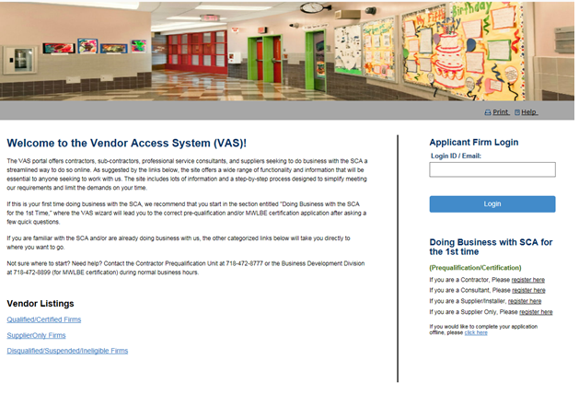
In the next screen
    - Provide current login id
    - Type in current password and a valid email (working email)
    - Please note that if the email already exists in the system, user needs to provide a new email. Same email cannot be used for multiple accounts
    - Click on Submit button

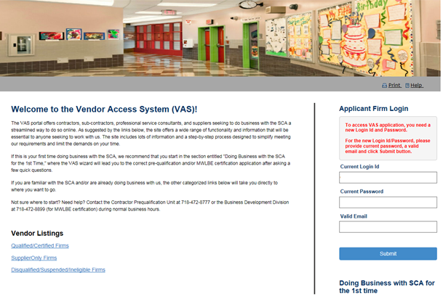

  - System will automatically migrate the user to new credentials with email as new username and a system generated password
  - The new password will be emailed to the user's email
  - User will see below screen upon successful migration

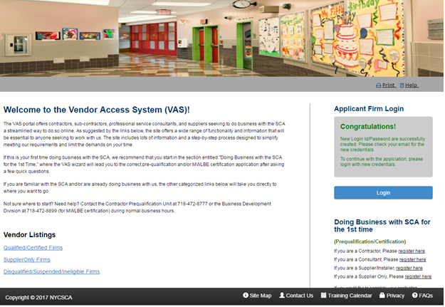

  - Click on the login button to access VAS application
  - Login the application using the new credentials from the email
  - User needs to reset the password on First Time login
  - Fill-in below fields to reset password

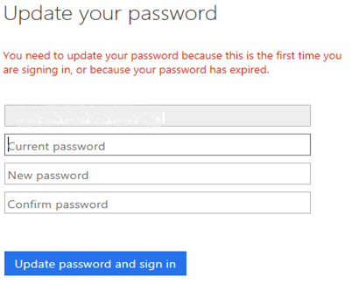
  - User will be automatically logged into the system

- Login after successful migration
  - Enter new login id I.e. email
  - Click on Log in button
  - System will redirect to actual login screen
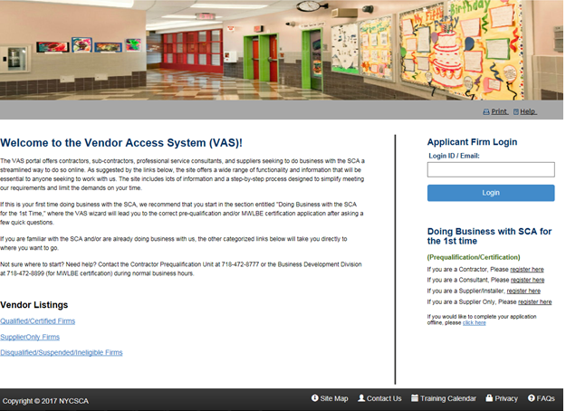

  - Provide Email and click Login button
  - In the following screen, provide username and password
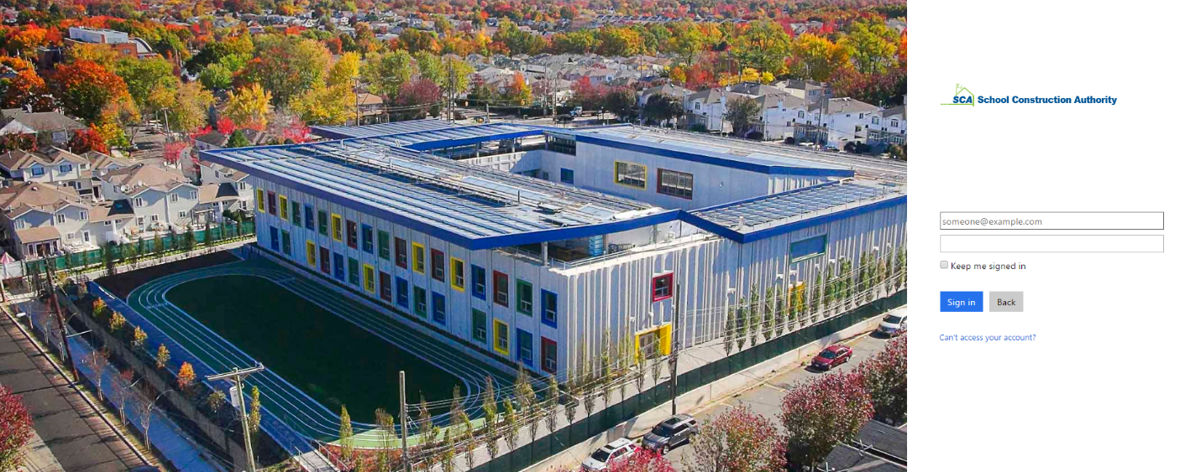
  - Click on Sign in button
  - If the email is not present then system will give email not found message.

- Password Reset – This to reset the password in case user wants to change the password
  - Once user logged into the system, user can reset the password through Reset Password link
  - User needs to provide Verification Code to reset the password
  - Click Send button to send Verification code. The code will be mailed to the user's email
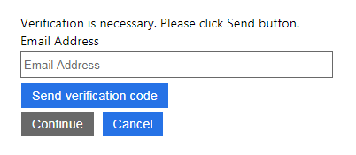

  - Update the verification code from the email sent to user's mail.
  - The mail will be generated from Microsoft something like below

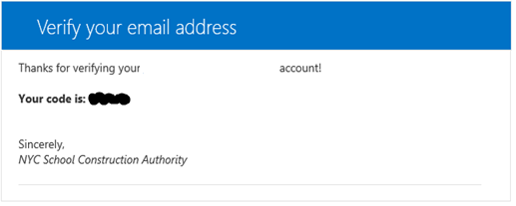
  - Update the verification code and click on verify code
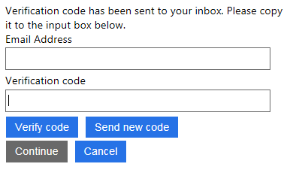
  - Once the code is verified click on Continue button

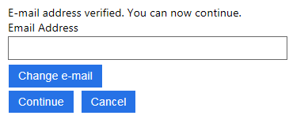

  - Provide new password to reset the password

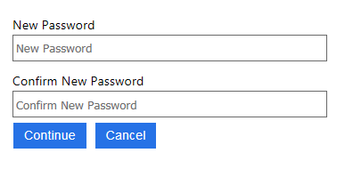

- Forgot Password -- Reset password when user does not remember the password
  - When password is forgot, click on Forgot your password link
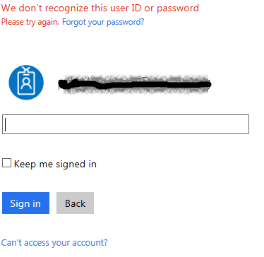

  - Provide user Id and captcha as shown in the screen.
  - Below is a sample screen to provide user id and captcha

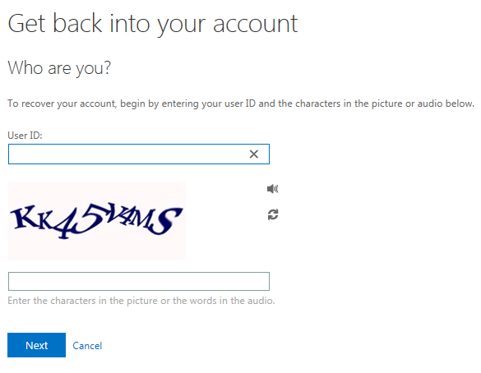

  - Click on Email button to send verification code to user email
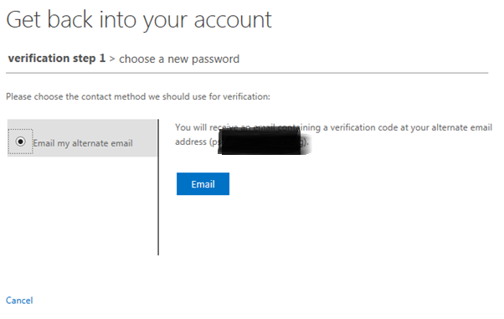
  - Get the verification code from email
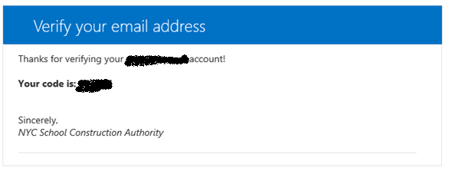

  - Provide verification code and click on Next button

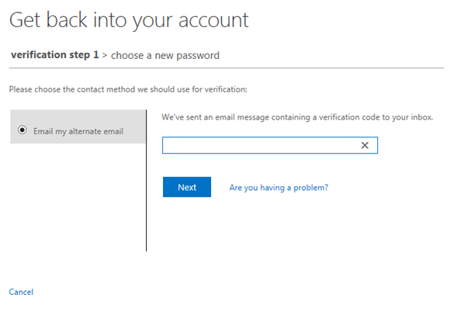
  - Provide new password and click on Finish button
